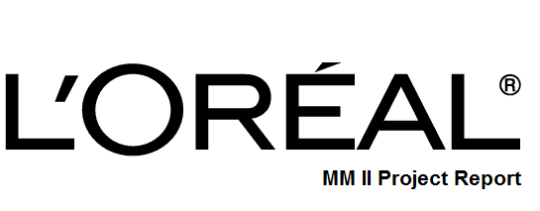

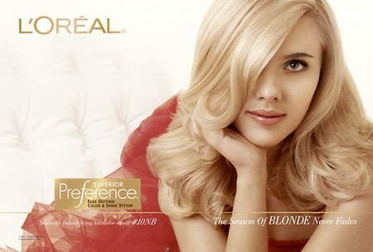

Mallika Gupta (2010114)

Nikhil Beriwal (2010133)

Niraj Thakur (2010136)

Nisarg Ostwal (2010137)

Palak Narang (2010141)

Submitted To:

Professor R.Kamble

CONTENT

PARTICULARS PAGE No.

INTRODUCTION 3

PRODUCT STRATEGY 5

PLACE STRATEGY 9

PRICE STRATEGY 11

PROMOTION STARTEGY 14

SWOT ANALYSIS 18

RECOMMENDATIONS 19

EXHIBIT I 20

EXHIBIT II 20

EXHIBIT III 21

REFERENCES 22

INTRODUCTION

L’Oreal was founded in the year 1909 by Eugene Schueller, a French chemist who developed an innovative hair color formula. Today, the L’Oreal Group is the world's largest cosmetics and beauty company and it’s headquarter is in the Paris suburb of Clichy, France. It got its start from the hair color business but soon it developed activities in the field of cosmetics, concentrating on skin care, sun protection, make up, perfumes and hair care. L’Oreal main branches are Cosmetics, The Body Shop and Dermatology. L'Oreal is active in the dermatological and pharmaceutical fields, however Cosmetics is the key revenue generator (See Exhibit I). It is also the top nanotechnology patent-holder in the United States. L’Oreal famous advertising slogan is "Because I’m worth it". It has recently been replaced by "Because you're worth it". Its portfolio of brands includes the cosmetics range of L'Oreal Paris and Maybelline NY, shampoo range Garnier, luxury products such as Lancome and active cosmetics such as Vichy. Its closest global competitor in the premium make-up segment is Revlon.

India’s contribution to the growth of the global cosmetics market is about 60 percent. The beauty and the wellness sector in India are on a boom. L’Oreal started its operations in India thirteen years ago. The share of the Indian market to L'Oreal's turnover of 15.8 billion is small, but is growing. It operates in India through its wholly owned subsidiary, L’Oreal India has four divisions — consumer products, professional products, active cosmetics and luxury products. The biggest contributor to its revenue in India is the consumer products division led by its strongest brand in terms of sales - Garnier.

L’Oreal India has recently setup its own manufacturing plant in Pune. It imports most of its products from its facilities abroad and manufactures the rest in Pune. The Indian subsidiary headed by Chief Operating Officer Dinesh Dayal, who has been with the company for 20 years, is one of the key officials responsible for the formation and operations of L'Oreal India. The operations in India are conducted through a judicial mix of global and local methods of advertising to appeal to the Indian consumers.

L’Oreal advertising account is handled by Mccann Erickson. L’Oreal India has discovered over the years, the behavior of the Indian consumers and has realized that the Indian consumer is not as price conscious as is portrayed. The brand is more expensive than the average FMCG, but offers a true value for money. The company’s growth in India can be attributed to its innovation of new products, supply chain management, systems and structure. Being the world’s second largest cosmetics major, L’Oreal is planning to foray into the Rs 1,000-crore Indian herbal and ayurvedic cosmetics industry. After identifying its targets, L’Oreal India is in advanced talks with Biotique and VLCC to acquire herbal/ayurvedic cosmetics brands. The group is taking the acquisition route to enter this niche sector. L’Oreal has thus identified India as one of its top five growing businesses globally. L'Oreal's research facilities in France, the USA, and Japan bring together more than 3,000 scientists and research staff. Their discoveries are published in leading scientific journals. L’Oreal’s innovations are patented, creating some 586 patents in 2004 alone.

PRODUCT STRATEGY

L’Oreal operates in India through four main divisions: consumer products, professional products, active cosmetics and luxury products. The biggest contributor to its revenue in India is the consumer products division led by its strongest brand in terms of sales —Garnier.

**Consumer Products**

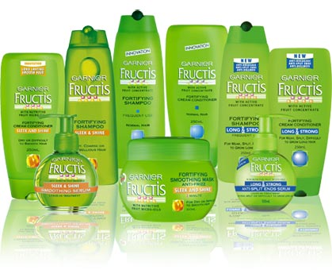 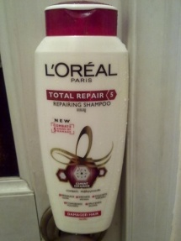 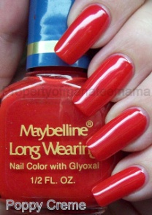

Garnier fructice L’Oreal Paris Maybelline

**Professional Products**

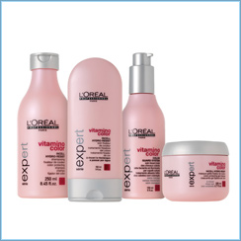 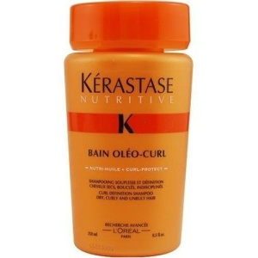 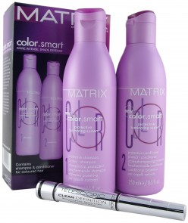 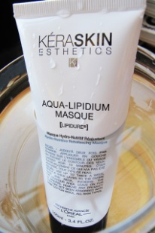

L’Oreal Professional Kerastase Matrix Keraskin

**Luxury Product**

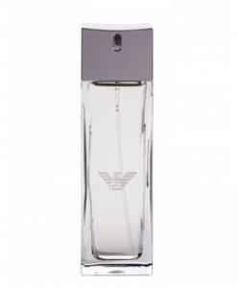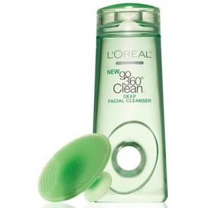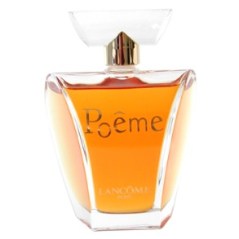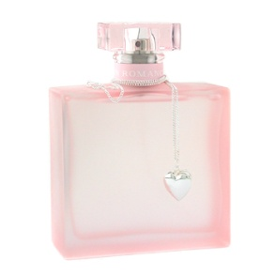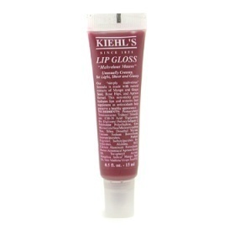

Giorgio Armani Diesel Lancome Ralph Laurel Keihl’s

**Active Cosmetics**

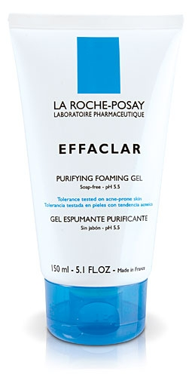 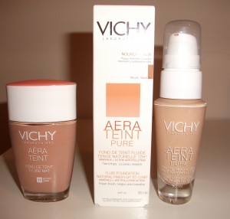

La Roche-Posay Vichy

In the hair color segment, Garnier operates in the mid-price and luxury segment. This has enabled it to garner a 20 per cent share in a market dominated by local hair colorants and dyes. Garnier attributes its performance to being the first player in India to introduce a cream-based hair color below the price of Rs 100 (2002) and the first home-highlighting kit (2005).

PRODUCT EXTENSION: - Garnier mainly produces hair care products, including the Fructis line, and most recently, skin care products under the name, Nutritioniste, that are sold around the world. One of their key ingredients is a fruit concentrate used in all their products. It is a combination of fruit acids, vitamin B3, B6, fructose and glucose. Garnier, the L'Oreal- owned brand that shook up the US hair care market with the introduction of Fructis in 2003, now has plans to bring over its skin care collection too. While L'Oréal was focusing on hair color market in the initial stages of its launch, Maybelline was in the premium color cosmetic segment while Garnier in the "naturals" segment.

In 2000 L’Oreal launched its range of cosmetics in to Indian market. Garnier concentrated on the Natural Hair care market **with the main USP of strong hair. The brand positioned as a Unisex brand mainly used its international campaigns in India to appeal to the Indian consumer. Garnier believes in beauty through nature. Scientifically developed and enriched with selected natural ingredients, its products help look healthy and feel good every day.**

LINE EXTENSION: - As mentioned above L’Oreal has been experimenting with their products a lot and they spend a lot on R&D (SEE EXHIBIT II), they have done a huge line extension in their product line up. Garnier itself has five different varients in its hair care segment (Shampoo), named as Fructis, Fructis Oil Repair, Fructis Blonde, Fructis Men & Fructis Wave Definition. Similarly L’Oreal Paris has six variants, named as Elvive, Elseve Absolute repair Shampoo, Elseve Vitamin Shampoo, Elseve Renuitrition, Vive Pro Thickening & Vive Pro Nutri Gloss. Similarly, there are many more variants of other brands too.

BRAND EXTENTION: - Acquiring influential and well positioned brand is an important strategy of L'Oreal in developing its brand architecture. It achieves rapid growth by acquiring brand in same or related business and is continually seeking these opportunities in the worldwide scope. L'Oreal expanded its brand architecture by acquiring Maybelline brand in 1996, which was a very successful transaction. The Maybelline’s image was enhanced by branded L'Oreal while L'Oreal got complementary in its brand architecture. Recent years in Asia, it acquired the third skincare brand Mininurse in China and Japanese top luxury brand Shu Uemura. This shows that L’Oreal is very aggressive in building the brand architecture by acquiring other influential brands.

PRODUCT DIFFERENTIATION: - L’Oreal came with a product name Elvive Full Restore 5 which has differentiated itself from the other products of L’Oreal. Initially L’Oreal came up with brands like Elvive Smooth-Silk Light, Elvive Anti-Dandruff, Elvive Damage care etc. but after lauching Elvive Full Restore 5 they made it clear that this product is superior to the other as it includes all the important features for which a customer was using different products.

PACKAGING STRATEGY: - Most L'Oreal makeup products aren't bubble-wrapped on cardboard like Artmatic and Wet & Wild - both serviceable products. L'Oreal displays are elegant. , who get up close and personal with their sister-viewers, confiding that, yes, L'Oreal DOES cost a little more ... "but I'm worth it.". This creates Consumer Affluence and hence customers are willing to pay a little extra for its product. The packaging strategy of Garnier products create a brand image in the mind of consumers, whenever a consumer sees the bright green packaging in hair care segment they relate it to Garnier.

Garnier, L'Oreal and Maybelline, the three brands of L’Oreal have been defined by their price segments and positioning. The company has been steadily increasing its product portfolio in the Indian market especially in the hair care segment. Its skin care brand of Garnier has been extended to a shampoo and hair conditioner under the Fructis brand, in spite of the presence of Garnier's Ultra Doux shampoo and hair conditioner. Its hair coloring portfolio has also been given a boost and the company has decided to rope in Kareena Kapoor as its new brand ambassador for its hair color brand of Garnier Nutrisse. Garnier concentrated on the Natural Hair care market with the main USP of strong hair. The brand positioned as a Unisex brand mainly used its international campaigns in India to appeal to the Indian consumer.

Garnier has been able to establish itself firmly in the Indian market and has clearly defined its target market which is the middle class and the upper middle class segment. Garnier has very effectively designed its promotional strategies by adapting to the changing customer demand. It has penetrated firmly in the Indian market both in skin care as well as hair care products covering a wide range from shampoos, conditioners, to gels, serums, hair mousse, anti-acne ointments, anti-wrinkle creams etc.

Two main natural ingredients of L’Oreal skin products are Fructose and Glucose. The role of Fructose and Glucose in nourishing hair is demonstrated in vitro culture of hair follicles. Fructose and Glucose are fuel for hair. The main ingredients are-Fruit AHA (Alpha Hydroxy Acids), Green Tea Extract, Caffeine, Anti Storage Gingko, Grape Seed Oil, Vitamins B3 and B6 & Fruit Oils.

PLACE STRATEGY

To run a company in profit the place factor out of the 4p’s of marketing mix plays a very crucial role. This includes decisions about where to sell the product or concerns about where the customers are, and how to get to them. It also includes the "channel of distribution" - meaning, all the different middlemen a company use to get the product out to the customer. L’Oreal’s success in the cosmetic industry is due not only to their high quality, but also to the corporation’s marketing efforts to make sure their various brands have a strong market presence. In past 100 years that it has expanded, it has supplied to 130 countries with offices in 58 different countries. To make its presence feel in different parts of the world L’Oreal has acquired many different companies like “The Body Shop International plc”, known as The Body Shop, which has over 2,000 stores in more than 50 countries.

As stated above in the Product strategy L’Oreal believes in Brand extention its acquisitions represent L'Oreal’s ambition to capture Asian market. They have the same product business with L'Oreal. In China the acquisition will enhance L'Oreal’s market position in skincare and acquire distribution channels Mininurse had. It is also a preparation for the future expansion in the most fast-growing market China. By acquiring Shu Uemura, L'Oreal want to use this Japanese brand to compete with SK-…¡which was a competitor in the same level, in order to meet the trend of prevalence of Japanese cosmetic brand in Asia. This is considered to be an effective and cost-efficient strategy which is consistent with L'Oreal’s overall brand architecture

As we know the brand loyalty of L’Oreal is very high and hence L’Oreal follows a pull strategy. Customers of L’Oreal goes directly to the outlets and buy the products.

DISTRIBUTION CHANNEL: - Second Level Consumer Marketing Channel

**ANALYSIS OF INDIAN MARKET**

Garnier being an important brand of L’Oreal in both hair care and skin care is available all round the globe easily. In Indian market the hair care products of garnier like “garnier fructis”, “ultra doux” etc is available in both organised and unorganized retail shops in India. The high end skin care products like “Nutritionsite” are available only in selected retail outlets in country. In India Garnier manufactures its products in Pune whereas it’s registered office is in Mumbai. To popularize its product line L’Oreal has occupied brand corners in many big malls and retail outlets in which garnier products get a major chunk. L’Oreal has tie ups with many big beauty salons and parlors who can promote and sell its products. Over the past decade the company has trained more than 30,000 hairdressers in India in the use of its products. And it has helped to establish about 300 salons in the past five years. The theory is simple: If there is no natural demand for your goods, stimulate it. “We have created a profession and a market,” Didier Villanueva, L’Oréal India’s country manager, said. “If you train people they will use your products.” Its sales in India, where it is No 2 behind Unilever, are growing at 35 per cent a year. This year, they are about €100 million (£71 million). Although L’Oréal’s professional products division represents only 17 per cent of total revenues, hair color was the Paris-based group’s genesis and remains the creative heart of the business. Money-spinning mass-market brands such as Garnier are being pushed hard in India, where the company estimates there is a market of 50 million. Garnier products are easily available for sale on many websites in India.

PRICE STRATEGY

The target segment for any product is that homogeneous group of people which is purported to be the most potential customer for the product. The market follows the Pareto Principle, which says that 80 per cent of the sales come from 20 per cent of the people. Thus, for any product, one of the major tasks of marketers is to identify the group of 20 per cent that gives 80 per cent revenue of that product’s sale to the company. No surprise then that major marketing efforts of companies attempt to attract the most potential group. In the present stage of immense competition, companies are required to effectively plan their pricing strategies to not only retain current customers but to also expand the customer base by targeting new segments with an aim to convert them into loyal customers.

Trying to strike a balance in its pricing strategy for the Indian market, `L'Oreal India Private Ltd believes that by introducing more stock keeping units (SKU's) it will be able to tide over the steep pricing of its products.

L'Oreal is looking at pricing in the Indian context and there is a kind of balance they have struck. Considering the large number of SKU's that they already have worldwide, they are planning to market the products at an almost comparable pricing.

Considering the company has set up its manufacturing facilities in Pune and has also been sub-contracting its products, it has been easier for it to control its prices in the Indian market.

For aspirational products Garnier has adopted an international pricing strategy, which may not be the case for the rest of the products. However there is no hard and fast rule. Besides, the company has also been customizing its products for the Indian market and there is expected to be a blend of both international as well as Indian formulations for its products. For instance its Garnier brand of Color Naturals is an `Indianised' product.

L'Oreal’s innovations always start from its luxury brands then penetrate to the brands in different price level and different markets eventually implemented in its consumer brands. The innovations based on the same technology platform will reduce the cost. The knack for L'Oreal to create the advantages is to spread around strategic investment by sharing the production of innovation between different product divisions. L'Oreal not only focuses on the single brand but also pays attention to the technology relevancy in the series of brands. For example, L'Oreal first introduced a break through anti-aging composite by using Lancôme brand. Subsequently, it was implemented in Vichy brand and brought into the consumer product division eventually. The broad distribution channel of consumer products was used to promote this technology at last. In term of same products in the different market, L'Oreal also exerts the technology platform to meet the specific needs of consumers. From L'Oreal’s experiences, the core technology platform is a key component to the success of an international company with complicated brand house. Without leveraging the resources between brands, it will cause increase of operational cost and waste of resources and will be very hard to manage the L'Oreal’s sophisticated brand architecture. Other than building the brand structure according to the product identity, L'Oreal relied on distribution channel to carry out its strategy of brand structure. There are four product departments in L'Oreal’s structure. Every department has several brands and each brand has many names. They are conspicuously different in packages and with distinct image and advertising. The different brands share the resources of distribution channel and have high integration effect on management. The luxury brands of L’Oreal are sold in strictly selected distribution channel like department store, perfumeries and tax free shop. Professional products are provided to the hairdressers. Active cosmetic products are sold in pharmacists. The most important sector consumer products are distributed through mass consumption channel like department store and supermarket.

L'Oreal has formed a brand matrix with great power of integration. Any new brand merged into the relevant channel will fully utilize the resources in existing channel as well as expand L'Oreal’s whole distribution channel by integrating its original channel. The dissemination of brand will improve company’s overall influential power.

L'Oreal recognized the leverage effect of it brand and focus its propagandas on brand rather than propagandas on particular product. It is dedicated in building the relationship between its brand and the market. It aims to enhance brand power by maintaining the good image in publicities. L'Oreal’s efforts were also embodied on its marketing strategy. It always concentrates on supporting those brands which can mostly represent its advantages and leverage resources to those premium products. Firms that aim to expand internationally or strengthen market position tend to acquire new brand into the brand architecture.

L’Oreal also follows the bundling strategy to increase its sales. They come up with a customized make up kit and sell it at a discounted rate. By discounting such products, L’Oreal taps the potential buyers easily.

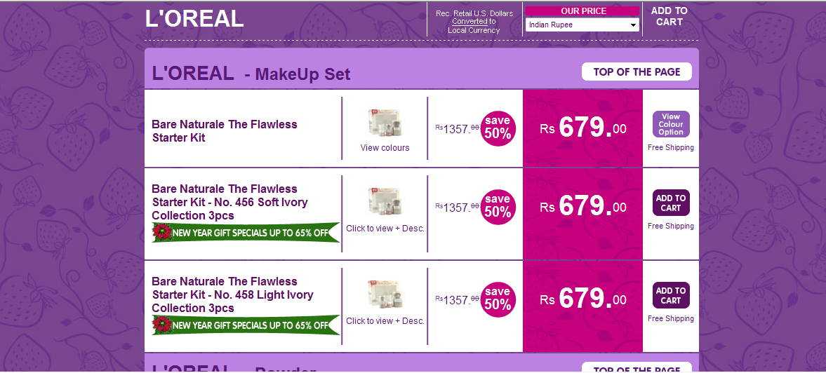

PROMOTION STRATEGY

L’Oreal has been very active and upfront in adopting new promotional techniques to market its products. The company follows a very popular technique to advertise and market its products that was the Viral Marketing policy. Viral marketing is a term coined to define the productive ways a marketing message is made available. And corporate are using the medium to circulate brands and brand messages. The idea has caught on like a virus, as efficiently as Information Technology has entered households and businesses.

Firms are now structuring their businesses in a way that allows them to grow like a virus and lock out the existing brick and mortar competitors through innovative pricing and exploitation of competitors' distribution channels. The beauty of this marketing technique is that none of it requires any marketing. Customers, who have caught the virus, do the selling. Viral marketing describes any strategy that encourages individuals to pass on a marketing message to others, creating the potential for exponential growth in the message's exposure and influence. Like viruses, such strategies take advantage of rapid multiplication to explode the message to thousands, to millions.

Off the Internet, viral marketing has been referred to as "word-of-mouth'', "creating a buzz'', "leveraging the media'' and even "network marketing.'' It's a deceptively simple concept: Create a message, send it via e-mail, and make it so compelling that recipients want to pass it on to everyone in their address book. Advertisers are hot on the tactic and the idea of putting consumers to work spreading the word about a brand or service seems sound.

CONTEST: - When Garnier launched its Fructis shampoo, they latched on to the idea. The firm had to introduce the aspect of five time’s stronger hair and the firm had a braid competition whereby consumers could register on a site and create a knot on the Fructis braid, as part of their entry into the contest. The knot creation was actually created (visually presented on the site) and as a next step, consumers were expected to invite their friends to visit the braid and add to their score. A record 76,000 consumers created their own knot on the braid and forwarded the link to more than 82,000 of their friends, a survey report indicated. Viral marketers practice delayed gratification. They may not profit today, or tomorrow, but if they can generate a groundswell of interest from something free, they know they will profit soon and for the rest of their lives. Since 'Free' happens to be the most powerful word in a marketer's vocabulary, most viral marketing programmes have attached themselves to it. The idea is to give away valuable products or services to attract attention. And, more importantly, someone else's resources are depleted rather than our own. Garnier has positioned itself as a lifestyle product mainly targeting teenagers and young girls. This is very evident from Garnier ads be it for Garnier fructis shampoos or for hair color. In a recent advertisement of Garnier hair color, a daughter advises her mother to try the product and thus makes an attempt to promote product among middle- aged women. Hence, expanding the base of the target segment gives a whole new market to marketers, provided they are successful in convincing the customers of the second-rung segment.

Mr. Pramod Jain, Marketing Manager L’Oreal (Nagpur) said “Companies need to be very strategic in presenting the product and its features to attract another segment. At the same time, companies need to be sensitive about the impact of targeting other segments on the existing target segment. It may be damaging, especially, if in a process of expanding its customer base, a premier brand is targeted at the aspiring middle-class also. In case of any signals of lowering demand with the existing target group, companies should adopt line extensions by bringing suitable changes in the products.”

POINT OF PURCHASE DISPLAY: - L’Oreal apart from its own outlet puts its product in display at various places. We have seen L’Oreal stalls in malls, various unisex saloons, VLC outlets etc. This kind of display allows the consumer to see the product and enquire about the same.

RELYING ON INTERNATIONAL AD CAMPAIGNS: - Increasing its ad spend for the launch of its new products, L'Oreal has been relying more on its international campaigns to make an impact in the Indian market. McCann Erickson in Mumbai handles the L'Oreal and Maybelline account while Publicis India is in charge of Garnier. "The ad accounts have been aligned according to our international affiliations with these agencies and we try to have a mix of both the Indian and international ads," says Mr. Rajgopal.

L'Oreal India currently has three brands in its consumer products portfolio and there are product overlaps between its hair care, skin care and color cosmetics brands. Garnier, L'Oreal and Maybelline have been defined by their price segments and positioning.

OTHER PROMOTION STRATEGY: - The cosmetics giant is using hairdressing schools to stimulate demand for products many Indians saw as an alien extravagance.

Since it opened its first academy in Bombay in 2006, 73 hairdressers have graduated. The six-month course turns out professionals capable of working as a junior in one of the select but growing number of international-standard salons in India’s big cities.

L’Oréal’s distribution network also plays a vital role. Over the past decade the company has trained more than 30,000 hairdressers in India in the use of its products.

And it has helped to establish about 300 salons in the past five years. The theory is simple: If there is no natural demand for your goods, stimulate it. “We have created a profession and a market,” Didier Villanueva, L’Oréal India’s country manager, said. “If you train people they will use your products.”

In a media-driven culture obsessed with Bollywood, urban consumers are very demanding and image is everything. They read glossy magazines such as Vogue, which launched an Indian edition in September, and follow the changing fashions of their favourite celebrities.

Much like Britain’s tabloid fascination with David Beckham’s changing hairstyles, the recent decision by Mahendra Singh Dhoni, the 26-year-old captain of the one-day cricket team and the face of Brylcreem in India, to chop his long locks made front-page news.

Unprecedented economic growth in India, which is forecast by McKinsey to become the world’s fifth-biggest consuming nation by 2025, has created a raft of opportunities for international lifestyle brands.

Emerging markets such as India are driving the growth of the cosmetics industry. L’Oréal, which uses Aishwarya Rai, the Bollywood star and former Miss World, as one of its international faces, estimates there are 70 million potential consumers being created every year.

Its sales in India, where it is No 2 behind Unilever, are growing at 35 per cent a year. This year, they are about €100 million (£71 million).

Although L’Oréal’s professional products division represents only 17 per cent of total revenues, hair color was the Paris-based group’s genesis and remains the creative heart of the business. Money-spinning mass-market brands such as Garnier are being pushed hard in India, where the company estimates there is a market of 50 million people.

In India, advertisements for L'Oréal-branded products and the company's Garnier line generally feature a pale model and focus on the ingredients in the product, using take- action language like "YES to fairer and younger looking skin" or "Against inside cell damages."

SWOT ANALYSIS

**STRENGTHS**

Strong and Focused Brand Portfolio.  
Presence in Emerging Markets.  
Strong R&D Capability.  
Variants available.  
Geographical Coverage.

**WEAKNESSES**

Dependence on Western European Markets  
Late Entry into Asian markets.  
Unable to gain much of market share.

**OPPORTUNITIES**

Growth in Adjacent Categories.  
Demand for Natural Cosmetics.  
Growth of Direct Sales Channels  
Changing Consumer Lifestyles.  
Beauty products market growing with a significant rate.

**THREATS**

Competition from Private Labels.

Price Competition among Branded Manufacturers.

RECOMMENDATION

* L’Oreal should more actively participate in fashion events as it will increase the Market presence of the brand.
* L’Oreal focuses more on Word of mouth publicity and it believes in Viral Marketing, hence it should focus more on making the consumers use the product for the first time. If a consumer uses the product, there is a high probability of them using it again.
* L’Oreal should focus more on including natural products in their product portfolio. We have Garnier in the list which uses natural ingredients; however we can include other brands too. We can still put Maybelline in the premium color cosmetic segment but we can use the natural ingredients in place. People today are more concerned about the quality of the product apart from that they are also concerned about the effects and side effect of the same, hence L’Oreal should take this into consideration.
* L’Oreal’s target customers are middle class and educated people (mostly working and youngsters). L’Oreal has already captured most of the market where they can tap their target audience; however once are where they can approach would be the corporate offices. They can put up a stall of L’Oreal in the office premises of different corporate, allowing the employees to check new products and buy the one they want to.

EXHIBIT I

**2009 Consolidated sales (In Euro millions)**

|  |  |
| --- | --- |
| **Cosmetics** | **16257** |
| **The Body Shop** | **726** |
| **Dermatology** | **489** |

EXHIBIT II

* Euro 609 dedicated to cosmetic and dermatological research in 2009
* 18 research centers across the world and 13 evaluation centers in the world .
* 1/3 rd of the R&D budget devoted to basic research.
* 5000 formulas developed each year
* 674 patents filed in 2009.
* 100 active cooperation agreements with leading academic and research institutions.

EXHIBIT III

Sales by operational division and geographic zone

|  |  |  |  |  |  |  |
| --- | --- | --- | --- | --- | --- | --- |
|  | **3rd quarter 2010** | | | **at September 30, 2010** | | |
| **€m** | **Growth** | | **€m** | **Growth** | |
| **Like-for-like** | **Reported** | **Like-for-like** | **Reported** |
| **By operational division(1)** |  |  |  |  |  |  |
| Professional Products | 684.2 | 2.90% | 16.10% | 2 046.8 | 4.50% | 13.30% |
| Consumer Products | 2 392.2 | 6.50% | 15.10% | 7 214.5 | 5.90% | 11.30% |
| Luxury Products | 1 144.3 | 5.70% | 12.60% | 3 248.3 | 8.30% | 12.20% |
| Active Cosmetics | 307.9 | 3.40% | 9.30% | 1 081.0 | 4.30% | 8.30% |
| **Cosmetics total** | **4 528.6** | **5.50%** | **14.20%** | **13 590.6** | **6.10%** | **11.60%** |
|  |  |  |  |  |  |  |
| **By geographic zone(2)** |  |  |  |  |  |  |
| Western Europe | 1 715.5 | 1.50% | 2.60% | 5 427.8 | 1.80% | 2.60% |
| North America | 1 129.4 | 3.80% | 17.80% | 3 248.2 | 4.60% | 11.80% |
| New Markets, of which: | 1 683.6 | 11.30% | 26.20% | 4 914.6 | 12.40% | 23.40% |
| - Asia, Pacific | 808.7 | 11.50% | 28.50% | 2 348.9 | 12.30% | 22.80% |
| - Eastern Europe | 317.6 | 2.90% | 11.10% | 1 024.3 | 8.60% | 16.80% |
| -  Latin America | 410.9 | 18.20% | 35.90% | 1 115.1 | 19.20% | 35.40% |
| - Africa, Middle East | 146.6 | 12.40% | 25.50% | 426.3 | 6.30% | 15.40% |
| **Cosmetics total** | **4 528.6** | **5.50%** | **14.20%** | **13 590.6** | **6.10%** | **11.60%** |
| The Body Shop | 172.1 | -0.60% | 6.2% | 506.4 | -0.10% | 4.3% |
| Dermatology(3) | 151 | 27.10% | 40.40% | 421.4 | 18.40% | 24.70% |
| **Group total** | **4 851.7** | **5.80%** | **14.60%** | **14 518.4** | **6.20%** | **11.60%** |

REFERENCES

1. <http://www.loreal.co.in/_hi/_in/index.aspx>
2. <http://www.loreal.com/_en/_ww/index.aspx>?
3. <http://www.loreal-finance.com/eng/key-figures>
4. <http://www.loreal.com/_en/_ww/index.aspx?direct1=00006&direct2=00006/00002&direct3=00006/00002/00003&direct4=http://www.loreal-finance.com/v9/us/contenu/communique_finance.aspid_page=724>
5. <http://www.mbaknol.com/management-case-studies/case-study-loreals-promotional-strategies-in-indian-cosmetics-market-for-garnier/>
6. <http://inen.strawberrynet.com/makeup/l-oreal/?gclid=CIuI8fC426UCFUQa6wod_D9FzQ>
7. <http://www.strategy4u.com/resource_library/strategytips/articles/20030310.13.shtml>