INTRODUCTION

Advertising, generally speaking, is the promotion of goods, services, companies and ideas, usually performed by an identified sponsor. Marketers see advertising as part of an overall promotional strategy. Other components of the promotional mix include publicity, public relations, personal selling, and sales promotion.
Advertising involves the process where in a message is designed so as to promote a product, a thought, an idea or even a service. The concept of advertising has assumed a dynamic form with the use of the various mediums of communication. From the newspaper, magazines, posters, neon and fluorescent signboards, billboards to the commercial on TV, laser shows to inflated high-rise figures and objects, advertising has come a long way. The work is formidable as it spearheads a process intended to attract, modify, change and influences public opinion.
From the local business to multinational firm and all need to advertise. While politicians, social organizations, government special groups need to advertise their motto, national airlines, auto mobile manufactures, food and consumer goods manufacturers have to reach the consumer. Specialist products and services are often advertised through trade magazines and exhibitions. Lately mail-shots, handbill circulation, special offers have become very popular. There are still other ways of advertising. There are window displays, display on telephone directories, transit sign on buses, lamp posters, banners, etc. Advertising through the electronic media has been perhaps the most popular medium.
Advertising, as an effective medium, uses a variety of techniques to create effective advertisements. A basic appeal is at the heart of advertising. Slogans and product characters are created to catch the attention of the viewers. Most winning advertisements would encompass factual information with emotional appeal.

Awareness proceeds change. Companies mainly seek to change the current buying habits of their target market, and determine how they are going to reach that group in the most effective way possible.
Advertising Fundamentals
Nearly everybody in the world is subjected to advertising. We talk about the good ads and sometimes about the bad ones. For some people, the advertisements debuting during the cricket world cup broadcast are a bigger attraction than the game itself. Memorable ads are part of the culture of the last three or four generations of humanity, as our civilization is awash with advertising.
Advertising is Communication
Advertising sends a message. The advertising campaign, regardless of its scope or size, portrays the organization, products and services, and values. Each attribute is tested with each new customer the companies acquire.

Advertising should enhance the credibility of an organization and present the best solution to meet customers’ needs The number of advertising alternatives is enormous. To sort through it all, the company needs to constantly relate their advertising to their strategy. It’s not a matter of clever ads or large budgets. Much better results can be achieved if the focus is on the message the company wants to send and reach the people they want to receive that message.

HISTORY OF ADVERTISING IN INDIA

-Indian Advertising starts with the hawkers calling out their wares right from the days when cities and markets first began
-Shop front signages
-From street side sellers to press ads
-The first trademarks
-Handbills distributed separately from the products
18th Century
# Concrete advertising history begins with classified advertising
# Ads appear for the first time in print in Hickey's Bengal Gazette. India's first newspaper (weekly).
# Studios mark the beginning of advertising created in India (as opposed to imported from England) Studios set up for bold type, ornate fonts, more fancy, larger ads
# Newspaper studios train the first generation of visualisers & illustrators
# Major advertisers: Retailers like Spencer's, Army & Navy and Whiteaway & Laidlaw
# Marketing promotions: Retailers' catalogues provided early example
# Ads appear in newspapers in the form of lists of the latest merchandise from England
# Patent medicines: The first brand as we know them today were a category of advertisers
# Horlicks becomes the first 'malted milk' to be patented on 5th June 1883 (No. 278967).
# 1931- National Advertising Service Pr. Ltd. Bombay set up
# 1936- Indian Broadcasting Company becomes All India Radio (AIR)
# 1978 -First television commercial seen

# 1990-Marks the beginning of new medium Internet

# 1991- First India-targetted satellite channel, Zee TV starts broadcast

# 1993-India's only advertising school, MICA (Mudra Institute of
Communications Ahmedabad), is born

ADVERTISING INDUSTRY OF INDIA

The Indian advertising industry is talking business today. It has evolved from being a small-scale business to a full-fledged industry. It has emerged as one of the major industries and tertiary sectors and has broadened its horizons be it the creative aspect, the capital employed or the number of personnel involved. Indian advertising industry in very little time has carved a niche for itself and placed itself on the global map.

Indian advertising industry with an estimated value of es13, 200-crore has made jaws drop and set eyeballs gazing with some astonishing pieces of work that it has given in the recent past. The creative minds that the Indian advertising industry incorporates have come up with some mind-boggling concepts and work that can be termed as masterpieces in the field of advertising.

Advertising agencies in the country too have taken a leap. They have come a long way from being small and medium sized industries to becoming well known brands in the business. Mudra, Ogilvy and Mathew (O&M), Mccann Ericsonn, Rediffussion, Leo Burnett are some of the top agencies of the country.

Indian economy is on a boom and the market is on a continuous trail of expansion. With the market gaining grounds Indian advertising has every reason to celebrate. Businesses are looking up to advertising as a tool to cash in on lucrative business opportunities. Growth in business has lead to a consecutive boom in the advertising industry as well.

The Indian advertising today handles both national and international projects. This is primarily because of the reason that the industry offers a host of functions to its clients that include everything from start to finish that include client servicing, media planning, media buying, creative conceptualization, pre and post campaign analysis, market research, marketing, branding, and public relation services.

Keeping in mind the current pace at which the Indian advertising industry is moving the industry is expected to witness a major boom in the times ahead. If the experts are to be believed then the industry in the coming times will form a major contribution to the GDP. With al this there is definitely no looking back for the Indian advertising industry that is all set to win accolades from the world over.
Scope of Advertising Industry in India
The advertising industry in India has several competitive advantages:
- India has a rich pool of strategic planning, creative and media services personnel: Indeed, Indian advertising industry has been exporting senior-level talent to many countries, particularly to the Gulf, South-East Asia, China, the UK and the US. Indian talent is recognised and respected in global agency networks.
- No other country has access to so many trained management graduates who can provide strategic inputs for brand and media planning.
- Indians are multicultural: we learn at least two languages and that gives us a head start in understanding cultural diversity.
- Most of the top 20 agencies in India have a global partner or owner, which should provide an immediate link to global markets.
- Our production standards in TV and print have improved: With a vibrant animation software industry, we have access to this area of TV production.
- India's advanced IT capabilities can be used to develop Web-based communication packages for global

Statistics of advertising industry
# The overall advertising and media industry is expected to close at Rs 21,314 crore in revenues in 2008, riding a 20 per cent growth rate

# Television advertising market is projected at Rs 8,674 crore in 2008

# The print industry stands at nearly Rs 10,000 crore.

# The cinema medium will corner around 0.7 per cent of the total advertising budget in 2008.

# Outdoor media industry will grow at 14 per cent to touch Rs 1,454 crore,

# Radio is likely to record a 40 per cent growth in 2008 to touch Rs 672 crore
# Internet advertising will constitute only 1.7 per cent of the overall advertising spends in 2008, up from the current 1.4 per cent.

Working of an advertising agency

Firms in the advertising and public relations services industry prepare advertisements for other companies and organizations and design campaigns to promote the interests and image of their clients. This industry also includes media representatives—firms that sell advertising space for publications, radio, television, and the Internet; display advertisers—businesses engaged in creating and designing public display ads for use in shopping malls, on billboards, or in similar media; and direct mail advertisers. A firm that purchases advertising time (or space) from media outlets, thereafter reselling it to advertising agencies or individual companies directly, is considered a media buying agency. Divisions of companies that produce and place their own advertising are not considered part of this industry.
Most advertising firms specialize in a particular market niche. Some companies produce and solicit outdoor advertising, such as billboards and electric displays. Others place ads in buses, subways, taxis, airports, and bus terminals. A small number of firms produce aerial advertising, while others distribute circulars, handbills, and free samples.
Groups within agencies have been created to serve their clients’ electronic advertising needs on the Internet. Online advertisements link users to a company’s or product’s Web site, where information such as new product announcements, contests, and product catalogs appears, and from which purchases may be made.
Some firms are not involved in the creation of ads at all; instead, they sell advertising time or space on radio and television stations or in publications. Because these firms do not produce advertising, their staffs are mostly sales workers.
Companies often look to advertising as a way of boosting sales by increasing the public’s exposure to a product or service. Most companies do not have the staff with the necessary skills or experience to create effective advertisements; furthermore, many advertising campaigns are temporary, so employers would have difficulty maintaining their own advertising staff. Instead, companies commonly solicit bids from ad agencies to develop advertising for them. Next, ad agencies offering their services to the company often make presentations. After winning an account, various departments within an agency—such as creative, production, media, and research—work together to meet the client’s goal of increasing sales.
Widespread public relations services firms can influence how businesses, governments, and institutions make decisions. Often working behind the scenes, these firms have a variety of functions. In general, firms in public relations services advise and implement public exposure strategies. Firms in public relations services offer one or more resources that clients cannot provide themselves. Usually this resource is expertise in the form of knowledge, experience, special skills, or creativity; but sometimes the resource is time or personnel that the client cannot spare. Clients of public relations firms include all types of businesses, institutions, trades, and public interest groups, and even high-profile individuals. Clients are large and small for-profit firms in the private sector; State, local, or Federal Governments; hospitals, universities, unions, and trade groups; and foreign governments or businesses.
In an effort to attract and maintain clients, advertising and public relations services agencies are diversifying their services, offering advertising as well as public relations, sales, marketing, and interactive media services. Advertising and public relations service firms have found that highly creative work is particularly suitable for their services, resulting in a better product and increasing their clients' profitability.

Work Environment
Ad agencies are based within office settings. Accounts Executives, Account Planers, Media Executives, Art Directors and Copywriters spend most of their working time in agency office. Account Executives have to travel extensively, visiting clients and suppliers. While other staff, travel occasionally to attend meetings with clients, or visit locations during film production. Ad agencies are very busy places and often work is on till late hours. In 2004, workers in the industry averaged 33.8 hours per week, a little higher than the national average of 33.7.
Most employees in advertising and public relations services work in comfortable offices operating in a teamwork environment; however, long hours, including evenings and weekends, are common. There are fewer opportunities for part-time work than in many other industries; in 2004, 14 percent of advertising and public relations employees worked part time, compared with 16 percent of all workers.
Work in advertising and public relations is fast-paced and exciting, but it also can be stressful. Being creative on a tight schedule can be emotionally draining. Some workers, such as lobbyists, consultants, and public relations writers, frequently must meet deadlines and consequently may work long hours at times. Workers, whose services are billed hourly, such as advertising consultants and public relations specialists, are often under pressure to manage their time carefully. In addition, frequent meetings with clients and media representatives may involve substantial travel.
Most firms encourage employees to attend employer-paid time-management classes, which help reduce the stress sometimes associated with working under strict time constraints. Also, with today’s hectic lifestyle, many firms in this industry offer or provide health facilities or clubs to help employees maintain good health.

Advertising Process
When preparing your search proposal, you should take into account that the “lead-in” time needed to place an ad can vary anywhere from days to months depending on the publication. You should plan to have your ad approved and an estimate of the cost done at least one month prior to the date when you want the ad to be published. The advertising process for professional staff and faculty positions involves five basic steps:
- Writing an Ad
- Getting Approval for the Text of the Ad
- Estimating the Cost of the Ad
- Placing Ads & Posting Announcements
- Paying for Ads
STAGE | WORK PERFORMED AT STAGE
Briefing Stage | - Briefing from the client  - Internal briefing to the creative and media  - Any research briefing if required
Creation Stage | - Ad campaign and media plan development  - Internal review and finalization  - Presentation to client and approvals  - Any pre-testing if required
Production Stage | - Budget and estimate approvals  - Production of film, press ads, collaterals  - Media Scheduling and media booking  - All release approvals for creative & media
Post Production Stage | - Material dispatch to media  - Media release monitoring  - Any post-testing if required  - Billing and collection

Organization Structure
The activities within an advertising agency are typically divided into 4 broad groups: account management, the creative department, media buying, and research. These divisions are usually physically separated, although all four areas work closely together to produce an advertising campaign in its entirety.
Account managers usually have daily interaction with a counterpart at the client's office and coordinate the activities of the other departments according to the client's wishes. The creative department designs original themes or concepts for ads, while the media department places finished ads within the media in which they will receive the most exposure to a target audience. The research department provides data about consumers to help the agency and the client make informed advertising decisions.
Recently added to advertising agencies' roster of services are public relations, direct marketing, and promotional services. Other activities that used to be completed by outside vendors, such as photography and high-tech print work, have been brought in-house in many agencies.

ORGANIZATION CHART

Board of Directors
Managing Director
Client Services Director
Creative Director
Servicing Group
Media
Research
Creative Groups
Audio Visual
Language
Studio
Production
Finance / Accounts
Branches
Secretarial / Legal Personnel

Advertising creatives

Some of the most successful advertisement creative produced by various ad agencies in India are shown below.
 | 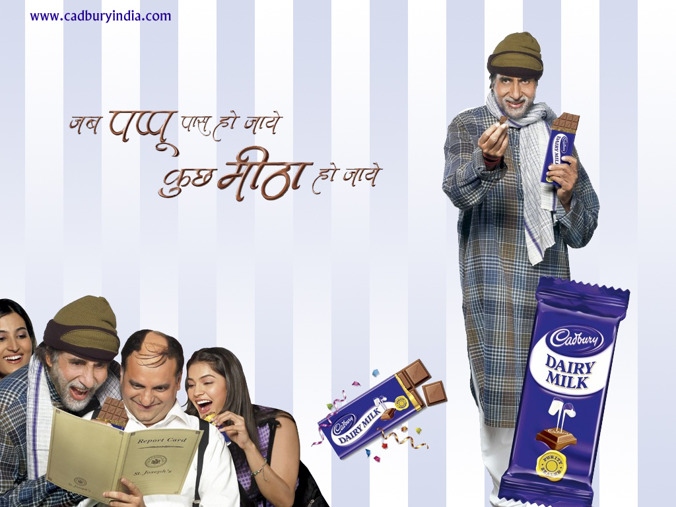
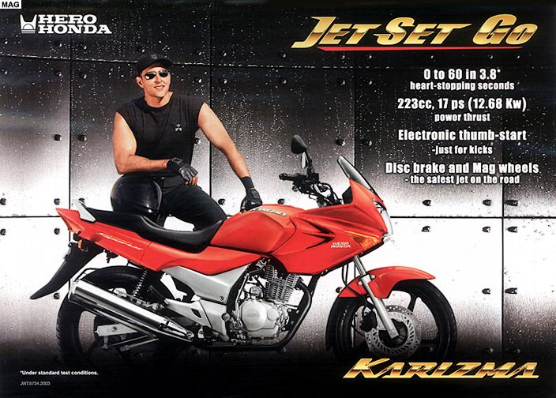 | 
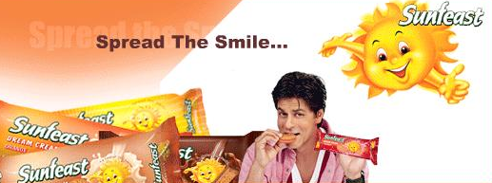 | 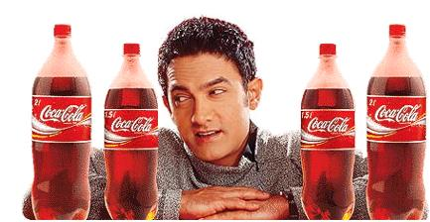

Catchy & Memorable Advertising Slogans & Jingles - Indian Advertising Industry

Slogans and Jingles form an essential part of the advertising industry. The main role of an advertising slogan or radio jingle is to create an identity for the brand.

Once the catchy slogan or jingle becomes popular, it further leads to brand recognition and services as a reminder for the target audiences. A lot of effort goes into brainstorming and creating an advertising slogan / tag line / jingle for a brand / product. The creative tag line must fall in place and gel with the overall marketing efforts and corporate identity of the brand being advertised and promoted.

Over the years, it has been seen that certain advertising campaigns have been a huge hit with its target audiences. People, till date, relate to the brand through its catchy and creative ad slogan . jingle. Such is the power of creativity!

Here are a few of my all time favorites - radio jingles, advertising slogans and tag lines - I can't help but relate these brands with their creative one liners - Gagan Vanaspati - "Khao Gagan, Raho Magan"
Complan - "I'm A Complan Boy - I'm A Complan Girl!"
Tomato Ketchup - "Ketchup Hoga Kaddoo Bhara, Isme Kaddoo Nahi Zara"
Lijjat Papad - "Kharram Khurram, Khurram Kharram - Mazedar Lazedar Swaad Swaaad Mein Lijjat Lijjat Papad"
Nirma Detergent - "Nirma Detergent Tikiya - Iski Jhaag Ne Jadu Kar Diya - Paani Mein Rah Kar Bhi Ye Kam Gale Dheron Kapde Dhoye Aur Zyada Chale"
Hawkins Pressure Cookers - "Hawkins Ki Seetee Baji, Khusboo Hi Khushboo Udi, Mazedar Lazedar Khana Hai Tayyeyar - Murg Musaalam, Muttar Paneer, Kheer Aur Dum Aloo"
Uma Falls - "Uyii Maa Nahi, Uma - Uma Falls"
Texla Tv - "Texla TV Jab Se Aaya, Sabke Mann Mein Texla Hi Chaya"
Mentos - "Dimaag Ki Batti Zala De"
Sprite - "Clear Hai!"
Coke - "Thanda Matlab Coca-Cola", "Piyo sar utha ke"
Saffola - "Abhi to main jawan hoon"

CASE STUDY ON WORKING OF ADVERTISING AGENCIES

Case study:1
Client : Reliance Textile Industries Ltd. (Vimal Suitings)
Ad Agency : Mudra Communication Pvt. Ltd., Ahmedabad

Marketing Objective
The Research and Development department of Reliance Textile innovated a suiting, using imported yarns, which imparted exclusive properties to the fabric – maximum porosity per square centimeter and excellent crease recovery to free the fabric from unwanted wrinkles. The range of colours of pastel shades was subdued and classy.
Considering the final product and pricing, it was decided to beam the marketing of the product at the uppermost segments of society, such as directors, chairmen, industrialists, businessmen, in short gentlemen of some standing in society. A prime requirement, however, was that the strategy should not offend other prospective consumers by excluding them completely. Rather, this suiting had to be promoted as a very sophisticated, exclusive suiting.

Creative strategy
To reach the primary target audience the personnel selected to be featured in the advertising campaign were four gentlemen who were well known by the position they held in prestigious or organizations by virtue of their business interests.
Since the brand name, Herr Mode, was adapted from the German and stood for “fashion for the gentlemen”, this was used as the copy platform and read as follows:
Herr Mode:
In German it stands for fashion for the gentleman.
In India it stands for the finest suiting for gentleman.

To include other consumers as well, the same theme “finest suiting for gentleman” was retained.

Media Strategy
Colour advertisements were scheduled in selected prestigious general interest magazines all over the country. To achieve the specific marketing objective of reaching the primary target audience, a few business journals, and journals read by top level personnel, were also used as a primary medium. To cover other ‘aspiring’ consumers, the colour advertisements were adapted to black and white formats and scheduled in all major newspapers of the country. Posters and other point of sale material were distributed to retailers stocking Herr Mode suiting all over the country.

Case 2

Agency: Ogilvy & Mather
Client: Asian Paints

O&M building brands of Asian Paints
Albert Einstein said “Everything should be made as simple as possible, but not simpler.” And so it is with brands! As many of them try to make things simpler, they only end up complicating the core message. Some, however, continue talking to their consumers in the same language for decades on end, and with great aplomb. For well over six decades, images of Gattu (the Asian Paints mascot developed by R.K. Laxman) remains imprinted in the psyche of Indian consumers. But when gattu gave his place to Sunil Babu in 2002, Asian Paints arguably unleashed a whole new exciting industry in the country, converting it into a more thrilling propostion.
The year 2006 saw Asian paints came out with its ‘Chhote Nawab’ campaign, which once again created magic with brand’s patrons and explored virtually every territory, from sublet absurdity to fond emotions. Abhijit Avasthi, Group Creative Director, Ogilvy & Mather has been working on Asian Paints brand proposition for a long time and asserts his familiarity with the tone and manners of their communications. ‘while the corporate communication (har ghar kch kehta hai) of Asian Paints is emotional in its appeal, the work on Apex Exterior has always been product-centric and humorous in the manner of ‘Wah Sunil Babu, Badhiya hai’ and the ‘Chhote Nawab’ Campaign.”
Chhote Nawab followed the phenomenal successs of the Sunil babu campaign and the quirky element in the commercial did woneders, both for the product and the message. The emphasis was on array of eye-catching colours and it even packed enough punch to attract the youth. In the later half of the year, this paint brand came up with yet another characteristics commercial, which told the story of how two kids cajole their grandmother to buy chocolates by linking it to their favourite wall colour. Someone once said ‘angels can fly because they take themselves lightly; devils fall because of their gravity’, and this 64 year old paint veteran certainly seems to have understood this light & racy path to success! “Badhiya Hai”!

CLASSIFICATION OF ADVERTISING

Product advertising

Within the context of the 4 Ps of marketing we have the Product. Be it an FMCG product or an industrial good, we need to understand that advertising plays an important role in promoting the product. Be it at any stage of the product life cycle, every product needs to be communicated for varied reasons to its target customer as to why they ought to go for that product.
A product has to be good and should give satisfaction to the needs of the consumer only then will the advertising objective can be a success. Even a bad product could be sustained in the market place with a good advertising, but what matters in the long run is the ability of the product to seemingly stand out in the minds of the consumers. If the consumer knows the brand and the associated benefits attached with the product the advertising objective can easily be achieved thereby bringing about an increase in the sales.

Product or brand knowledge coupled with a clear positioning, derived from a well thought out marketing strategy, is essential to every successful advertising program. The other elements in good product advertising are packaging, trademark, and such other physical and psychic attributes of the product like taste, color, texture, aroma, style and design. The saleabilty influence of these product attributes is to be analyzed before incorporating them in the advertising messages delivered through various advertising media.
Products can be classified as under:
Industrial Products
This is undertaken by sellers of industrial goods. They advertise to business people to purchase the products and services so that they can use such items in their business activities. Examples of such advertising include Ernco Transformers, Kirloskar Industrial Pumps, etc. the media used includes trade journals, industrial magazines, and direct mail.

Consumer Products for direct consumption
This type of advertising is done to the consumers. Such advertising is done to create awareness and to induce action on the part of consumer, i,e., purchase of goods and service or some other action. The media use include television Colgate tooth-paste, Thumps Up, Dove Soap, etc.

Service Advertising
Service constitutes:
-They are activities, benefits or satisfaction offered for sale
-They are Intangible, Inseparable, Variable and Perishable in nature.
-Require strict quality control, supplier credibility and adaptability.

Specialized services like consulting; being a doctor even an advertising agency is an example of advertising. They may talk about congenial environment, quickness and promptness of service, economy, exclusiveness, and status significance. Hotels and airlines, when advertising their services, attach greater importance to service with a smile, courtesy, thoughtfulness and claim that they offer a home away from home.

Examples:
Banks also advertise the services that they offer to their clientele, like the personalized banking, computer banking, or maybe just the sheer experience of banking being a pleasure. Services like physical goods also use channels to make their output available and accessible, e.g., location of particular hospital to cater to a particular catchment area. Promotion of services also emphasizes the locational aspect. Retail services, which are growing at a good rate use promotion as a major tool. In this respect I want you to think of the advertisement of ICICI bank who have roped in Amitabh Bachan to be their brand ambassador.

Corporate advertising

In this form of advertising an institution presents its own story to build up an image of itself in the minds of the public. It is more like a public relations approach advertising. It could talk about how it is associating with a cause, like the Star TV Network putting the cause for girl child education in the forefront. It may emphasize on its contribution to the society and it could also talk about the mission of the organization. That way it could show all the products of the organization, like the Hero Honda’s “Desh Ki Dharkan”, where they show all the brands of the
organization. Sahara by saluting the Indian cricket captains is associating with cricket. There are number of corporate advertisements.
EXAMPLE
The ad of Hindustan Petroleum : the advertisement talks about powering India since 25 years. Especially where locomotives are concerned. Hence focusing on the fact that they power the Indian Railways.

Public Services Advertising


Public service advertising is the use of commercial advertising techniques for non-commercial purposes (see also propaganda). Typical topics for public service advertising include public health/public safety issues, emergency preparedness instructions, natural resources conservation information, and other topics of broad interest.

Public service advertising campaigns are widespread around the world. Such advertising is generally produced and distributed on a cooperative basis by governmental agencies or nonprofit organizations acting in concert with private advertising and mass media companies. In most cases, the nonprofit provides the programming that is to be advertised, while the participating advertising agency and media companies provide creative services, media planning, and dissemination services on a pro bono basis.

“School Chalen Hum”, “Mille Sur Mera Tumhara”, these advertisements have become very popular and have seemed to touch the public. During the Kargil war there were a lot of advertisements, which focused on the Indian soldiers fighting on the front. The advertisement was for the Prime Minister’s Fund for the Kargil war. The print advertisements had won a lot of awards.

Rural advertising

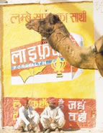
Corporations and advertising agencies have started working in the rural area with a different approach as compared to urban areas, like puppet shows in Punjab, Folk media like Ragini in Haryana for communicating qualities of Virat cement, Pala and Daskathia in Orissa for promoting safe electricity consumption and tooth pastes of Colgate Palmolive, Baul songs in West Bengal for advertising insecticides are some of the examples. Britannia has entered in to the rural market by participating in rural melas and displaying its down market brand Britannia Tiger Biscuits. These rural melas and weekly haats have become more popular medium of rural advertising by the media planners.
Through this arrangement they can break the saddle of scant geographical distribution of customers in rural markets as people of number of villages assemble together to participate in the fair. It is a good ground for brand awareness building, trial sales and sampling. It provides a wider audience at a fairly low cost. Companies like HLL, Titan and Colgate Palmolive use festivals like Rathyatra, Kumbhmela, and Onam for brand promotion. These companies are following a typical media schedule and are always in a march from one place to the other with our festival calendar and a collapsible arrangement of the exhibition setup. Companies can also use popular forms of entertainment like puppetry, nautanki, ragini, bhangra, qaualli and traditional dance shows to increase the brand experience. The companies can develop a story line relating to the brand and show the characters using the brands for their advantage and even the dresses of the characters can be that of the brand’s packaging.

ADVERTISING MEDIUMS

Commercial advertising media can include wall paintings, billboards , street furniture components, printed flyers, radio, cinema and television ads, web banners, web popups, skywriting, bus stop benches, magazines, newspapers, town criers, sides of buses, taxicab doors and roof mounts, musical stage shows, subway platforms and trains, elastic bands on disposable diapers, stickers on apples in supermarkets, the opening section of streaming audio and video, and the backs of event tickets and supermarket receipts. Any place an "identified" sponsor pays to deliver their message through a medium is advertising.
Covert advertising embedded in other entertainment media is known as product placement. A more recent version of this is advertising in film, by having a main character use an item or other of a definite brand - an example is in the movie Minority Report, where Tom Cruise's character Tom Anderton owns a computer with the Nokia logo clearly written in the top corner, or his watch engraved with the Bulgari logo.
The TV commercial is generally considered the most effective mass-market advertising format and this is reflected by the high prices TV networks charge for commercial airtime during popular TV events.
Virtual advertisements may be inserted into regular television programming through computer graphics. It is typically inserted into otherwise blank backdrops or used to replace local billboards that are not relevant to the remote broadcast audience. More controversially, virtual billboards may be inserted into the background where none existing in real-life. Virtual product placement is also possible. Increasingly, other mediums such as those discussed below are overtaking television due to a shift towards consumer's usage of the Internet.
Advertising on the World Wide Web is a recent phenomenon. Prices of Web-based advertising space are dependent on the "relevance" of the surrounding web content and the traffic that the website receives. E-mail advertising is another recent phenomenon. Unsolicited bulk E-mail advertising is known as "spam".
Profile of major advertising mediums
MEDIUM | ADVANTAGES | LIMITATIONS
Newspapers | Flexibility; timeliness; good local market coverage; broad acceptance; high believability. | Short life; poor reproduction quality; small pass along audience.
Television | Combines sight, sound and motion; appealing to the senses; high attention; high reach. | High absolute cost, high clutter, fleeting exposure, less audience selectivity
Direct mail | Audience selectivity, flexibility, no ad competition within the same medium, personalization. | Relatively high cost, junk mail image.
Radio | Mass use, high geographical and demographic selectivity; low cost. | Audio presentation only; lower attention than television; non standardized rate structure; fleeting exposure.
Magazines | High geographical and demographic selectivity; credibility and prestige; high quality reproduction, long life; good pass-along readership. | Long ad purchase lead time; some waste circulation; no guarantee of position.
Outdoor | Flexibility; high repeat exposure; low cost; low competition. | Limited audience selectivity; creative limitation.
Brouchers | Flexibility; full control; can dramatize message. | Overproduction could lead to run away costs.

NEWSPAPER ADVERTISING IN INDIA

Reading newspaper is a daily practice of many people in India, and due to this popularity of newspaper in India it is known to be a good medium of advertising. The success of newspaper advertising in India is due to its wide reach and visibility. Through advertising in newspapers, you can target the Indian market on a wider scale as well as get in contact with a large group of people. So, it would not be wrong to say that through newspaper advertising you can advertise your product or service at one shot among a large group of people. Another beneficial factor of newspaper advertising in India is that it has different newspapers in different languages, and in this way you can easily capture your target group and advertise accordingly to meet your business objectives. www.pitchonnet.com offers you all sought of information regarding newspaper advertising in India.
Newspaper advertising in India has many distinctive advantages if compared to other means of advertising and these advantages cannot be ignored. You need not have to pay huge amount of money for newspaper advertising, the cost is very economical. Also the advertisements can be inserted in any popular newspaper in just 24 hours. Moreover it helps in a better brand recall value. Almost every Indian likes reading newspaper so as to remain updated with latest happenings in and around the society, hence it is the best way to get maximum publicity. Hence, we can say that newspaper advertising saves time, money and effort as compared to other modes of advertising. There are many newspapers in India that are directly or indirectly associated with advertising like Hindustan Times, Times of India, The Statesman, The Pioneer and so on.
Various business magazines available in the market offer all necessary information and updates about the advertising world. These business magazines do have current statistics and market prices of newspaper advertising. You can also search over the internet for recent updates in the field of newspaper advertising. For more information, visit www.pitchonnet.com and know more about newspaper advertising in India.
TELEVISION ADVERTISING

English-language advertising in India is among the most creative in the world. TV advertising (especially in the Hindi language) has made major headway in the past 10 years, especially with the advent of satellite TV. Hindi TV channels - such as ZEE and Sony TV - have fashioned themselves on lines of Western channels, and most advertising on such channels is glitzy, smart and tailored for the middle classes. Such channels have forced the state-owned channel, Doordarshan, to add spice to their programmes which, earlier, were quite drab. The importance of the Hindi-speaking market (which is also fluent in English) is borne out from the fact that STAR TV, once an all-English channel, is now rich in Hindi programmes. Even the British Broadcasting Corporation is reportedly toying with the idea of airing Hindi programmes.
Most major international advertising firms have chosen local Indian partners for their work in this market. Mumbai remains the centre of the advertising business in India.
Television advertising in India is on a roll. Despite talks of a slowdown in the economy, the television advertising witnessed 26% growth during the 1st half of 2008 compared to same period in 2007, according to the Adex report released by TAM Media Research.
While Cellular Phone Services' topped the category on TV during January-June '08, aerated soft drinks and corporate/brand image segments featured second and third, respectively.

'HUL' and 'Reckitt Benckiser (India) Ltd' maintained their respective 1st and 2nd rank on TV during 1st half of 2008 and 2007. In fact eight of the top 10 advertisers on television in the aforementioned quarter were consumer product makers including Pepsico, Coca Cola, Reckitt Benckiser, ITC and Colgate Palmolive.
There are enough reasons for Indian advertisers to continue to reach their target audience through television. Seventeen million new viewers got added to the TV viewing universe as per latest IRS, showing a growth of 4%. Multi-TV homes in urban have also increased by 16% touching a figure of 3 million giving more scope to individuals to view their preferred content.
Total number of channels as reported by TAM is now 442, up from 368 a year back. DTH has picked up well with more number of entrants into the market; and the installed base is now estimated at about 6-8 million.
Along with this increase in TV viewing audience, time spent on TV has also gone up. As per TAM it has gone up by 6%. This increase in time spent is partly due to the fresh content now available.
This positive trend in viewing behaviour seemed to have encouraged the advertising fraternity. Total number of advertisers on TV went by 4% in 2007-08. Existing advertisers have also increased investments on the medium. Television advertising revenue, as a result, is estimated to have touched around Rs 7,400 crore in FY 07-08 with an expected growth rate of 13%
DIRECT MAIL ADVERTISING
The mail service in India is slow though generally reliable. Telephone service is poor, but rapidly improving.
While private courier services are growing strongly and the telecommunications sector is opening up for a range of modern services, until goods can be ordered conveniently and delivered with certainty, direct marketing will be limited to door-to-door sales. An inefficient state-owned banking system also prevents prompt transfers of funds from consumers to retailers. Credit card companies are increasingly targeting India's one million cardholders through directly-mailed offers of goods and services.
The most successful direct marketers in India today are the millions of door-to-door sales representatives who visit neighborhoods and villages across India. From ice cream vendors to carpet sellers, India’s residential neighborhoods are frequently visited by merchants offering a variety of products. Some soft-drink companies have used beauty queens to make surprise knocks on the doors!
RADIO ADVERTISING

The geographical area covered by radio in India in India is as high as 98 percent and the penetration level is approximately 97 percent. But FM presently covers only 17 percent of the area and 21 % of the population of India through transmitters. Currently radio has just 2 percent of the 9000 crore Indian advertising market according to an Arthur Anderson’s survey. Globally depending on each country, radio has a 5 % to 12 % of the advertising cake. On the higher side are countries like the United States with 13 %, Canada with 12.7% and Spain with 9.1%. FM station executives are not forthcoming on multi-platform strategies as yet. Given that radio has penetrated into 100 million homes and a FM set costs around Rs. 50/- FICCI estimates FM’s share up from the present 1.5 percent to 5 % in five years. They have also forecasted that revenues from radio advertising in India will be Rs. Rs. 1200 crores by 2005 and Revenue of radio services is expected to rise to Rs 689 crore by 2008 at a CAGR of 30 per cent.

While TV is a family medium, radio is personalized. Also advertising of certain product seems to work very well while some might not. For example, cellular phone service or auto related products would have a good impact when advertised on radio is primarily known as a “drive time” medium most people who turn in are doing so while commuting. Thus the potential if FM is better is bigger town, as the car population is much bigger. This would be the key when evaluating the medium. Also one must not forgot that radio continues to be a medium that has tremendous reach among the poor and marginalized sections of society.

With the coming of more channels, and the emergence of lifestyle advertising, radio will become a push and pull medium. It is not just making a comeback but is being reincarnated into a new avatar.

OUTDOOR ADVERTISING
Out-of-home has revolutionized the way outdoor communications is being looked upon by marketers and today, it has transcended the traditional outdoor media options, extending to communicate with the customers at various touch points.
the new Outdoor media options starts from the cornerstone of Outdoor the billboards, street- furniture (bus- stops, walls etc.), transit media such as buses, railways and mobile-vans to new alternate media such as mall kiosks, building boards etc. clearly illustrating the media options that planners have and can choose from in OOH depending upon the target audience they have.
OOH as estimated by PWC is expected to become Rs 2,000 cr industry by 2010. Though the part of media-spend in OOH is only 6% for now the industry has shown promising growth. The industry structure as for now is fragmented and less organized.
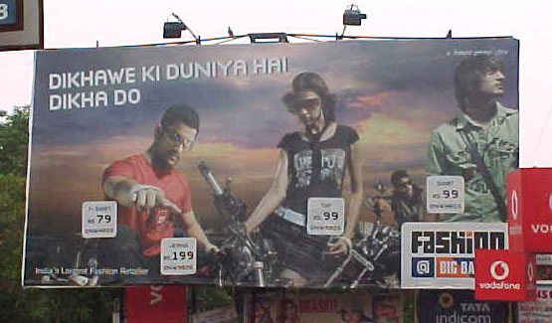
The relevance of OOH in local advertising and rural advertising has suddenly brought OOH to the attention of all brand marketers. Innovativeness, flexibility, impact and coverage that OOH can achieve are the feathers in cap of OOH media over other non- traditional medium.

Outdoor advertising will go digital in 2008, after a boom in the retail and infrastructure landscape in the country saw the business grow rapidly in 2007. Billboards became a common sight across malls, roads, bus stops and airports last year. Now, they will keep pace with consumers on the move. Whether consumers are travelling in underground metro trains, catching a flight, sipping coffee in a cafe or simply shopping, banners and hoardings in such places that were once static will walk and talk with them.
Experts say growth in outdoor media is a function of a booming economy and the subsequent expansion in infrastructure and consumption. According to a joint study by audit and consulting firm Ernst and Young and industry lobby Federation of Indian Chambers of Commerce and Industry, the number of malls in the country will go up from the existing 300 to 600 by 2010 and, in the next five years, some 30,000km of road length will be added to connect metropolitan cities. Besides, metro rail networks are being set up in various cities and 57 new airports are likely to come up (there are around 80, currently). India will also have 4,000 new escalators (there are now 600) and that these too, will provide an opportunity to target consumers on the move. The growth in the infrastructure and retail sector is quite conducive to growth of outdoor advertising.

MAGAZINE ADVERTISING



When Conde Nast launched its premium lifestyle magazine 'Vogue' in India, it carried a whopping 168 pages of advertisements of a total 400 pages. Now, the publisher is preparing to launch its luxury men's magazine GQ and expects a similar rush of advertisers in Asia's third-largest economy, where rising incomes and growing literacy are boosting readership and revenues of magazines and newspapers.
From specialist magazines on whisky, golf and parenting, to regional-language newspapers and financial dailies, new titles are coming thick and fast in one of the few markets in the world where advertising and readership for print media are expanding. It's a fast growing economy and with consumption so robust and with incomes rising, it's a fertile ground for the print media There is also a buoyancy in print advertising that is encouraging new launches and niche publications in particular. Print publication advertising revenues in India generated 94 billion rupees ($2.4 billion) in 2007, or 48 percent of all of the country's media advertising revenues.

New trends in advertising in India

SMS advertising

Mobile advertising, a $1 billion industry globally with a three billion subscriber base, is set to take off in a big way in India too. Service providers, market research firms and independent companies, which just focus on this medium, are all seeing value in the expanding Indian mobile market, estimated to be 500 million subscribers by 2010.
The market for mobile advertising, which is still at its nascent stage, is estimated to grow to Rs 20-25 crore by March in the country. It was estimated to be a mere Rs 5-6 crore about six months ago.
Reliance Communications, a leading CDMA service provider and a pioneer of mobile advertising in the country, has effectively offered mobile advertising solutions for more than 20 clients over the past four years. Starting off with LG during World Cup Cricket in 2003, it has since then handled Cadbury’s, Coke, Maruti, Hyundai and even financial brands like ICICI, Kotak and HDFC among others.
”With the mobile handset population poised to top 500 million in India by 2010, it has become a huge and vibrant communication platform, which no brand marketer can afford to ignore,” Reliance Communication Applications & Solutions president Mahesh Prasad told ET.
According to him, the growth of 3G networks, IPTV and high-end gaming on mobile phones, is expected to open new avenues for the medium. “Our mobile marketing solutions offer creative means and focused targeting to reach our more than 37 million subscribers anytime, anywhere in an non-intrusive manner,” Mr Prasad added. Kaybase, a Chennai-based emerging market research organisation, which had special thrust on technology since its inception, has also found mobile advertising medium as a far more effective communication stream.
With the thrust on technology, Kaybase through a tool, Critical Incident Track (CI Track), made use of the very high mobile penetration in the country, and the relatively non-intrusive nature of an SMS. “It is a tool to conduct ongoing contact audit of the client’s services. Its chief advantage is the low cost and the real-time reporting features,” said Kaybase director R Ashok.
Even as companies chalk out different plans to effectively tap this medium, mGinger, a Bangalorebased start-up with specific focus on mobile advertising, was recently in news for a different reason. Draper Fisher Jurvetson and NEA Indo-US ventures jointly invested about $2 million in the company.
Ginger runs a permission-based mobile advertisement service, whereby mobile users are paid to receive ads on their mobile. The company provides mobile ads that are customised according to region and age group. A subscriber receiving ads through mGinger will receive 20 paise per ad, while those who recommend friends for the service receive 10 paise per advertisement.
Official sources in mGinger said that a lot of hype was made about the payment model in the country, but not about the value addition that come through the mobile ads. The Do-Not-Call registry, introduced recently would help in blocking unsolicited ads and make way for ads tailor-made for the consumers, they added.

World wide web
Advertising on the World Wide Web is a recent phenomenon. Prices of Web-based advertising space are dependent on the “relevance” of the surrounding web content and the traffic that the website receives.
Conventional printed sales and marketing materials of all types (from newspapers and magazines, to brochures and business cards) are becoming obsolete as customers look to the internet (via phones, pc's, laptops, PDA's and in the future TV too) for quick, up-to-the-minute information about products, services and suppliers of all sorts.
Advertising media internet is more promising than the conventional media in the sense that internet serves not only as a communication channel but also a transaction and distribution channel. One can get information and make purchases and payments all through the net.
Internet has become the single stop for various purposes because of its capacity for multimedia content. It carries not only text and graphics but also audio and video content. This nature of the Internet is suitable for achieving high impact of any advertising.
Advertisers are using innovative software tools to place their ads
on the internet in many new innovative forms like animated pop ups, banner ads, sponsor logos, interstitials, advertorials, 3-D visualization and advertainment.
Search Engine Marketing (SEM) and EMail Marketing (EMM) are quickly replacing other forms of advertising for reaching, targeting, and selling to businesses and consumers alike. Powerhouse online advertising companies like Google, MSN, Yahoo are proving this to businesses worldwide.
In India, though there is no latest survey available on the internet media advertising, experts predict of a boom in internet advertising.
According to an MSN study, the online advertising in India is likely to cross the 100 million dollars by 2010.
According to Nasscom (Survey, August 2000) there are 1.6 million homes in India with Internet connections and on average at least 3 people use one system. At present it must be around 30 million internet users in India, says an expert in the field.
India's advertising industry generates about 2.2 billion dollars annually. Spending on internet advertising was about 34 million dollars in this financial year and experts predict it may cross 57 million dollars in 2008..
Internet listings, internet directories advertising, and 'pay-per-click' advertising offered by the major search engines, are now viable and relevant for very small 'local' businesses, and are all examples of this fundamental shift in marketing.
Unpaid advertising
Unpaid advertising (also called word of mouth advertising), can provide good exposure at minimal cost. In the case of India, 87 per cent of those who use the Internet trust others’ advice rather than any kind of advertising, proving that word-of-mouth is the most powerful advertising tool, a press release issued by the research agency found.Word of mouth brings with it a big “trust” factor, which is quite often missing in other forms of advertising. Indians by nature tend to believe a friend or an associate while evaluating a product.
Personal recommendations (“bring a friend”, “sell it”), spreading buzz, or achieving the feat of equating a brand with a common noun (in INDIA, “Xerox” = “photocopier”, thanda- coca cola, and “Band-Aid” = adhesive bandage) — these are the pinnacles of any advertising campaign. However, some companies oppose the use of their brand name to label an object. Equating a brand with a common noun also risks turning that brand into a genericized trademark - turning it into a generic term which means that its legal protection as a trademark is lost. Unpaid advertising is used a lot in rural areas of India.

Social network advertising
In India social networking is a relatively new concept due to obvious reasons: low penetration of PCs and laptops and patchy broadband connections. What that means is that while people were aware of these social networking groups and applications they had limited means to access them. However in the last four years the social networking landscape has changed quite a bit in India. In a relatively short period of time certain social networking sites like Orkut and Fropper appear to have taken off, and new ones like Linkedin and Facebook are beginning to find traction among Indian users.
It is Online Advertising with a focus on social networking sites. This is a relatively immature market, but it has shown a lot of promise as advertisers is able to take advantage of the demographic information the user has provided to the social networking site.

In-film advertising

In-film advertising used to mean a couple of product billboards placed behind the hero's car, Till Taal came along. That's the film that put Coke — and product placements — firmly in the plot.

In-film advertising has only gathered more fans since. It's not just the colas, brands like Hero Honda, Bru, and Fair & Lovely have got into the act. It has become a well-thought out and legitimate part of a brand's marketing plan, and as the film industry gets more corporatised, it's likely to get more popular.

This season's got a blockbuster hitting the screen, with all the attendant song, dance and scandal. Kaante stars Amitabh Bachchan, Sanjay Dutt, Sunil Shetty, Kumar Gaurav, Lucky Ali and Mahesh Manjrekar — and Thums Up. Coke's paid Sanjay Gupta, the film's producer, to feature the cola in some scenes — rumours put the figure at Rs 4 crore, but Coca-Cola, as well as the producer, say it isn't so — and it's also airing promos for the film that incorporate the Thums Up brand.

Leo Entertainment, the film marketing division of Leo Burnett, is working with White Feather Productions in their marketing efforts.

Celebrity advertising
Recently advertisers have started pouring crores of rupees every year into celebrity advertising.

Think of Sachin Tendulkar. He means Pepsi in soft drinks, Boost in malted beverages, MRF in tyres, Fiat Palio in cars, TVS Victor in two-wheelers, Colgate Total in toothpastes, Britannia in biscuits, Visa in credit cards, Airtel in mobile services and Band-aid.
Does it actually help each of the brands? Does the consumer think in categories and slot brands accordingly or is it one big maze of brands and saliency is dependent on recency. Interestingly, while celebrity advertising is big, few agencies actually present celebrity advertising as a solution to client problems.
When a viable exciting solution is not present for communication/marketing of a particular product, a client looks at a celebrity solution, sometimes, to follow competition. When attacked with a celebrity, a quick response is to get another one to combat. The result is often, at best, achieving parity.
There is no doubt that celebrity advertising has its benefits -- the four Qs:
Quick saliency: It gets cut through because of the star and his attention getting value. Good lass Nerolac has ensured high saliency for its brand with the inclusion of Amitabh Bachchan in its advertising.

Quick connect: There needs to be no insight but the communication connects because the star connects. Sachin, Shah Rukh and their ilk's ensure an easy connect for Pepsi with the youth.
Quick shorthand for brand values: The right star can actually telegraph a brand message fast without elaborate story telling. Kapil Dev and Sachin Tendulkar seem to have done that successfully for Boost in the early '90s. And helped to differentiate it in the malted beverages market.
Quick means of brand differentiation: In a category where no brand is using a celebrity, the first that picks one up could use it to differentiate itself in the market. Boost did it in the malted beverage category.

Specialty Advertising

Specialty Advertising is a very commonly used advertising technique in which useful Company information is imprinted on items of daily use. A Company / Organisation looking for mass exposure to their advertising message may choose Specialty advertising as part of their marketing efforts. Depending on the advertising goals, Companies may choose to put their name, logo, slogan, website url or phone number on simple but widely used items.

Such Customized products and other useful merchandise prove to be perfect give-a-ways to present and prospective customers, employees, staff, business partners, friends etc. Many Companies also hand over these items as souvenirs at conferences, trade fairs and seminars.

The best thing about using simple articles of daily use to carry your advertising / brand message is that these products stay with your target audience, reminding them of you every time they look at it or use it.

A large number of promotional products are available that can carry your advertising message to your prospective and present customers on a daily basis. These include -

Mugs

Pens

Caps

Lighters

Mouse Pads

Clocks

Playing Cards

Note pads

T-shirts

Tote Bags

Letter Openers

Decoration pieces

Hats

Bookmarks

Calendars

Watches

Stickers

and other office products

Indian retail merchandising

Since the introduction of the retail store format, merchants have always placed like items together for quick and efficient service. In both full-service and self-service stores, customers have liked to see the entire range of a product before deciding on a purchase. The customer felt they were making sure they got the best deal and the full value of a product when they shopped this way. This method of merchandising or organizing a store is called Category Merchandising. All items are placed together on one aisle or in one section of the store to get maximum exposure.

In India changes in the demographic profile and the majority of women entering the workforce have altered much more than just the obvious. Consumers have drastically less time to shop than before and shopping is seen less as a pleasure and more as work, thus shopping habits have changed too.

Example:
All the merchandise is displayed in a lifestyle setting so customers can imagine how it would look in their homes. Most of these stores have no separate sections for different items. Instead, the entire store is organized and displayed like a home, with living room furniture displayed with accessories, bedrooms with the beds made in assorted linens complete with the nightstands and sleeping attire. This method is called Lifestyle or Solutions Merchandising as it provides solutions to consumers.

THE GOOD, BAD, UGLY OF ADVERTISING IN INDIA

Advertising has many connotations, simply put it means notifying or informing persons of things by using mass media-external communications.
To attract the attention the plain message is couched in such imaginative moulds that it becomes an art form needing creative instincts of an artist to conceptualize the contents.
However, the highly focused presentation of the message is a costly affair needing analytical thinking along the pre-conceived theories of marketing a product. This makes advertising a scientific endeavor without jeopardizing its claim to remain in the realm of art.

Good category
The Good category, (Rare) of advertisements has all the qualities & attributes. It conveys the message in a simple, straight forward, pleasant manner to the aesthetic senses almost instantly but with a lasting effect. It leaves a smile on the lips of the viewer who falls in love with the brand advertised and starts treating it as a supreme model to assess other products of similar type before changing his loyalty.
Examples:
1. Fevicol, Pidilite Industries, O & M master piece, advertising their adhesives through simple settings –
Scene -1 an overcrowded bus on a bumpy road with fevicol advertised on the back of the bus -fevicol ka jodh hai, (tutega) chuttega nahin!

Scene -2 Catching fish nonchalantly without a fish tackle in comparison to a seasoned catcher who is not successful in spite of his best efforts!
This hits the nail on the head with pleasant surprise and without the barrier of language. We would know for all times to come that fevicol is the best adhesive.
2. The best use of language, precise & humorous with most appropriate colloquial phrases & interjections under scoring the core quality, value of the product is seen in a series of advertisements from the coca cola stable which are presented & performed to perfection by the famous cine star, Aamir khan.
First we learn that "Thanda Matlab Coca Cola"( Generic Positioning- Association of the brand directly with the Product category; cold drinks=coca cola).
Aamir the local dada instills this fact in the minds of the simpleton at the soft drinks counter (dhabha, kirana shop). The fact is reinforced by the bucolic romantic in a village setting, when he wins the heart of urban beauties by his rural hospitality; an innovative scheme to cool the drink -bottles in the well (another association substitute water with coke?!).
The Bihari dandy beau rescues the damsels being exploited by the unscrupulous vendor and etches in our memory that the price of the thanda is reduced to R. 5 now. The point to note in the third advertisement of the series is the subtle approach - this time it is common knowledge that "Thanda Matlab Coca Cola", as we see when the girl asks for a thanda the vendor is not fumbling with any other soft drink bottle as happened in the first advertisement; he takes out the coca cola only which is doubtlessly the well established Thanda. It is the masterly unobtrusive reinforcement of a fact for which earlier advertisements were exclusively made. We smile again & again seeing these very well produced advertisements which are not only good but can be labeled as a piece of art created for the mundane purpose of increasing the sales of soft drinks.
3. How the viewer is taken towards the terse message of the advertisement through sentimental journey is best depicted by the sophisticated credit card- Master card, advertisement where the family photo of three generations grouped together is shown as priceless. The viewer becomes sentimentally involved and before he/she realizes that the word priceless is anyway associated with spending money to buy & acquire the desired things, the voice tells him/her that for everything else there is master card (Life= emotions/sentiments (Priceless)+ desire to buy (MasterCard)). In a split second one is brought down from the endearingly nostalgic world of sentiments to the real world where needs can be easily satisfied by similarly endearing & supportive credit card. A highly sophisticated & subtle way it is to soften up the prospective user before the hand sale; a winner through & through!

4. Kelivenator refrigerator with its unforgettable slogan,' the coolest one' by a talking penguin beautifully highlights the cooling quality of the Company product. The grand father's dentures starts chattering while immersed in the water because the door of the kelivenator kept behind him is opened. The Singer's throat is similarly affected by the chill and he is unable to sing, the cause again is the opened kelivenator. These situations which are quite common due to chill effects are the best endorsement for the quality of the cooling machine; the message comes to us loud & clear that kelivenator is the coolest one.

Bad category
The bad advertisement is one which is unintelligible lacking connection with the brand advertised, distracting, crude, highlighting the negative values while trying to exploit the situation, dishonesty, encouragement to wrong dangerous practices & habits also make a advertisement bad.

Examples:
1. Now we can across such meaningless advertisements as one from an apple juice (Surrogate advertisement for Aristocrat whiskey) provides make belief & teasingly incomplete strip tease show whose supposedly funny ant-climax results in the observer getting his top naked. 'Kutch bhi ho sakata hai (anything can happen) is the irrelevant slogan which the viewer of the advertisement is somehow expected to connect with apple juice (Whiskey) drinking. It is also highly disrespectful towards the viewer treating him to be as much a moronic as the male model protagonist of the advertisement who sips the apple juice (Whiskey) to get excited.

2. The axe effect is such that all the females in the proximity of the male user become his infatuated followers and he leads them as the proverbial pied piper did to rats. This time the feminine intelligence & virtue have been challenged by a perfume which does not get promoted by such indecent & highly exaggerated claims. It does not flatter the male taste either that the male would really believe that the axe effect would make him so irresistible to the female of the species.

3. The Pepsi advertisement showing the little mastero- Sachin Tendulkar posing as a person who has lost his memory but smartly dispatching the other two cricketers to Honolulu is senseless to say the least, it is difficult to find out how the whole episode connects with the soft drink & the brand.It is sad to see the favorite cricketer making a fool of himself to promote a product which fails to take off in the dumb advertisement.

4. The Goa pan masala advertisement encourages the arrogant behavior of the groom's family. The grooms father shouts at the bride's father remonstrating him for the poor hospitality & threatens to get up &
leave but for the timely intervention of the Goa Pan Masala supplier. Everything goes well after the masala is tasted. The groom's father behavior remained putrid &childish throughout & was in very cheap taste! In any case the pan masala is too petty an offering to please such a father of the groom; dowry is the next logical step obviously. The Advertisement has nothing to denounce such malpractices on the other hand it has encouraged such encounters before the wedding sending shockwaves among the bride's family.

Ugly category
An ugly is one extreme of the continuum which is downright indecent, hurting some specific sentiment totally misdirected & dumb, at times the viewer is compelled to ask which particular product was being advertised. The bad taste left behind hurts the image of the sponsors. One is apt to wonder why the censorship should not be imposed on TV advertisements also, in such ugly advertisements a deliberate effort is made to shock the viewers with totally unacceptable ideas or methods not permissible in the Indian social fabric.

Examples:
1. Pass- pass is projected as such a mouth freshener that it compels the school peon to indulge in malpractice. He is punished by the teacher in front of the complaining children. The teacher himself errs having been tempted by the taste of Pass-pass. He is caught by the female colleague who threatens to report the matter to the principal. It all happens before the children. This is too much for the character & behavior of teachers. What will the children learn? The entire setting is radically wrong sending negative signals to impressionable, young minds. A mouth freshener should not be depicted as if it were the proverbial apple which tempted Adam & the paradise was lost. Let our teachers not lose their morals for petty things, for god's sake!
2. Why such an obsession with urine for a soft drink advertisement is difficult to understand. The shock does not endear the product to the viewers who tend to think of urine whenever they see Sprite!
(Bujhayee sirf pyaas, ?!). It is an ugly way to promote a product. Earlier the sprite drinker takes out the drink can from the gullet of the tiger & drinks it. "Cheeta bhi Peeta hai", takes one nowhere. One may not be inclined to touch the soft drink can after seeing the advertisement. It is a very ugly & crude way to promote a drink.

The difference in presentation of a Good, Bad & Ugly advertisement is mainly owing to the sponsor's view point & artists creative choices. However, someone has to be wasteful about what can be shown in public & what should remain hidden. Money making through unacceptable means may be prevented by law but awareness about what is good & what is not, is also important to discourage bad practices. If ignorance of law is not excused, ignorance about good & bad taste should not be excused. It may have far more significance for the betterment of the society, & its people.

Ethics in advertising
Advertising must present the truth and live up to the trust of the society.It must comply with laws, regulations and ethical codes, pay respect to human rights and provide fair-minded expression.It must not work against sound social order or good customs of the society.It must esteem grace and dignity to contribute to the establishment of sound and healthy life of the people.It must provide information that puts primary emphasis on the benefit of the consumers.It must also contribute to the optimum solution of the client's issues through effective and efficient communications.
Advertising, in India at least, seems to be independent of the product and service quality. A lot of advertising today in India is creative, clever and clutter-breaking. Let us take one category that we are familiar with - mobile services. The advertising in the category has been clutter-breaking and award-winning.
#We all like the Hutch advertising where the dog keeps following the little boy everywhere. Wonderful advertising! But is the coverage really anywhere as good as the advertising makes it out to be
#The Airtel commercial with the grandson and the granddad playing chess, while one of them is on the train and the other is at home in his village, is another creative ad which in no way represents the truth of the coverage.
# We have a Python around a naked male and female model and …. have to guess that it’s the “ shoe ” we have to look at !
# We have heroes drinking soda of a major breweries company and…. Have to believe his “PUNCH ” is due to the soda !
# Cigarette hoardings are rampant outside schools and colleges and….we have to believe its just the “location ”

Advertising, in India at least, seems to be independent of the product and service quality. So we have great ads extolling the quality even if the product has indifferent quality. Obviously one of these two parties has a convenient view of ethics and the person who faces the consequences is the consumer.
Case studies on ethics of advertising
CASE: 1

Brand: Pepsodent Toothpaste

Company: Hindustan Lever Ltd.

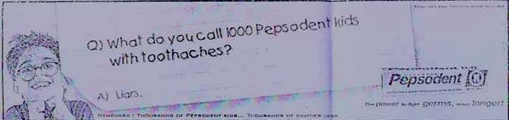
Advertising Agency: Ammirati Puris Lintas

Medium: Print

The advertisement appeared in the Sunday Times Of India.
The ad states “Q) What do you call 1000 Pepsodent kids with tooth aches? A) Liars”.
The problem in this case is the word ‘Liars’. No Child is ready to accept that he is a liar even if he is lying. It is wrong to call any child a liar and more so if he is using any toothpaste. There is no toothpaste in the world that guarantees against cavities, and that can prevent a toothache. Hence the ad is false and misleading

CASE 2:

Brand: Ibaya –“The Complete Shopping Experience”

Company: Indishop Pvt. Ltd.

Advertising Agency: Lowe Lintas & Partners

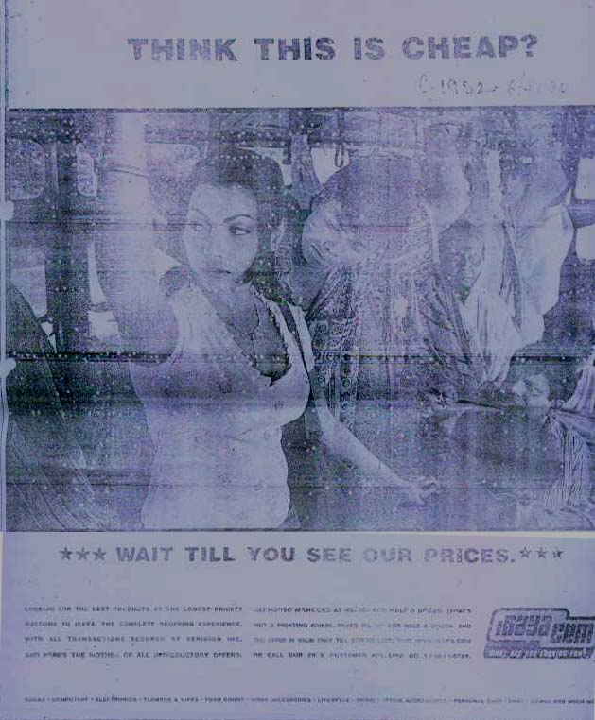
Medium: Print

This advertisement appeared in The Times of India. The advertisement which has been, published has nothing to do with the subject matter of the advertisement. The picture is of a very low grade and cheap nature. The advertisement (headline) states, "Think This Is Cheap?". The reference to, "Alphonso mangoes at Rs.30/-" is suggestive and not in good taste.

Hence this advertisement was upheld under Chapter II as the headline “Think This is Cheap?”, linked with the visual depiction, and the copy, “looking for the best products at lowest prices?”, was considered suggestive and an affront to women, which is likely to cause grave or widespread offence. The advertisement was withdrawn.

CONCLUSION

In today’s India which is fast moving & dynamic, people’s wants, need and desires are changing; it’s very important to know them and give them what they want. This is the main objective of advertising where ad agency plays major role in market research, making of creative, launching it in the market, taking the feedback of consumer and making any product famous and acceptable among consumers. Ad agencies are playing an important role in shaping present and future of not just selected brand but of entire company.

There is no one -- sure-fire -- best way to advertise your product or service. It is important to explore the various advertising media and select those which will most effectively convey your message to your customers in a cost-efficient manner. Always remember, advertising is an investment in the future of your business.

Bibliography & Webliograpy

Books
- ADVERTISING MANAGEMENT Concepts and Cases
by Manendra Mohan
- Advertising Management
by B. S. Rathor

- OGILVY ON ADVERTISING
by David Ogilvy

- 4 Ps Business & Marketing

- Economic Times

Websites
- www.magindia.com
- www.ogilvyindia.com
- www.agencyfaqs.com
- www.adage.com
- http://en.wikipedia.org/wiki
- www.aaaindia.org

