INTRODUCTION

The modern world of marketing communication has become colorful and inundated with advertisements, and it is hard to get noticed. It is an uphill task for the designer of an advertising campaign to differentiate itself from others and attract viewers’ attention. Everyday consumers are exposed to thousands of voices and images in magazines, newspapers, and on billboards, websites, radio and television. Every brand attempts to steal at least a fraction of an unsuspecting person’s time to inform him or her of the amazing and different attributes of the product at hand. The challenge of the marketer is to find a hook that will hold the subject’s attention.In helping to achieve this, use of celebrity endorsers is a widely used marcom strategy.
In this jet age, people tend to ignore all commercials and advertisements while flipping through the magazines and newspapers or viewing TV. But even then, the glamour of a celebrity seldom goes unnoticed. Thus, celebrity endorsement in advertisement and its impact on the overall brand is of great significance. In this process, the companies hire celebrities from a particular field to feature in its advertisement campaigns. The promotional features and images of the product are matched with the celebrity image, which tends to persuade a consumer to fix up his choice from a plethora of brands. Although this sounds pretty simple, but the design of such campaigns and the subsequent success in achieving the desired result calls for an in-depth understanding of the product, the brand objective, choice of a celebrity, associating the celebrity with the brand, and a framework for measuring the effectiveness.
Companies invest large sums of money to align their brands and themselves with endorsers. Such endorsers are seen as dynamic with both attractive and likeable qualities and companies plan that these qualities are transferred to products via marcom activities. Furthermore, because of their fame, celebrities serve not only to create and maintain attention but also to achieve high recall rates for marcom messages in today’s highly cluttered environments.

- BRAND

A brand as a name, term, sign, symbol, or design, or a combination of them, intended to identify goods or services of one seller or a group of sellers and to differentiate them from those of competitor.

- CELEBRITY ENDORSEMENT

A celebrity endorser is an individual who is known by the public for his or her achievements in areas other than that of the product class endorsed. Eg: - In the Coco-Cola advertisement; actor Amir Khan is the celebrity endorser for the product or brand called Coke, and this process is referred to as Celebrity Endorsement.

- NEED FOR CELEBRITY ENDORSEMENT

The charisma of the celebrities almost always entices people and their words are worshipped by a lot of people. Their influence also goes on the political front, where they are invited for political endorsement. The business firms, thus, resort to celebrity endorsement to perk up brand recall and product sales. This has now become a trend and is being perceived as a strategic means of brand building exercise. For example, when actor Shah Rukh Khan endorses Santro-Zip drive; the consumers are made to think that he is giving his opinion to go for this car. Two reasons why advertisers need celebrity endorsement are to increase the credibility & attractiveness of their advertisement.

Volume Growth in Celebrity endorsement ON TV

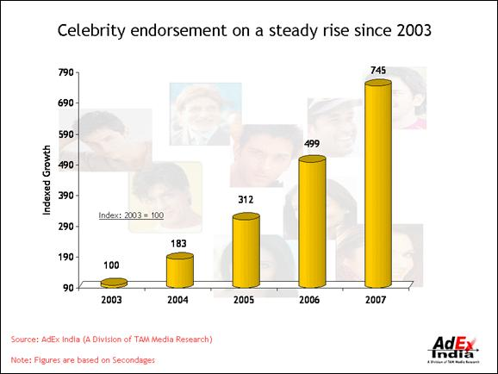
Share of Celebrity Profession on TV

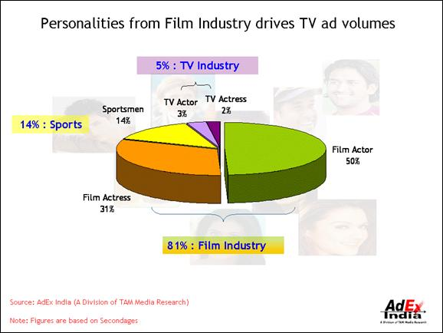

- Actors -- Amitabh Bachchan, Shahrukh Khan, Aishwarya Rai,, Preity Zinta, Aamir Khan and Pierce Brosnan

- Models -- Mallaika Arora, Milind Soman, Naomi Campbell, etc

- Television Personalities --Husain, Smriti Irani

- Sports figures -- Sachin Tendulkar, Sania Mirza, Anna Kournikova, Michael Schumacher, Tiger Woods

- Entertainers -- Cyrus Broacha, Oprah Winfrey

- Pop-stars --Madonna, Shakira

- DIFFERENCE BETWEEN BRAND AMBASSADOR & BRAND FACE

A Brand Ambassador would be one who is not only a spokesperson for the brand or is just appearing as a testimonial for the brand’s benefits. He/she is an integral part of the brand persona and helps to build an emotional, which goes beyond just appearing on TV commercials. For example, Fardeen Khan is the brand ambassador for Provogue while he remains a brand face for Lux Body Wash.
On the other hand, a Brand Face would be the current celebrity who is just used as a tool to increase brand recall and is only appearing in the advertisement. It is usually seen that a brand face is a temporary contract and is very short term at times. An example would be Sona Chandi Chawanpryash using Sourav Ganguly for a while in its commercials. Brand faces are easily forgotten and fade away with the campaign’s end.

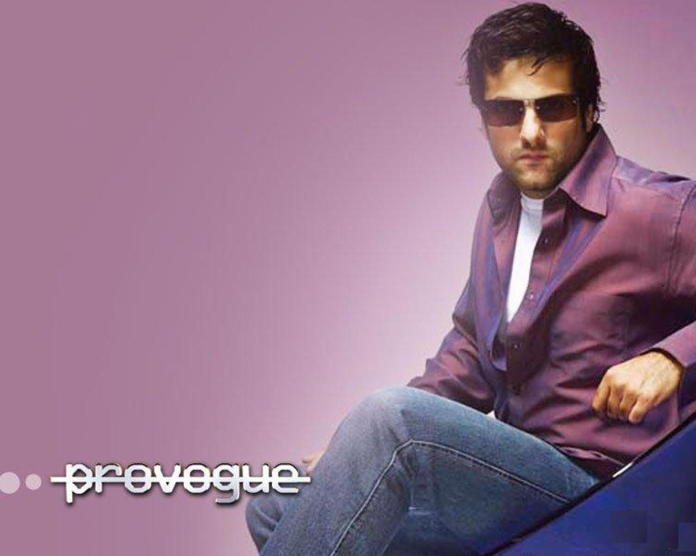
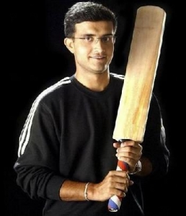

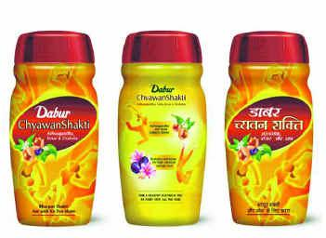

USES OF CELEBRITY ENDORSEMENTS
- Establishes Credibility
Approval of a brand by a star fosters a sense of trust for that brand among the target audience- this is especially true in case of new products. The role of a celebrity endorser in an advertising campaign is, without doubt, linked to the reputation of the celebrity. If the reputation is damaged, more often than not for reasons other than professional ,then the quality of his reputation dos suffer:particulary if it is to do with his (or her) public behavior. Example: Dyna ad by Katrina Kaif.

- Attracts Attention
Celebrities ensure attention of the target group by breaking the clutter of advertisements and making the ad and the brand more noticeable. Example: Shahrukh khan in pespi, Hrithik Roshan in Sony Erricson.

- Associative Benefit
A celebrity’s preference for a brand gives out a persuasive message because the celebrity is benefiting from the brand, the consumer will also benefit. Example: Amitabh Bachchan in ‘Dabur Chwyanprash’.

- Psychographic Connect
Stars are loved and adored by their fans and advertisers use stars to capitalize on these feelings to sway the fans towards their brand. Example: Dhoni in 7Up.

- Demographic Connect
Different stars appeal differently to various demographic segments (age, gender, class, geography etc.). Example: Amitabh Bachchan with child in Dadur Honey, Sunny Deol in Lux cozi ad.

- Mass Appeal
Some stars have a universal appeal and therefore prove to be a good bet to generate interest among the masses. Example: Sharukh khan And Amitabh Bachchan in Polio Promotion.

- Mitigating a tarnished image
Cadbury India wanted to restore the consumer’s confidence in its chocolate brands following the pitch following the high-pitch worm’s controversy;so the company appointed Amitabh Bachchan for the job.

- Rejuvenating a stagnant brand
With the objective of infusing fresh life into the stagnant Chyawnprash category and staving off the competition from various brand , Dabur India roped in Bachchan for an estimated project of 8 crore.

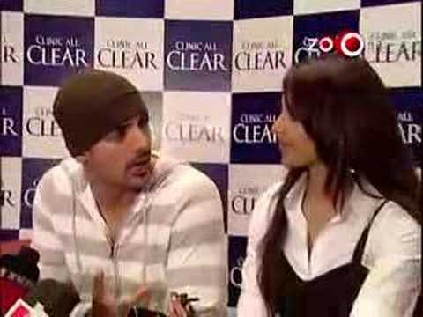

Risks Associated With Celebrity Endorsement

The various risks associated with celebrity endorsements are as follows

- Negative publicity - If the celebrity is strongly associated with the brand then the occurrence of the negative publicity can spill over the brand.. E.g., Salman Khan lost his endorsement deal with Thumbs-Up after his infamous incidents like buck-killing and rash-driving.

- Overshadowing - When celebrity endorser is used, the risk of consumers focusing on the celebrity and not on the brand exists.

- Overexposure- This risk arises when the celebrity chooses to endorse several different products simultaneously which might leave the consumers confused. E.g., Sachin Tendulkar endorses several brands such as MRF, TVS Victor, Pepsi, Fiat, Boost, etc.

- Overuse - Sometimes the company can use many different celebrities to appeal to different market segment. But multiplicity of endorser might blur the image.

- Extinction - The favorable response obtained by a particular brand may weaken over time if the brand gets significant exposure without the association of the celebrity. If the celebrity contract is for a considerable period of time, then it can lead to draining out capital without proper return.

- Financial Risk - The decision for hiring an expensive endorser may not be always feasible if there is a poor brand fit.
Therefore, for celebrity endorsements to work effectively there are some fundamental ground rules: -
- Clear brand promise and brand personality.
- The communication objectives for the campaign should be frozen.
- Focus must be on the synergy between the brand and the celebrity image.

Why Celebrity Endorsement Fails?

There maybe cases where brands are not able to take-off even after the backing of celebrities. And this leads to speculations in the Ad World on the soundness of celebrity endorsement as an effective communication strategy.

- Negative impacts of Celebrity on the brand

A popular drawback of celebrity endorsement is the 'Vampire Effect' or the celebrity overshadowing the brand¹⁶. Some viewers forget the brand that a celebrity is approving. Others are so spellbound by the personality of the celebrity that they completely fail to notice the brand being advertised. Two new drawbacks can be seen these days what marketers call Celebrity Trap and Celebrity Credibilit. Celebrity trap is when the celebrity becomes an addiction for the marketing team and the task to find substitutes becomes more and more difficult, leading to surfeit of celebrities. Celebrity credibility refers to skepticism by the consumers regarding the celebrities, especially when there is anything negative regarding the celebrity associated with the brand in the news, then brand is bound to be affected.

- Positive Impact of Celebrity on the Brand

Plethora of research has tried to explore the effects that a celebrity exhibits. Celebrity endorsements: -
- Creates and helps in retaining attention of the targeted audience.
- Achieves high brand recall in an environment with multitude of products.
- Transfers of qualities associated with the celebrity to the product.
- Perceived as entertaining.
- Portrays trustworthiness due to lack of apparent interest

Is Celebrity Endorsement Always the Best Method for Promoting a Brand?
Companies in many cases, prefer not to use a celebrity, but instead go ahead with a spokesperson which has been tailor made for the product by the company. The following are the advantage of such a strategy

- Control: Companies control the created spokesperson as it has been built in conformity with the brand and target audience, and hence can be ensured with a consistent image.

  - Single utilization of created endorsers: Such spokespersons are exclusive for a brand and hence avoiding any brand conflict.

  - Focus more on brand and its features: In Non-Celebrity advertisements the main focus is on the brand and its characteristics while in celebrity the focus sometimes shifts entirely to the celebrity’s features .

Celebrities - To Use or Not to Use

- SITUATION 1: Cadbury has always come up with sweet, emotional, clutter breaking commercials. Who can forget the lady dancing on the cricket pitch to celebrate her boyfriend's century. But when the company was hit with the worm controversy it had to rope in the national icon Amitabh Bachchan.He embodied the values of Cadbury as a brand and connected with all of India - mothers, teenagers, children, media persons and trader partners. This reinstated customer faith in Cadbury and sales have now touched pre-worm crisis days.

- SITUATION 2: Asian Paints will always be remembered for its 'Mera wallah cream' campaign and more recently the 'Wah Sunil babu' campaign. There have been very forgettable celebrity endorsements from Akshaye Khanna and Saif Ali Khan in the past (probably people were not able to visualize stars painting their own walls). This is a case of a company whose non-celebrity commercials have done way better than their celebrity campaigns in terms of recall and message delivery.

IMPACT OF CELEBRITY ENDORSEMENT

1. CELEBRITY POPULARITY

- SHAHRUKH KHAN – MAYUR SUITINGS – POSITIVE IMPACT

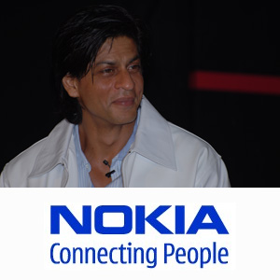
“Sharukh Mayur Khan” is how this product came to be known, Shahrukh brought to the product his persona of high class lifestyle, giving the consumer the belief to aspire and good clothing a sure way to reflect the aspiration. The ad shows a great fit between what the product stands for, what the consumer expects and what the celebrity means to the consumer, hence explaining the strong impact in sales and brand recall. When it comes to brand endorsements, there can be no bigger star than Shah Rukh Khan.
After endorsing countless top brands such as Pepsi, ICICI Bank, Nokia, Hyundai, Tag Heuer etc, SRK will now be seen endorsing yet another premiere brand.
According to media sources, SRK has been roped in as a brand ambassador by FMCG major Colgate Palmolive. The deal with the superstar was signed a couple of days ago.
Colgate-Palmolive is a key player in the oral care category – toothpaste, toothbrush, toothpowder and whitening products.
Now with SRK endorsing Colgate, things are only going to get bigger and better for the FMCG giant. As for SRK, after bagging this premium endorsement deal, he has indeed proved that they don’t call him ‘King Khan’ for nothing!

- RANI MUKHERJEE - HERO CYCLES – NEGATIVE IMPACT

Rani Mukherjee endorsing a cycle makes a case where the celebrity is used only for her popularity without looking for Brand-celebrity fit.
Cycles in India are generally used by men and the target segment belongs to low income group. By using Rani, the consumers could not be assured of the product’s qualities and could not relate the product to the ambassador. Hence, the consumers were not motivated towards the product and the ad was called back, thereby emphasizing the need for a brand-celebrity fit.

2. FIT WITH ADVERTISING IDEA

- DHARMENDRA - RAJDOOT MOTORCYCLES

This strong man from yester years, still resonates as the only brand ambassador, who managed to sell a motorcycle in each and every corner of India in the 80’s. Dharmendra’s image of being a brawny man, hailing from the rustic roots of India, gave Rajdoot motorcycles the perfect brand ambassador it was looking for. He not only gave to the product a sturdy and robust image, but also brought to the product trust and honesty which it was trying to build in its first time buyers.

3. MULTIPLE ENDORSEMENTS

- AMITABH BACHCHAN

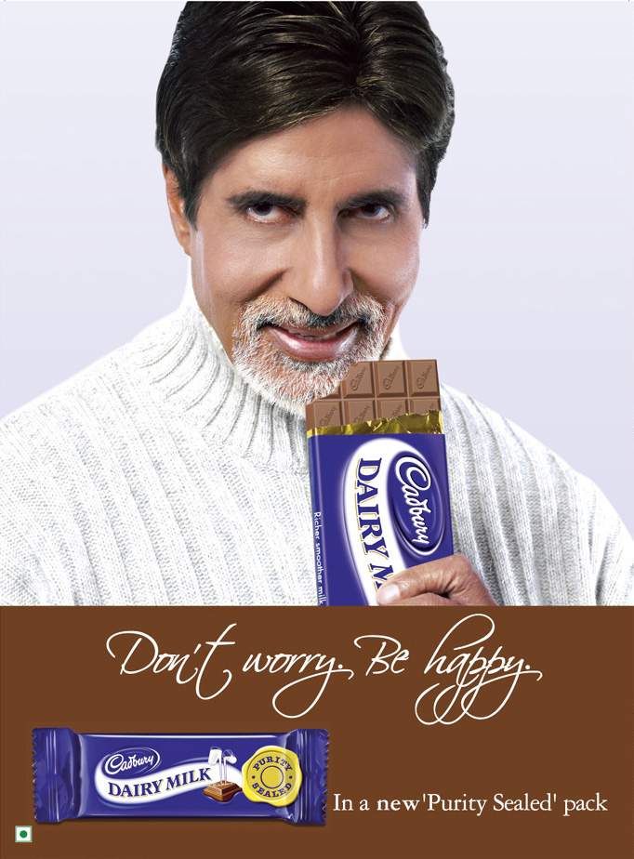
Our framework argues that exclusivity makes the product-celebrity association stronger thereby making the product resonates with the qualities of the celebrity. In cases where the celebrity endorses multiple products, he dilutes his equity.
There’s no better example in the Indian industry than Amitabh Bachchan who endorses ICICI Bank, Cadbury, Versa, Dabur, Rin, Parker Pens, Pepsi, Nerolac Paints and many more. In each of the cases the ads use some or the other attribute of Amitabh to endorse the product, but makes no strong link in the minds of the consumer. Hence in the end the consumer is lost and has difficulty identifying, what does Amitabh really stand for?
4. CELEBRITY – PRODUCT MATCH

- RANI MUKHERJEE – TITAN RAGA – POSITIVE IMPACT

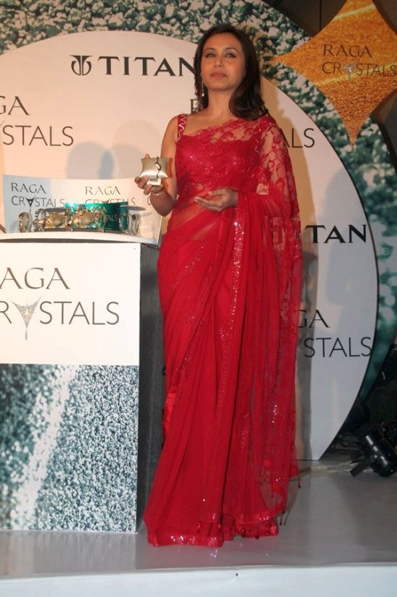
Titan Raga, a brand which deals exclusively in womens watches chosen Rani Mukherjee as their brand ambassador. Rani will promote the exquisite collection of womens watches in TV, print and outdoor ads. Titan Raga wants to promote a range of watches that will be affordable to middle class women. There is an increasing and emerging market for womens watches. Rani Mukherjee, knowing that she is a bollywood icon whom many women across the globe identify with.

5. CELEBRITY AVAILABILITY

- HUTCH - THE CHILD AND THE DOG - CREATED SPOKESPERSON


Hutch managed to grab the attention of the consumers, by not using a celebrity. The child and dog campaign came across as a fresh initiative at endorsing a product. The child and dog have had a very high brand recall as they represent only Hutch and have been created by the company according to the needs of the product and the message. It communicates to the consumer, “We are there, wherever you are and that too unobtrusively.” The protagonist says all of the above and creates a strong bond with the consumer.

6. CELEBRITY CONTROVERSY RISK

- MOHAMMED AZHARUDDIN - BRITANNIA -CHANGE OF THE CELEBRITY IMAGE

Mohammad Azharuddin, at the peak of his career was a brand ambassador for an assortment of products. But the match-fixing case besmirched his image and all of the products started disassociating their endorsements from him. Thus, a product is sold on basis of the qualities of the endorser and with a change in the inherent value system of the celebrity; the bond with the consumer is lost.
The perfect example here is of Salman Khan and the controversy in which he crushed a man to death with his Pajero when he was driving under the influence of alcohol. Also, any act on the part of the endorser that gives him a negative image among the audience and goes on to affect the brands endorsed. The brand, in most instances, takes a bashing.

7. CELEBRITY – TARGET AUDIENCE MATCH

- SMRITI IRANI

She is endorsing the WHO recommended ORS Campaign in India. Indian mothers can associate with Smriti Irani through the facets she projects on screen or in regular life which helps develop a connect with the target audience since mothers medicate their children with ORS.

8. SPORTS PERSONALITY

- SACHIN TENDULKAR

Sachin Tendulkar was paid a huge sum of Rs. 12 Crore to endorse Fiat Palio, even though Tendulkar as a brand could command such an exorbitant amount. It’s for the company to evaluate if the returns generated by the endorsement would commensurate the initial spend. In this case due to excessive spending and failure of the product to take-off the advertisements had to be withdrawn.
Aviva Life Insurance, a joint venture between UK's biggest insurer Aviva and Dabur, has roped in master blaster Sachin Tendulkar as brand ambassador and named its new child insurance policy after the cricketer's title-Little Master.

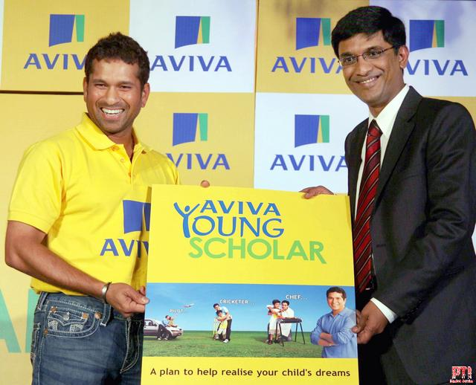

Announcing this, Aviva India Managing Director Bert Paterson said: "Sachin is the most popular icon in India for all age-groups and his popularity transcends the boundaries of religion, caste and region. Our new product-Aviva Little Master-is a tribute to our brand ambassador."
The company will be launching a nationwide campaign featuring Tendulkar soon.

9. CELEBRITY - PHYSICAL ATTRACTIVENESS

- JOHN ABRAHAM

John Abraham endorsing Wrangler and Timex Sunglasses are some examples which portray the celebrities’ physical attractiveness that helps create an impact.

10. CELEBRITY – REGIONAL APPEAL FACTORS
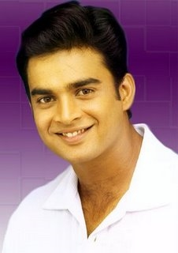
- R. MADHAVAN

It endorsing Pepsi in southern India or Sachin Tendulkar endorsing in India are few examples of how celebrities are chosen to reach out to target audiences for brands in regional markets.

RESEARCH & ANALYSIS

The data has been collected from Mira road Region by 35 people.

- Are you influenced by the presence of a celebrity in an advertisement?

Yes No

- Do you think celebrities make a difference to the image of the brand?

Yes No

- Do you agree with the concept of brand ambassadors?

Yes No

- Will you compromise on your current preference if the competitor brings in ads featuring your favorite celebrity?

Yes No

- What are the chances that you would buy a new product just because of the presence of a celebrity?

Definitely yes Will not I might

- What would be the contribution of a celebrity in building up a brand image?

Totally builds up the image
Doesn’t make any difference to the brand
Celebrity + quality product builds up the right image

INTERPRETATION

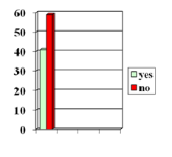
- Are you influenced by the presence of a celebrity in an advertisement?

From the curved conducted it is evident that almost 60 percent do not blindly believe or get totally influenced by the presence of a celebrity. However 40 percent are of the view that the presence of a celebrity will get them to go and ask for the product. This is an aspect due to which celebrities are used by advertisers.

- Do you think celebrities make difference to the image of a brand?

People do not think that celebrities alone can make up the image or break it up. In order for a brand to have a positive and successful image in the minds of the customer there are a large number of factors other than celebrities endorsing them. Quality, affordability and consistency are major factors that that contribute towards this.

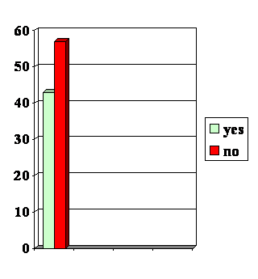
- Do you agree with the concept of brand ambassadors?

Again out here 60 % believe that brand ambassador as a concept is not very important. Hence it can be understood that people do not get much influenced by celebrities endorsing a product and giving it their personality. Or it can be said that one celebrity for one brand throughout is something that people won’t mind compromising on in other words they do not mind a brand not having a brand ambassador.

- Will you compromise on your current preference if the competitor brings in advertisements featuring your favorite celebrity?

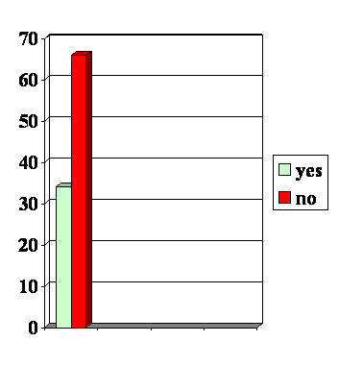
The majority of the people i.e. more than 60% here fells that they will not go for the competitors products if their favorite celebrity starts endorsing it. This shows brand loyalty among the young Indian consumers as the survey done by us has been focused mainly on the age group of 18-24 years. However there still are some 305 who say that they will go for it seen their favourite celebrity in the ad. This is important for a company if it is launching up say a new brand in a sector which it wasn’t operating. This would thus help in pulling the competitors market share.

- What are the chances you would buy a new product due to the presence of a celebrity?

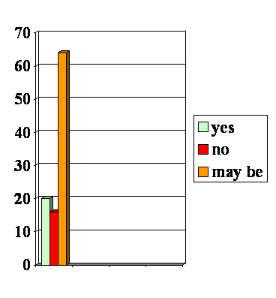
More than 60% of the people here are in a dilemma as to if they are going to try out a new product just because of the presence of a celebrity. This shows that majority of the public do not blindly believe on the image put up by the celebrity and the brand he/she is endorsing. Only 20% say that they will try it out only due to the presence of a known face. This further strengthens our view that celebrity endorsements alone cannot make up a brand.

- What would be the contribution of a celebrity in building up a brand image?
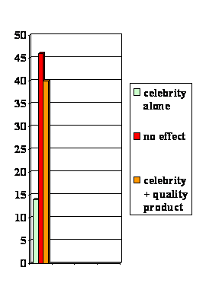

From the graph it can be easily concluded that the majority feel that there is no effect of the presence of a celebrity on the building up of a brand i.e. most of them feel that celebrities alone do not make up the brand. The product should be quality oriented, which alone can contribute majorly in building up a successful brand.

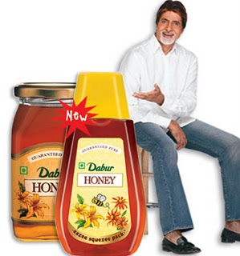
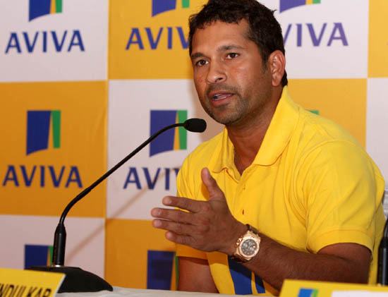

Facts And Figures
- Approximately 60-70% of all television commercials feature famous people.

- Aishwarya Rai had once endorsed 'Fuji-Film' camera rolls. The company made an agreement with her to endorse their camera rolls. But, Aishwarya's magic did not work there and they had to terminate the contract.

- Amitabh Bachhan (AB) was seen endorsing Maruti's Versa Car. The AB factor worked wonders as far as generating curiosity was concerned but the actual product couldn't meet the expectations of people, and hence, the endorsement strategy didn't work. He has been used very effectively by Parker Pens, ICICI Bank and Cadbury's to name a few.

- Bata's sales doubled soon after they adopted Rani Mukherjee as their brand ambassador.

- The consumer looks for a variety of aspects from the endorsement like the credibility and likeability of the endorser. Credibility also means the fit between the brand and the celebrity.

- Multiple endorsements do clutter the minds of the consumer.

- More than the bad performance in the professional field, it is the association of the celebrity with a controversy or ill-behaviour that causes negative impact to the endorsements. During the match fixing scandal in India, the commercials featuring Ajay Jadeja and Mohammed Azharuddin were all taken off air so that they did not have a negative effect on the brand.

- The celebrities' accessibility, regional appeal factors, popularity, attractiveness, belief system are some other important platforms, which are raised when we study the impact of celebrity endorsement on brands.

CONCLUSION
Celebrity endorsement can be a goldmine or a minefield for a company's brand building process. There have been extensive studies relating to the process of celebrity endorsement and brand-building. These studies indicate that celebrity endorsement has worked well in some consumer segments while failing in others. Few celebrities have been more successful than those with almost parallel fame. So the role of celebrity endorsement in the advertising space is equivocal and cannot be seen as a assured strategic tool to win profits, market share, revenues, etc.
Consumers can identify the clear difference between a good script and a good brand idea. For example, while Pepsi's Sachin and Bachchan (kite flying) ad was seen as one with a good script, Coca-Cola's Thanda Matlab... was seen as an insightful and strong brand idea. For all the flak it drew in its vainglorious attempts to run down competition, Thumbs-Up was seen as the only example of seamless linkage between brand positioning and brand celebrity.
There is an increasing challenge to the marketing manager to develop and implement an integrated marketing communication (IMC) plan to realize the true value of the celebrity endorsements. There is a gradual shift from the traditional approach of showing celebrities in advertisement to making them the "spokes-person" of the brand. Companies have taken celebrity endorsement to next level by projecting brands as a way of life. Smart companies are using their brand ambassadors in other mediums such as movies to promote their brands. E.g., Amitabh Bachchan, who endorses the financial instruments of ICICI Bank, is shown as a branch-manager of ICICI Bank in the movie Baghban.

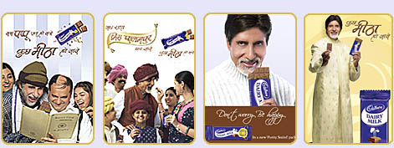
BIBLIOGRAPHY
INTERNET
- www.thedayaftertomorrow.com
- www.indiantelevision.com
- www.blonnet.com
- www.coolavenues.com
- www.wikipedia.com



