DECLARATION

I hereby declare that the Research project report titled “A study of the Marketing Strategies of McDonald’s with special reference to Indore.” is a bonafide record done by me during the period July-August 2009 as part of my MBA program at Govindram Seksaria Institute of Management and Research, Indore. This study has been undertaken in partial fulfillment of the requirement for the award of Master of Business Administration by DAVV, Indore.

I also declare that this report has not been submitted in full or part thereof, to any
university or institutions for the award of any degree or diploma.

Place: Indore Sreejit Kaimal
Date: 05/09/2009 MBA(2008-2010)
GSIMR, Indore(M.P)

ACKNOWLEDGEMENT

“I have searched for the definition of success, in the context of leading a successful life. It turns out that there are as many definitions as there are seekers and that success lies as much in the attempt as in the achievement.” - Robert Frost

“Feeling gratitude and not expressing it is like wrapping a present and not giving it.” - William Arthur Ward

I have immense pleasure to express my sincere gratitude to Dr. T. Duhan, Director of Sri Govindram Seksaria Institute of Management and Research, Indore for providing me a platform to endorse my practical knowledge and pursue my goals by giving such a project during our session.

I would like to sincerely thank all those people who gave their constructive input in the completion of this project and to all those who untiringly guided me. I am indebted to all those people who have contributed time, encouragement, information and assistance or in some manner enabled me to learn, to grow in experience to develop a better understanding.

I would like to politely extend my gratitude to my mentor guide
Ms. Neha Chouhan for her kind assistance, able guidance and moral support that influenced me to try and put my best efforts in every task assigned to me.

Last but not the least I would like to thank my parents for their words of encouragement and guidance all throughout the way.

TABLE OF CONTENTS

S.No. | CONTENTS | Page No.
1. | Company Description | 5
2. | History of McDonald’s | 8
3. | Goals and Objectives | 10
4. | Mission statement | 10
5. | McDonald’s India-A Profile | 11
6. | Evolution of McDonald’s marketing in India | 13
7. | McDonald’s Strategic Marketing Mix | 16
8. | Importance of PLC in McDonald’s | 22
9. | McDonald’s SWOT Analysis | 28
10. | Competitors Analysis | 31
11. | Research Methodology | 32
12. | Data Analysis and Interpretation | 34
13. | Recommendations and Conclusion | 41
14. | Appendices | 44
15. | Bibliography | 48

COMPANY DESCRIPTION:

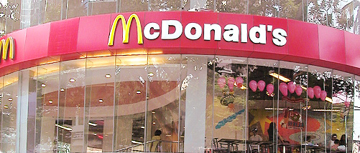

Established in California during the 1940s by two brothers, the McDonald’s restaurant became a popular teen hangout in the first flush of post-war affluence. To feed these youthful bodies, the brothers reduced the menu to the perennial favourite – hamburgers, applied assembly line techniques to food production and expanded to four restaurants by 1953. Taking note of the brothers’ success, in 1955, Entrepreneur Ray Kroc bought the right to franchise the McDonald’s System. Renamed the McDonald’s Corporation in 1960, Kroc focused his marketing effort on the family meal and children, spending heavily on television advertising which promoted the smiling clown face of its child-friendly brand mascot, Ronald McDonald. Today, the McDonald’s franchise exceeds 30,000 restaurants globally and serves over 50 million people in more than 121 countries each day.

The business began in 1940, Their introduction of the "Speedee Service System" in 1948 established the principles of the modern fast-food restaurant. The original mascot of McDonald's was a man with a chef's hat on top of a hamburger shaped head whose name was "Speedee." Speedee was eventually replaced with Ronald McDonald in 1963. Believing that the McDonald formula was a ticket to success, Kroc suggested that they franchise their restaurants throughout the country. When they hesitated to take on this additional burden, Kroc volunteered to do it for them. He returned to his home outside of Chicago with rights to set up McDonald's restaurants throughout the country, except in a handful of territories in California and Arizona already licensed by the McDonald brothers. Kroc's first McDonald's restaurant opened in Des Plaines, Illinois, near Chicago, on April 15, 1955--the same year that Kroc incorporated his company as McDonald's Corporation. As with any new venture, Kroc encountered a number of hurdles. The first was adapting the McDonald's building design to a northern climate. A basement had to be installed to house a furnace, and adequate ventilation was difficult, as exhaust fans sucked out warm air in the winter and cool air in the summer. Most frustrating of all, however, was Kroc's initial failure to reproduce the McDonalds' delicious french fries. Once the Des Plaines restaurant was operational, Kroc sought franchisees for his McDonald's chain. The first snag came quickly. In 1956 he discovered that the McDonald brothers had licensed the franchise rights for Cook County, Illinois (home of Chicago and many of its suburbs) to the Frejlack Ice Cream Company. Kroc was incensed that the McDonalds had not informed him of this arrangement. He purchased the rights back for $25,000--five times what the Frejlacks had originally paid--and pressed forward. Kroc decided early on that it was best to first establish the restaurants and then to franchise them out, so that he could control the uniformity of the stores. Early McDonald's restaurants were situated in the suburbs. Corner lots were usually in greater demand because gas stations and shops competed for them, but Kroc preferred lots in the middle of blocks to accommodate his U-shaped parking lots. Since these lots were cheaper, Kroc could give franchisees a price break. McDonald's grew slowly for its first three years; by 1958 there were 34 restaurants. In 1959, however, Kroc opened 67 new restaurants, bringing the total to more than 100.

Kroc had decided at the outset that McDonald's would not be a supplier to its franchisees--his background in sales warned him that such an arrangement could lead to lower quality for the sake of higher profits. He also had determined that the company should at no time own more than 30 percent of all McDonald's restaurants. He knew, however, that his success depended upon his franchisees' success, and he was determined to help them in any way that he could. In 1960 the McDonald's advertising campaign "Look for the Golden Arches" gave sales a big boost. Kroc believed that advertising was an investment that would in the end come back many times over, and advertising has always played a key role in the development of the McDonald's Corporation--indeed, McDonald's ads have been some of the most identifiable over the years. In 1962 McDonald's replaced its "Speedee" the hamburger man symbol with its now world-famous Golden Arches logo. A year later, the company sold its billionth hamburger and introduced Ronald McDonald, a red-haired clown with particular appeal to children. The present corporation dates its founding to the opening of a franchised restaurant by Ray Kroc, in Des Plaines, Illinois on April 15, 1955 , the ninth McDonald's restaurant overall. Kroc later purchased the McDonald brothers' equity in the company and led its worldwide expansion and the company became listed on the public stock markets in 1965. Kroc was also noted for aggressive business practices, compelling the McDonald's brothers to leave the fast food industry. The McDonald's brothers and Kroc feuded over control of the business, as documented in both Kroc's autobiography and in the McDonald brothers' autobiography. The site of the McDonald brothers' original restaurant is now a monument. The menu was simple: hamburgers, cheeseburgers, French fries, shakes, soft drinks, and apple pie. The carhops were eliminated to make McDonald's a self-serve operation, and there were no tables to sit at, no jukebox, and no telephone. As a result, McDonald's attracted families rather than teenagers. Perhaps the most impressive aspect of the restaurant was the efficiency with which the McDonald's workers did their jobs. Mac and Dick McDonald had taken great care in setting up their kitchen. Each worker's steps had been carefully choreographed, like an assembly line, to ensure maximum efficiency. The savings in preparation time, and the resulting increase in volume, allowed the McDonalds to lower the price of a hamburger from 30 cents to 15 cents. With the expansion of McDonald's into many international markets, the company has become a symbol of globalization and the spread of the American way of life. Its prominence has also made it a frequent topic of public debates about obesity, corporate ethics and consumer responsibility.

Redesign :

In 2006, McDonald's introduced its "Forever Young" brand by redesigning all of their restaurants, the first major redesign since the 1970s. The new design will include the traditional McDonald's yellow and red colors, but the red will be muted to terra cotta, the yellow will turn golden for a more "sunny" look, and olive and sage green will be added. To warm up their look, the restaurants will have less plastic and more brick and wood, with modern hanging lights to produce a softer glow. Contemporary art or framed photographs will hang on the walls.The exterior will have golden awnings and a "swish brow" instead of the traditional double-slanted roof. The new restaurants will feature areas:
· The "linger" zone will offer armchairs, sofas, and Wi-Fi connections.
· The "grab and go" zone will feature tall counters with bar stools for customers who eat alone; Plasma TVs will offer them news and weather reports.
· The "flexible" zone will be targeted toward families and will have booths featuring fabric cushions with colorful patterns and flexible seating.
· Different music targeted to each zone.

Business model :

McDonald's Corporation earns revenue as an investor in properties, a franchiser of restaurants, and an operator of restaurants. Approximately 15% of McDonald's
restaurants are owned and operated by McDonald's Corporation directly. The remainder are operated by others through a variety of franchise agreements and joint ventures. The McDonald's Corporation's business model is slightly different from that of most other fastfood chains. In addition to ordinary franchise fees and marketing fees, which are calculated as a percentage of sales, McDonald's may also collect rent, which may also be calculated on the basis of sales. As a condition of many franchise agreements, which vary by contract, age, country, and location, the Corporation may own or lease the properties on which McDonald's franchises are located. In most, if not all cases, the franchisee does not own the location of its restaurants. The UK business model is different, in that fewer than 30% of restaurants are franchised, with the majority under the ownership of the company. McDonald's trains its franchisees and others at Hamburger University in Oak Brook, Illinois. In other countries, McDonald's restaurants are operated by joint ventures of McDonald's Corporation and other, local entities or governments. As a matter of policy, McDonald's does not make direct sales of food or materials to franchisees, instead organizing the supply of food and materials to restaurants through approved third party logistics operators. According to Fast Food Nation by Eric Schlosser (2001), nearly one in eight workers in the U.S. have at some time been employed by McDonald's.

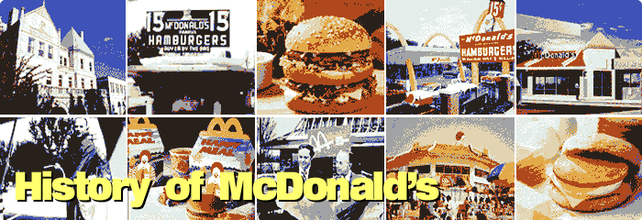

1955 | Ray Kroc opens his first restaurant in Des Plaines, Illinois and the McDonald's Corporation is created.
1957 | Quality, Service, Cleanliness and Value (QSC& V) becomes the company motto.
1959 | The 100th McDonald's opens in Chicago.
1961 | Hamburger University opens in Elk Grove, near Chicago.
1963 | One billion hamburgers sold.  Ronald McDonald makes his debut.
1964 | Filet-O-Fish sandwich is introduced.
1965 | McDonald's Corporation goes public.
1967 | The first restaurants outside of the USA open in Canada and Puerto Rico.
1968 | The Big Mac is introduced.  The 1,000th restaurant opens in Des Plaines, Illinois.
1972 | A new McDonald's restaurant opens every day.  The Quarter Pounder is introduced.
1973 | Egg McMuffin is introduced.
1974 | The first Ronald McDonald House opens in Philadelphia.  The Happy Meal is launched.

1983 | Chicken McNuggets is introduced.  New Hamburger University campus opens in Oak Brook, Illinois. Set in 80 wooded acres. Training is provided for every level of McDonald's management worldwide.
1984 | 50 billionth hamburger sold.  Ronald McDonald Children's Charities is founded in Ray Kroc’s memory to raise funds in support of child welfare.
1989 | McDonald's is listed on the Frankfurt, Munich, Paris and Tokyo stock exchanges.
1990 | McDonald's opens in Pushkin Square and Gorky Street, Moscow.
1993 | The first McDonald's at sea opens aboard the Silja Europa, the world's largest ferry sailing between Stockholm and Helsinki.
1994 | Restaurants open in Bahrain, Bulgaria, Egypt, Kuwait, Latvia, Oman, New Caledonia, Trinidad and United Arab Emirates, bringing the total to over 15,000 in 79 countries on 6 continents.
1996 | McDonald's opens in India – the 95th country.

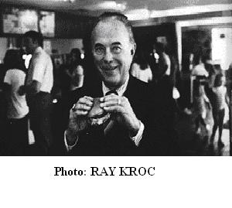
GOALS AND OBJECTIVES:

1. McDonald’s vision is to be the world’s best quick service restaurants experience.
2. McDonald’s is committed to maintaining and developing the best food products in the
quick service restaurant market.
3. In order to deliver this, the company has made a number of commitments to food
safety and nutrition.
4. Lead the Quick Service Restaurant market by a program of site development and
profitable restaurant openings, and by attracting new customers. Increasing sales
through promotions will
enable them to continue their program of expansion.
5. McDonald’s have an objective to continual enhance and improve their menu. This will
better satisfy their customers and give customers more reason to visit. Many ideas for
new items on the menu come from the franchisees responding to customer demand.
Consumer tastes change over time and McDonald’s has to respond to these changes.

MISSION STATEMENT:

"McDonald's vision is to be the world's best quick service restaurant experience. Being the best means providing outstanding quality, service, cleanliness, and value, so that we make every customer in every restaurant smile."
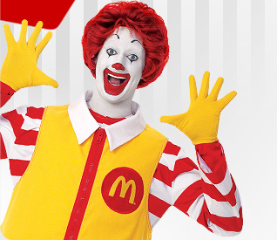

Happy Eating

McDonald’s India-A Profile:

McDonald's opened its doors in India in October 1996. Ever since then, the family restaurants in Mumbai, Delhi, Pune, Ahmedabad, Vadodara, Ludhiana, Jaipur, Noida Faridabad, Doraha, Manesar and Gurgaon have proceeded to demonstrate, much to the delight of all the customers, what the McDonald's experience is all about.

McDonald’s in India is a 50-50 joint venture partnership between McDonald’s Corporation [USA] and two Indian businessmen. Amit Jatia’s company Hardcastle Restaurants Pvt. Ltd. owns and operates McDonald's restaurants in Western India. While Connaught Plaza Restaurants Pvt. Ltd headed by Vikram Bakshi owns and operates the Northern operations. Amit Jatia and Vikram Bakshi are like-minded visionaries who share McDonald's complete commitment to Quality, Service, Cleanliness and Value (QSC&V). Having signed their joint-venture agreements with McDonald's in April 1995, they trained extensively, along with their Indian management team, in McDonald's restaurants in Indonesia and the U.S.A. before opening the first McDonald’s restaurant in India.

Respect for local culture
McDonald's India has developed a special menu with vegetarian selections to suit Indian tastes and preferences. McDonald's does not offer any beef or pork items in India. Only the freshest chicken, fish and vegetable products find their way into our Indian restaurants.
In addition, they've re-formulated some of their products using spices favoured by Indians. Among these are McVeggie™ burger, McAloo Tikki™ burger, Veg. Pizza McPuff™ and Chicken McGrill™ burger. They've also created eggless sandwich sauces for the vegetarian customers. Even their soft serves and McShakes™ are egg-less, offering a larger variety to their vegetarian consumers.

International Standards
McDonald's India's local suppliers provide them with the highest quality, freshest ingredients. Complete adherence to the Indian Government regulations on food, health and hygiene is ensured, while maintaining their own recognized international standards. Fast, friendly service - the hallmark of McDonald's restaurants the world over is the mantra we abide them.
Stringent cleaning standards ensure that all tables, chairs, highchairs and trays are sanitised several times each hour. Such meticulous attention to cleanliness extends beyond the lobby and kitchen to even the pavement and immediate areas outside the restaurant.

McD Philosophy
"We take the burger business more seriously than anyone else." When McDonald's founder, Ray Kroc made that memorable statement, he was letting the world in on the philosophy and secret behind McDonald's phenomenal success.
Their vision to be India’s "best" quick service restaurant experience is supported by a set of principles and core values.

The principles that guide them…
- Quality, Service, Cleanliness & Value - It is an unflinching McDonald's ideology that their customers must always get quality products, served quickly and with a smile, in a clean and pleasant environment; and all at a fair price.
- They are committed to exceeding their customers' expectations in every restaurant every time.
- They have a passion and a responsibility for enhancing and protecting the McDonald's brand.
- They believe in a collaborative management approach, employing a mutually respectful business philosophy.
- They will seize every opportunity to innovate and lead the industry on behalf of their customers.

Business Model :

- Franchise Model – Only 15% of the total number of restaurants are owned by the Company. The remaining 85% is operated by franchisees. The company follows a comprehensive framework of training and monitoring of its franchises to ensure that they adhere to the Quality, Service, Cleanliness and Value propositions offered by the company to its customers.

- Product Consistency – By developing a sophisticated supplier networked operation and
distribution system, the company has been able to achieve consistent product taste and quality across geographies.

- Act like a retailer and think like a brand – McDonald’s focuses not only on delivering sales for the immediate present, but also protecting its long term brand reputation.

Challenges in Entering Indian Markets :

- Regiocentricism: Re-engineering the menu - McDonald’s has continually adapted to the customer’s tastes, value systems, lifestyle, language and perception. Globally McDonald’s was known for its hamburgers, beef and pork burgers. Most Indians are barred by religion not to consume beef or pork. To survive, the company had to be responsive to the Indian sensitivities. So McDonald’s came up with chicken, lamb and fish burgers to suite the Indian palate.
- The vegetarian customer – India has a huge population of vegetarians. To cater to this
customer segment, the company came up with a completely new line of vegetarian items like McVeggie burger and McAlooTikki. The separation of vegetarian and non-vegetarian sections is maintained throughout the various stages.

Evolution of McDonald’s marketing in India:

When McDonald's India launched in 1996, urban Indians in Mumbai and Delhi typically ate out three to fives times a month, according to AT Kearney, the management consultancy. In the 12 years since then, that average frequency has doubled and analysts forecast that by 2011 the Indian quick service restaurant market will be worth 30,000 crore (about $6.3bn at October 2008 exchange rates). But from their earliest investments in India, multinational company (MNC) owners of restaurant chains have struggled to adapt to the needs of India's many markets. Some pulled out of the country after failed ventures. At the time, consolidation of the hugely fragmented Indian retail sector had also barely begun, and there was scepticism that Indians would prefer burgers and fast food to local food offerings. However, in the intervening decade, McDonald's has continued to open new outlets in the country, evolving its marketing strategy through several phases.

Twelve years of McDonald's India:
McDonald's India was set up as a 50:50 joint-venture between McDonald's at a global level and regional Indian partners such as Hardcastle Restaurants Private Limited in western India, and Connaught Plaza Restaurants Private Limited in northern India. The first Indian McDonald's outlet opened in Mumbai in 1996. Since then, outlets have begun trading in metropolitan and Tier II towns across the country. By September 2008, it had premises in Mumbai, Bangalore, Baroda, Pune, Indore, Nasik, Chennai, Hyderabad, Surat and Ahmedabad. Amit Jatia, Managing Director, McDonalds India, said: "The past decade has witnessed a marked change in Indian consumption patterns, especially in terms of food. Households in middle, upper and high-income categories now have higher disposable income per member and a propensity to spend more."

Phase I: Launching the brand
The starting point for McDonald's India was to change Indian consumers' perceptions, which associated it with being 'foreign', 'American', 'not knowing what to expect' and 'discomfort with the new or different'. McDonald's wanted to position itself as 'Indian' and a promoter of 'family values and culture', as well as being 'comfortable and easy'. Simultaneously, the brand wanted to communicate that, operationally, it was committed to maintaining a quality service, cleanliness and offering value for money. Says Arvind Singhal, Head of Marketing at McDonald's India: "From a marketing communications standpoint, we chose to focus on familiarizing the customer with the brand. The brand was built on establishing functional benefits as well as experiential marketing." Until 2000, McDonald's India did not have enough reach to use mass media such as television advertising. Instead, most of its marketing effort focused on outlet design, new store openings and PR about its attempts to tailor a menu to Indian tastes. Amit Jatia said: "Products like McAloo Tikki burger, Veg Pizza McPuff and Chicken McGrill burger were formulated and introduced using spices favored by Indians. The menu development team has been responsible for special sauces which use local spices do not contain beef and pork. Other products do not contain eggs and are 100% vegetarian. The Indianized products have been so well received that we even export McAloo Tikki™ burger and Veg. Pizza McPuff™ to the Middle East."
However the company did not escape food criticism in the country. For instance, it hurt the religious sentiments of Indians by using beef flavoring for its "Vegetarian" French Fries. Says Sridhar, National Creative Director, Leo Burnett: "When McDonald's launched we took a conscious call of not introducing any beef or pork in our products. Thus, when controversies around McDonald's products started during the early and growth stages of the Indian business, we reacted quickly. We educated our customers about the build of our products and did extensive kitchen tours for our customers. We showed them how we use separate vegetarian and non-vegetarian platforms for cooking – a first in any market for McDonald's."

Phase II: Brand advertising
By 2000, McDonald's India was ready to begin TV advertising. Arvind Singhal said: "The first Indian TV commercial, Stage Fright, attempted to establish an emotional connection between the (Indian) family and the brand. Over the years advertising has reinforced this positioning, supported by promotions." The Stage Fright campaign aimed to establish McDonald's as a familiar, comfortable place. It featured a child who suffers stage fright and is unable to recite a poem. On entering McDonald's, he easily recites it in the store's familiar environment. A second campaign featured a child and his family moving into a new place. He misses his previous surroundings – until McDonald's provides something familiar. These storylines were supported by other initiatives. The company's one-minute service guarantee attempted to reinforce its reputation for fast, friendly and accurate service and it also ran in-store events for mothers and children. Mr Singhal says: "To kids sitting on the Ronald McDonald bench, pumping sauce from the sauce machine became brand rituals."
K.V. Sridhar, National Creative Director, Leo Burnett, the company's agency in India, adds: "In the launch phase the communication focused solely on building brand and product relevance. The brand's scores on relevance to families and kids were very high." Later, McDonald's realized there was untapped potential in the youth audience who considered McDonald's expensive and mainly for children. Sridhar says: "In 2004, we launched the Happy Price Menu with a value message for a younger audience. For the first time McDonald's India saw a surge of younger consumers and people from socio-economic class B walk into our stores. "We had realized that the Indian consumer was price sensitive and even though the organization managed to establish a sense of familiarity, Indian consumers continued to perceive McDonald's as an expensive eating out option."

Phase III: Appealing to both ends of the age spectrum
In 2008, the latest campaign from the McDonalds-Leo Burnett stable uses father-son duos from the Indian film industry to reiterate the theme of "Yesteryear's Prices". It features Bollywood stars from past decades together with their sons and a message that prices have not risen in line with the passage of time. The Happy Price campaign has also been promoted via virals. Outdoor has also promoted a home delivery option in a country where home delivery is common in urban areas. McDonald's has also been exploring strategic tie-ups with Indian sports properties such as the IPL cricket tournament, where it was one of the event's food providers. Amit Jatia, however, says: "The eating out market in India is very large and has huge potential fuelled by rising disposable incomes. There are many Indian and international players who have entered in the market since the last decade and unbranded food chains have also grown significantly. "The Indian consumer has seen value in what we have to offer at our restaurants which is a testament to our model."
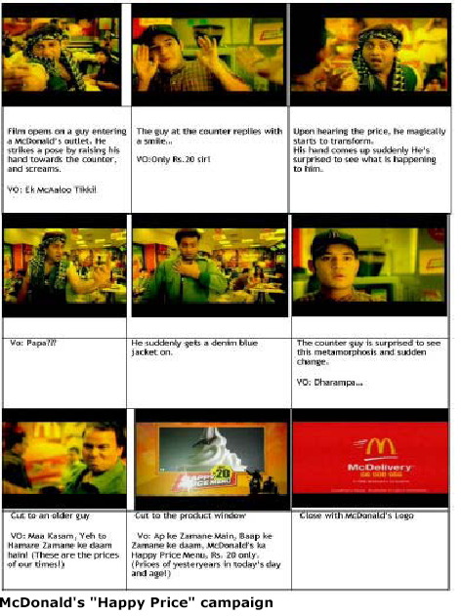

McDonald's Strategic Marketing Mix
Introduction:

When the Dick and Mac McDonald opened their first restaurant in San Bernardino, California in 1948, they never could have imagined the extraordinary growth their company would experience. From modest beginnings, they found a winning formula selling high quality products quickly and low-cost. It was not until 1955 when Ray Kroc, a salesman from Chicago, became involved in the business that McDonald's really began to flourish. Kroc realized the same successful McDonald's formula could be exploited throughout the United States and beyond with the use of franchising. A franchise is an agreement or license to sell a company's products exclusively in a particular area, or to operate a business that carries that company's name.
In 1955, Kroc knew that the key to success was through rapid expansion; thus, the best way to achieve this was through offering franchises. Today, over 70 percent of McDonald's Restaurants are franchises. In 1986, the first franchised McDonald's opened in the United Kingdom. Now, there are over 1,150 restaurants, employing more than 49,000 people, of which 34 percent are operated by franchisees. Moreover, there are over 30,000 these restaurants in more than 119 countries, serving over 47 million customers around the world. In 2000 alone, McDonald's served over 16 billion customers. For perspective, that number is equivalent to providing a lunch and dinner for every man, woman, and child in the world! McDonald's global sales were over $40 billion, making it by far the largest food service company in the world.

Because of the invention of franchising and the development of some of the most creative marketing and branding campaigns, McDonald's is one of the world's most well-known, valuable brands holding a leading share in the globally branded, quick service restaurant segment of the informal dining-out market in virtually every country in which they do business. As a leader in the fast food industry, McDonald's is often targeted. Some of the ways McDonald's handles the attacks of the media and competition is by creating a marketing mix to highlight the positive impacts the organization. McDonald's must keep the strategic nature of its marketing efforts to stay on top and provide what customers want.
Marketing Mix:
Marketing mix must focus on the product, pricing, promotion, and placement of item in order to make it successful. Marketing strategies must feature customer orientation, input, and accessibility in the fight to the top of the market. McDonald's is no different. One can recognize that McDonald's primary target market is children ages 3-11 and their parents. McDonald's understood that the parent was making the purchasing decision, most likely based on price.

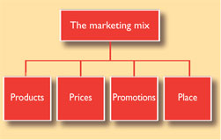

What McDonald's marketing executives did was ingenious. They put a $.50 toy in with the hamburger, french fries, and drink and gave it a special name, the "Happy Meal". Then McDonald's marketed the Happy Meal to the kids. If you have you ever asked your child where to buy a Happy Meal, they will tell you that there is only one place you can buy one, and that is at McDonald’s. The year in which some McDonald's Favorites were Introduced are:-
1955 - Hamburgers, cheeseburgers, fries, shakes, soft drinks, coffee and milk
1963 -Filet-O-Fish
1968 -Big Mac and Hot Apple Pie
1973 -Quarter Pounder and Egg McMuffin
1974 -McDonaldland Cookies
1977 -Breakfast Menu
1978 -Sundaes
1979 -Happy Meals
1983 -Chicken McNuggets
1986 -Biscuit Sandwiches
1987 -Salads
1998 -McFlurry Desserts
1999 -Breakfast Bagels
2000 -Chicken McGrill and Crispy Chicken
2001 -Big N' Tasty
2003 -Premium Salads, Newman's Own® salad dressings and McGriddles
2004 - Chicken Selects® Premium Breast Strips
McDonald's restaurants have a variety of strategies that apply to product, placement, promotion, and price that makes them one of the most successful, well-recognized organizations in the world.
Product Strategies:

McDonald's marketing strategies should be looked at historically in order to see the larger picture of the firm's success. There have been so many strategies since the inception of the firm that it is difficult to account for them all, the two most memorable are the development of the "Golden Arches" and "Ronald McDonald". These two icons have given customers a mental image of what to look for when they want quality food for a low price fast. The firm revolutionized the fast food industry and positioned itself as the market leader with low-priced, quality food and provided an entertaining atmosphere for the children. These things were what that the market wanted at the time and the firm answered in spades.
The perceived secret of McDonald's success is the willingness to innovate, even while striving to achieve consistency in the operation of its many outlets. For example, its breakfast menu, salads, Chicken McNuggets, and the McLean Deluxe sandwich were all examples of how the company tried to appeal to a wider range of consumers. The long history of innovation and experimentation resulted in new profit centers like Chicken McNuggets and the breakfast menu. Innovation and experimentation also produced some disappointments like the McLean Deluxe, but inevitably experimentation in limited outlets provides McDonald's a way to retain its key strengths-quality and consistency-while continuing to evolve. The use of franchising, again, provides various perspectives that, in turn, lead to innovation for products and solutions. Franchisees agree to operate their restaurants in the "McDonald's way" but there remains room for innovation. Many ideas for new menu items come from franchisees responding to customer demand. Developing new products is crucial to any business even those that successfully relied on a limited menu for many years. As consumer tastes change, menu innovation injects enthusiasm allowing the firm to explore markets previously overlooked or ignored. The "Egg McMuffin", for example, was introduced in 1971. This item enabled McDonald's to accommodate consumers of the breakfast market. Filet-o-Fish, Drive-thrus, and Playlands were all products or concepts developed by franchisees. McDonald's tries a few new concepts simultaneous in different parts of the country to find the most promising new menu item. Those with the most potential could be rolled out further, while the ineffective ideas could be left to die quickly. This strategy may be expensive, but the potential to unleash new areas of growth in a maturing market seems to be right in line with what McDonald's has always done.
In addition to the local flavors that have been created in the US, McDonald's international restaurants have been conforming to local, regional, and ethnic tastes, too. In a recent McDonald's case study this was explained further: "For example, 'Maharaja McBurger' is a vegetarian burger marketed in India. The special requirements for 'Kosher' foods are followed in Israel. Similarly, McDonald's offers 'Halal' food in Muslim countries such as Saudi Arabia, UAE, Kuwait, Indonesia, Malaysia, Pakistan, and Bangladesh. During promotions, McDonald's also introduces several other products. For example, its 'Prosperity Burger' is popular in China, Taiwan, Hong Kong, and Singapore at the time of the Chinese New Year celebrations. In order to respond to the growing phenomenon of health consciousness, McDonald's has moved in favor of lean ground beef, 100% vegetable oil, 1% low-fat milk, low sodium, and low fat. This product strategy shows that McDonald's is interested in becoming part of the culture and is looking for ways to appeal to the market internationally.
McDonald's menu is based on five main ingredients: beef, chicken, bread, potatoes and milk. Their main products are hamburgers, chicken sandwiches, fries, and beverages. In addition, they serve a variety of breakfast items and desserts. Every McDonald's is uniform; you know exactly what you will get no matter what store you go in to. Although McDonald's has thousands of restaurants around the world, it standardizes menus and operating procedures in these restaurants to insure consistency throughout. To maintain consistency in the current menu while the firm tests new products to expand the product line, McDonald's relies on test marketing new menu items in pilot locations. New products are rigorously market tested so that the franchisee will have a reasonable idea of its potential before it is added to the menu. The introduction of new products, which have already been researched and tested, considerably reduces the risk for the franchisee. The franchisees additionally benefit from the extensive national market research programs that assess consumer attitudes and perceptions. What products do they want to buy and at what price? How are they performing compared to their competitors?
This approach allows the firm to identify which items are likely to prove popular with consumers while ensuring that the company can deliver new products with consistent quality nationwide. McDonald's already has a history of doing this so it will not require major changes to its operations strategy-at least initially. If the product line-up gets too large, then the task of maintaining quality becomes exponentially harder. The trick is to consider how to eliminate some of the existing menu items when you introduce new ones, while making sure the staff is fully trained in how to execute these products successfully.
McDonald's serves the world some of its favorite foods - Fries, Big Mac, Quarter Pounder, Chicken McNuggets, and the Egg McMuffin. To this end, McDonald's had done well with a limited product range. Declining per unit sales and competitors gaining ground, may indicate that McDonald's menu needs a face-lift. One way to do that is by inserting a couple of new, highly promoted menu items. This would refresh the product menu and provide new, satisfying experience for dinner consumers.
Placement Strategies:

McDonald's focuses on store placement and are always looking for the best locations. This strategy created some weakness in the last 10 years because it seemed that too many stores were put in some areas, cannibalizing sales from the other McDonald's. The company has also made convenience a focus, not only through how fast it serves customers, but also in the location of its outlets. Freestanding restaurants are positioned so that you are never more than a few minutes away by foot in the city or by car in the suburbs. In addition, McDonald's is tucking restaurants into schools, stores, and more.
Because McDonald's has pretty well saturated the U.S. market, it's only real opportunities for growth lie abroad, where the competition is not so cutthroat or by introducing new restaurant concepts under brands other than McDonald's. The organization's overall objective is to increase market share. In this instance, the focus is purely on localization with different strategies for different countries. Pricing could not possibly be standardized across the globe without alienating many countries with poorer economies, thus defeating the initial objective. McDonald's set an appropriate price for their product by looking at its competitors in each country. McDonald's is attempting to localize marketing communications due to the realization that it couldn't possibly appeal to all countries at the same time. The firm sees the necessity to "brand globally, act locally". For example, in China it was recognized that advertising on television would be a waste of money because commercials between programs are generally ignored. Instead, McDonald's uses newspapers and magazines to promote its image. Similarly, in East Asia, McDonald's targets children in order to gain optimum results. Of course, the ultimate message (brand) is the same; the medium is what is strategically modified.

Pricing Strategies:

The customer's perception of value is an important determinant of the price charged. Customers draw their own mental picture of what a product is worth. A product is more than a physical item, it also has psychological connotations for the customer. The danger of using low price as a marketing tool is that the customer may feel that quality is being compromised. It is important when deciding on price to be fully aware of the brand and its integrity. A further consequence of price reduction is that competitors match prices resulting in no extra demand. This means the profit margin has been reduced without increasing sales.

McDonald's strategy is to offer quality food quickly to customers at a good value. The pricing structure for McDonald's over years has supported this message. The company strives to differentiate itself from other fast food restaurants by offering a variety of menu items that appeal to a variety of people from those who just want great hamburgers, to those who just want a quick healthy meal. McDonald's differentiates itself by offering a dollar menu, combination meals, and a free toy with Happy Meals.
McDonald's, over the years, has also ran many promostions to increase traffic or product sales. For instance, the most recent roll out has been the 2004 Chicken Selects premium Breast Strips. Right now, you can go to your local McDonald's and "try them free." With this new product is offered a variation of the "usual" sauces for the Chicken Nuggest - a Chipotle Barbeque sauce is most commonly advertised. Another promotion was the "Campaign 55" where diners could buy a featured sandwich, like the Big Mac in April, for 55 cents when purchased with fries and a drink. This campaign wasn't as successful as the fast food giant found would have hoped.

Promotion Strategies:

McDonald's knows that some customers go to its stores to take a quick break from their day's activities and not because McDonald's made the food ten seconds faster than their competitors could. Therefore, McDonald's marketing executives then put together the phrase, "Have you had your break today?" They continued to develop this idea with "You deserve a break today," and now are in the "I'm Lovin' It!" mantra. "I'm Lovin' It!" doesn't seem to have as much punch as the earlier catch phrase, which still seems to be the favorite. McDonald's sees the use of these catch phrases and the use of the Golden Arches as a very successful way of differentiating the restaurants from other fast food competitors. McDonald's has taken price competition out of the picture because the customer feels they have gotten quality, convenience, service, and value - and McDonald's still makes you feel like you are getting a break in your hectic day. Creating catch phrases are only one kind of promotion, and McDonald's uses many kinds of promotions to keep the restaurants at the top of the industry.
With the rise of health consciousness it has become more difficult McDonald's to compete because their reputation brands them as cheap food served fast. The firm's response to obesity claims against the organization and other unfavorable public sediment is to add healthier items to their menu and promote and offer health-conscious alternatives to the "would you like fries with that" legacy. In addition, McDonald's has modernized their advertisements, pamphlets, and website to include nutritional information and addressing diet restrictions. Breaking the unhealthy association is difficult on its own, but with media and movies such as "Supersize Me" adding to the fray, McDonald's has had to look for alternative strategies to keep consumers happy.
Another promotional strategy McDonald's uses is the huge investment in sponsorship. This is also a central part of the image building process. Sponsorship of the 1998 football World Cup, the Premier League and the European Championships increases awareness of McDonald's brand. However, McDonald's still follows Ray Kroc's community beliefs today, supporting the Tidy Britain Group and the Groundwork Trust, as well as local community activities. McDonald's has become a known community partner with Ronald McDonald Houses across the nation for the use of families whose children are hospitalized and getting treatment far from home. This organization has created an image of partnership and community investment with these and other kinds of philanthropic activities.
Determining which way to market McDonald's and its products is a very important decision that can either cause products to fail or take flight. These same decisions must be made in regards to the marketing of the company as a whole. Strategy is the name of this game.
In a Nutshell:
McDonald's marketing mix is strategic because of the diverse approaches that are used. First, in identifying the "four P's" of marketing addressed earlier (product, price, promotion, and placement), research shows that McDonald's is very careful in making decisions that effect each area and/or how each area effects the other. McDonald's is concerned about how the firm will fulfill the needs and wants of its customers and in the activities associated with maintaining the relationships with its stakeholders. McDonald's stakeholders include customers, franchisees, suppliers, employees, and the local communities surrounding them.
McDonald's has shown care for customers through the decisions to add more healthful foods to the menus, by changing how products are packaged or how foods are prepared, and by philanthropic contributions and sponsorships. The restaurant has developed competitive advantages in the industry of serving quality fast food at a low cost. In addition to these decisions, the development of the Golden Arches or Ronald McDonald has provided consumers with memorable icons that are associated with quality, service, and value, just like the McDonald brothers and Ray Kroc intended.
McDonald's faces some difficult challenges in moving away from the fast food king to a more health conscious provider for customers who care about what they eat. The keys to its future success will be maintaining its core strengths-an unwavering focus on quality and consistency-while carefully experimenting with new options. The company's environmental efforts, while important, should not overshadow its marketing initiatives. Though there are many opportunities for this fast food giant, McDonald's must keep the strategic nature of its marketing efforts to stay on top and provide what customers want.

Importance of PLC in McDonalds :

The requirements of customers change over time and thus the product offering has to be changed accordingly. What is the fashion today may be out of market within
few weeks. Thus continuous innovation is required.
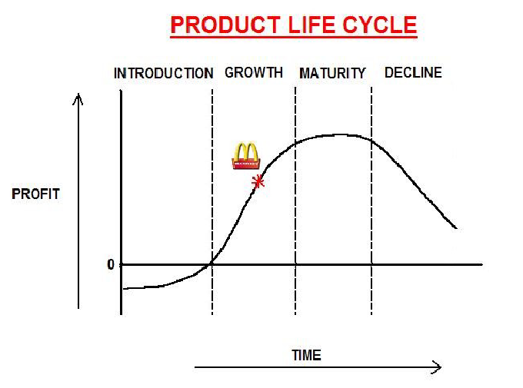

To counter these changes McDonalds has continuously introduced new products and has phased out the old ones which were at the decline stage of their PLC. The introduction is timed such that the new product does not cannibalize the product already in the maturity or growth stage. Thus the secret lies in getting profits with different products in the different stages of the PLC.

A perfect example of revitalising a product in decline phase:

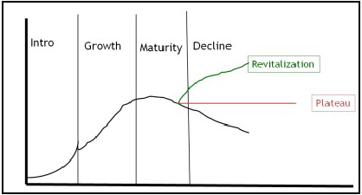

The French Fries have been an important part of the McDonalds menu worldwide. But now it was in the stage of decline and was actually not generating proper return. In an attempt to revitalize it, a new variant was introduced namely Shake Shake Fries. This is being served with chatpata spice mix which has resulted in increase in the sales of French Fries and has elevated it from to the decline stage. This is used to delay the decline of a well established product which has the potential of generating further revenue.

McDonald's Advertising :

McDonald's has for decades maintained an extensive advertising campaign. In addition to the usual media (television, radio, and newspaper), the company makes significant use of billboards and signage, sponsors sporting events ranging from Little League to the Olympic Games, and makes coolers of orange drink with their logo available for local events of all kinds. Nonetheless, television has always played a central role in the company's advertising strategy. To date, McDonald's has used 23 different slogans in United States advertising, as well as a few other slogans for select countries and regions. At times, it has run into trouble with its campaigns. This "image" or "reputation" advertising has become a trademark of the company and created many memorable television moments and themes, including:
McDonald's is Your Kind of Place (1967)
You Deserve a Break Today (1971)
We Do it All for You (1975)
You, You're The One (1976)
Nobody Can Do It Like McDonald's Can (1979)
Renewed: You Deserve a Break Today (1980 & 1981)
Nobody Makes Your Day Like McDonald's Can (1981)
McDonald's and You (1983)
It's a Good Time for the Great Taste of McDonald's (1984)
Good Time, Great Taste, That's Why This is My Place (1988)
Food, Folks and Fun (1990)
McDonald's Today (1991)
What You Want is What You Get (1992)
Have you Had your Break Today? (1995)
My McDonald's (1997)
Did Somebody Say McDonald's (1997)
We Love to See You Smile (2000)
There's a little McDonald's in Everyone (2001) - Canada Only
i'm lovin' it (2003)

Comparison of McStrategies:

Past McStrategies:

- Product Development
  - Successes: Fries, Happy Meal, Big Mac, Egg McMuffin, Promotions
  - Failures: McPizza, Fajita, Carrot Sticks, McLean, and the Arch Deluxe
- Market Development
  - Success: International growth
  - Failure: Over-expansion in US
    - Alternative locations
- Forward Integration
  - Distribution through franchisees with control over store presentation, menu items
- Joint Venture: Franchisees

New McStrategies:

- Leverage Brand Equity
- Product Development: Focus on core business
- Quality and taste issues
- Food delivery methods
- MBX (McDonald’s Big Extra)
- Family Value Meal

- Joint Venture (Franchisee): Change methods of dealing with franchisees
  - To better motivate owners and foster team spirit
  - Enhance owners’ participation in process improvements
- Market Penetration and Development
  - Continue International expansion
- Retrenchment
  - Home office cost reductions
  - Splitting into five geographic divisions
- Horizontal Integration
  - Purchase competition with differing target markets

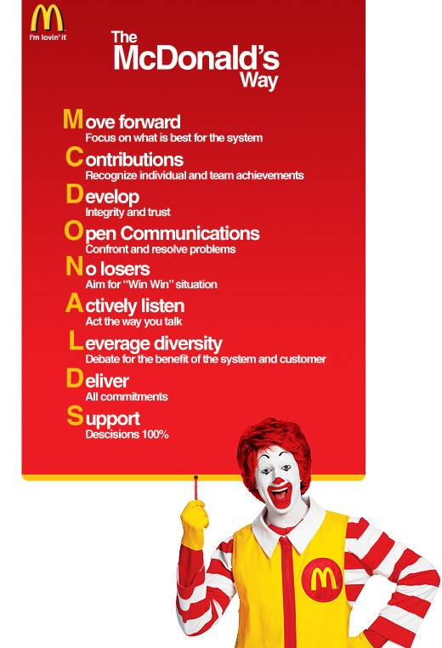
CUSTOMER ANALYSIS:

- SEGMENTATION:

The customers of McDonald’s have been segmented on the basis of AIOD into four categories, based on the product attributes that fulfill needs like ‘fast’ food, ambience, status
symbol and hygiene.

 |  | Activities | Interests | Opinions | Demographics
1 | “Fast”  food | Student,  Working,  Adventorous,  Energetic | Sports, Entertainment, fashion, music, Recreation | Influenced by peer pressure, Energetic, Impulse buying | Age: 16-24  years old.  Marital status:  Single; Heavy  users
2 | Ambience | Student,  working/selfmade  businessmen;  working on  projects. | Entertainment, Recreation, Fashion,  Music,  Socialization. | Ambitious,  Future  business and  social issues,  Politics. | Age: 20-35 yrs  old. Marital  status: Single  and Married.  Light to  medium users.
3 | Status  Symbol | Student,  working;  Hanging out,  Adventurous. | Sports,  Entertainment  , Fashion,  Music,  Recreation. | Energetic,  Impulse  buying,  influenced by  peer pressure. | Age: 16-25 yrs  old. Marital  status: Single;  light to medium  users
4 | Hygiene | Working  women/men,  house-wives;  Shopping,  Club  memberships. | Home,  Recreation,  shopping,  Fashion, | Planned  purchasing,  Authoritarian, Strong views,  Politics,Future business and  Social issues. | Age: 25-45 yrs  old; Marital  status: Newly  married, Full  Nest; Light  users

1) “FAST” FOOD:
This segment of customers enjoys the Quick Service Restaurant (QSR) facet of McDonald’s and has its needs fulfilled. Since McDonald’s competes rigorously in the market on the quick delivery attribute, the customers expect their food to be delivered to them fast, both at the outlet, and at home (home delivery). A large majority of this segment is composed of students whose activities are adventurous, enthusiastic, energetic, and recreational and revolve around sports, clubs, hangouts and shopping etc. This segment thus targets the market that indulges in impulse buying and is influenced by peer-pressure. These customers are heavy user of the product at hand. A minority of newly working people are also included in this segment.

2)AMBIENCE:
This segment enjoys the unique ambience provided by McDonald’s. Since the regular consumers of this product belong to the upper-middle class, they prefer having a meal with the level of customer service and a tinge of sophistication that the outlets provide. The customers of this segment are students as well as working class. These people enjoy recreation and socialization activities. They have strong views about the current affairs and the future business and social issues.

3)STATUS SYMBOL:
The people of this segment perceive the use of this product as a status symbol and basically comprise students and new-working class. These customers like being seen at the right places and like to associate and socialize with people of the same class. These customers are enthusiastic about entertainment, fashion, music and sports. They have fickle opinions and subject to change because of peer pressure. They follow fads and indulge in impulse buying.

4)HYGIENE:
This segment comprises people who are concerned with hygiene and how the food is prepared and served and also the cleanliness of the environment where they eat. It comprises of middle-aged people mostly housewives and working women/men. These are light users and make purchases once in a while, probably as a substitute rather than a first-choice. These people are
authoritarian, have strong views about politics, business and current affairs. They make planned purchases and weigh their options before they make a buying decision.

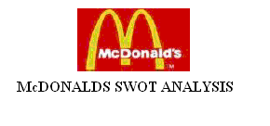

Strengths | Weaknesses
1)McDonald’s has a strong global presence with its nearest domestic competitor being only half its size, McDonald’s is the market leader in both the domestic and international markets. 2)McDonald’s benefit from cost reduction through economies of scale because of its enormous size and its huge global presence allows it to diversify risk involved with the economic performance of specific countries.  3)McDonald’s also has a strong real estate portfolio. The company’s outlets are located in areas that are highly known for visibility, traffic volume and ease of access.  4)McDonald’s also has exceptional brand recognition. This strong brand recognition creates significant opportunities for the company. 5)McDonald’s is able to generate more sales because of its brand recognition. Through aggressive market planning, McDonald’s has been able to recapture its youth market once again. | 1)The food industry is really saturated. As a result of this, McDonald’s has to deal with the prospect of looming market saturation, which could make it difficult to add new outlets.  2)There is also an increasing price competition driven by too many competitors, which reduces the company’s ability to increase revenue. Nevertheless, the swift of the company’s focus from a value menu to a more diverse one has recently limited the negative effect of the intense price competition that was traditionally taking place among the industry leaders.  3)Lack of product innovation is another weakness of McDonalds. The last break-through for McDonald’s was the Chicken McNugget in 1983, but again the company’s new strategy seems to have successfully dealt with the problem through the popularity of its new salads and other new products.

Oppurtunities | Threats
1)McDonald’s sold its Donatos Pizzeria back to its founder in 2003 and discontinued Boston market operations outside of the US.  2)To increase profitability the company has slowed its expansion of McDonald’s restaurants so as to refurbish and change the image of current restaurants and adding new features such as Internet access.  3)McDonald’s still has plans for more international expansion. McDonald’s still needs to penetrate in many countries especially in Europe, Asia and Latin America.  4)Changing trends in eating habits toward more health eating, seen as a threat to McDonalds can also be seen as an opportunity. McDonalds introduced new premium salads and Fruit n’ Yogurt Parfaits in the US which lead to growth in 2004 and the same products will probably bring some more growth in foreign markets. | 1)McDonald’s is exposed to changes in the global economy. The company’s aggressive international expansion has left it extremely vulnerable to other countries economic slowdown.  2)Foreign currency fluctuation is also another problem global companies like McDonalds.  3)The Fast food industry is becoming an increasingly competitive sector. McDonald’s keeps up with competitors through expensive promotional campaigns which leads to limited margins to gain market share. 4)McDonald’s is attempting to differentiate itself, with new formats and new menu items, but other fast food industry are doing the same too. McDonald’s, just like other fast food industry, often receives bad press because of its link obesity.  Top international Competitors for McDonald’s include: Yum! Brands, Inc, Wendy’s International, Inc., and Burger King Corporation.

Evaluation of Benefits and Limitations:

Benefits | Limitations
1) McDonalds is relatively inexpensive when compared to the ratio of cost against the reach of the other fast foods. It can reach wide Customers for a small fraction of traditional advertising budgets. The Service of the company allows customers to Choose and purchase Food and services at their own convenience. Therefore, McDonalds have the advantage of appealing to consumers in a medium that can bring results quickly. The marketing strategy of McDonalds is not under recession to be panic and can develop the strategic options for the company.  2) McDonalds also have the advantage of measuring the statistics easily and inexpensively. Nearly all aspects of its marketing strategy can be traced, measured, and tested. It is not under the position to advertise to build it market it is under the peoples mind and have a good priority for McDonalds. Therefore, customers can determine which service or offerings are more appealing to the audience. The results of marketing strategy can be measured and tracked immediately because the measurements of the performance of the employees are tracked for customer needs. Such measurement cannot be achieved through any advertising.  3) McDonalds marketing strategies directly impact food purchasing and eating habits. For example, in the late 1970s scientists announced a possible link between eating a high-fiber diet and a reduced risk of cancer. In 1984 advertisements claiming a relationship between high-fiber diets and protection against cancer appeared, and by 1987 approximately 2 million households had begun eating high-fiber cereal. Since then, other health claims, supported by scientific studies, have influenced consumers to decrease consumption of foods high in saturated fat and to increase consumption of fruits, vegetables, skim milk, poultry, and fish.  McDonald's has dubbed its new marketing effort "Rolling Energy." The effort was designed to focus on increasing credibility with consumers at a time when people are becoming more interested in taking an active role in their diets. | From the Customers perspective, the inability of shoppers to touch, smell, taste or "try on" tangible goods before making a purchase can be limiting. However, there is an industry standard for Customers to reassure by having liberal return policies as well as providing in-store pick-up services. Insufficient ability to measure impact, lack of internal capability, and difficulty convincing senior management.  In response to public pressure, McDonald's has sought to include more healthy choices in its menu and has introduced a new slogan to its recruitment posters: "Not bad for a McJob". (The word McJob, first attested in the mid-1980s and later popularized by Canadian novelist Douglas Coupland in his book Generation X, has become a buzz word for low-paid, unskilled work with few prospects or benefits and little security.) McDonald's disputes the idea that its restaurant jobs have no prospects, noting that its CEO, Jim Skinner, started working at the company as a regular restaurant employee, and that 20 of its top 50 managers began work as regular crew members. In 2007, the company launched an advertising campaign with the slogan "Would you like a career with that?" on Irish television, outlining that their jobs have many prospects.  In a bid to tap into growing consumer interest in the provenance of food, the fast-food chain recently switched its supplier of both coffee beans and milk. McDonald's coffee is now brewed from beans taken from stocks that have been certified by the Rainforest Alliance, a conservation group. Similarly, milk supplies used for its hot drinks and milkshakes have been switched to organic sources which could account for 5% of the UK's organic milk output.  McDonald's announced on May 22, 2008 that, in the U.S. and Canada, it will be introducing cooking oil for its French fries that contains no trans fats. The company will use canola-based oil with corn and soy oils by year's end for its baked items, pies and cookies.
Competitors Analysis :

McDonald’s has been a leading fast-foods outlet. But the outlet understudy has other competitors
eating away into its market share. In addition to its traditional rivals—KFC, Pizza Hut—the firm encounters new challenges. On the higher end, the KFC has become potent competitor in the quick service field, taking away customers from McDonald’s. Perhaps in the new environment, fast, convenient service is no longer enough to distinguish the firm. At this time, a new critical success factor may be emerging: the need to create a rich, satisfying experience for consumers. This brings us to service and experience based competition which McDonald’s can use for competitive advantage. Keeping in mind the demographics of the area, McDonald’s has Wi-Fi enabled the outlet to cater to the student community. It is for this overall “Food, Fun & Folks” experience that customers pay a premium over the other competitors. Competition also reduces product lifecycle; inducing firms to revise their products portfolios and to revisit their product market to understand changing needs, expectations and perception of different market segments. The new McBreakfast would be introduced between 6 to 11 am as a pilot project. This would open up a whole new revenue stream for McDonald’s by tapping into the student and working population by providing a healthy and wholesome breakfast. This shows how demographic shift can affect the demand for products and services. McDonald’s has anticipated these changes to maintain its competitive edge.

Two Dimensional Perceptual Mapping:

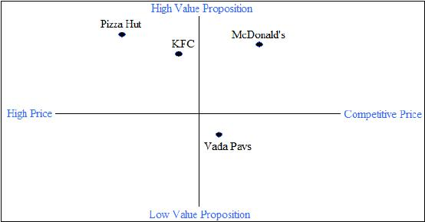

Research Methodology:

TITLE OF THE STUDY
A study of the Marketing Strategies of McDonalds with special reference to Indore.

OBJECTIVE OF THE RESEARCH
The basic objective of this project is to perform a thorough market analysis of McDonalds along with a detailed analysis of its marketing strategies with special reference to indore. The analysis incorporates – market segmentation, company analysis, competitor analysis, market analysis, corporate strategies and our recommendations...

PROBLEM STATEMENT
There has been a drop in the percentage of consumers in Indore where McDonald’s had
penetration for its products. This study is intended to find out the factors that influence the buying decision of the consumers of McDonald’s products.

SCOPE OF THE STUDY
The scope of the study is limited solely to the markets visited by the researcher for the
purpose of research. This may hence not be a total reflection of the whole population of McD’s consumers.

SOURCES OF DATA
- Primary sources: The primary data was collected through questionnaires. They were filled using the scheduled method of data collection by the researcher.
- Secondary sources: The secondary sources were used only for collecting information regarding the sample, they were however not used for analysis.
- In- Depth interviews: IDIs were conducted across 8 people. 4 of these were students from the GSIMR campus and 4 were executive class. The purpose of these interviews was to understand the consumer, to know their buying processes and to know what the users considered as important.
- Focused group discussion: A FGD of 5 people was conducted. It consisted of youngsters between the ages of 20-26 with 3 males and 2 females. The objective of the discussion was to understand the attributes that the consumers of McDonald’s products values and to know their perceptions about various brands.

LIMITATIONS OF THE RESEARCH

The limitations of the research were as follows:
- Lack of proper experience on the part of the researcher in conducting such studies in the past.
- The time period for carrying out the research was short as a result of which many facts have been left unexplored.
- The area for study which is quite a large area to judge out the consumer preferences
- Only 100 respondents have been chosen which is a small number to represent the whole of the population.
- While collection of the data many consumers were unwilling to fill the questionnaire.
- Many of the respondents did not fill the questionnaire completely because of which the sample size got reduced to 80.
- Method of sampling is chosen which seems not to be appropriate.

Analysis

The data was collected from within the campus and outside the campus. Around 100 responses were collected in all. Some of the responses were not complete and in all 80 responses –70 offline through questionnaire and 10 online were selected.

Tools Utilized

- Percentage Analysis
- Graph Chart
- Pie charts

DATA ANALYSIS & INTERPRETATION:

- What is your Gender ? Male/Female

- Which age group are you from ?
- 15-19 b) 20-24 c) 25-29 d) 30-34 e) 35-39 f) 40+

- Is McDonalds your favourite fast food chain ? Yes/No

- What is the reason for your answer to question no. 3 ?
a)Price b)Accessibility c)Food Quality d)Advertisement
e)Atmosphere f)Ethical Issues

5. Do you think McDonalds Operates ethically in your Country ? Yes/No
6. What is the reason for your answer to question no. 5 ?
a)Healthier Menu b)Actions to protect the Environment c)Considering Social Issues of the Community d)Better Advertisement

7. How often do you enjoy the catering service in McDonald’s?
a)Never b)Once or twice a week c)3 -4 times a week d)5 times or more than 5 times a week

For the following questions give nos. from 1 to 5.
1-poor 2-ok 3-average 4-good 5-excellent

8. How do you evaluate McDonald’s service in general?

9. Do you like the smell inside McDonald’s?
10. Do you enjoy the music inside McDonald’s?
11. Do you enjoy the decoration of McDonald’s branches in general?

12. Do you like the design of facilities inside McDonald’s? For example, chairs, tables.

13. Do you find you spend more time in CCD’s or Pizza Hut than in general McDonalds?
14. Do you think the hygienic environment of McDonald is acceptable?
15. Do you think the food of McDonald’s is delicious?
16. Do you consider the food of McDonald’s as healthy food?
17. Do you think McDonald’s provide a variety of food?
18. Do you think the size of McDonald’s food is acceptable?
19. Do you think McDonald’s provide a sufficient variety of food to vegetarians?

20. Do you think the general price level of McDonald’s service is acceptable?
21. Do you think the price reflects the quality of food?
22. Do you think the speed of food preparation is efficient?
23. Do you think the logo of McDonald’s is sharp enough for you to recognize the location of the branch?
24. Have you heard about McDonald’s FUN CLUB?
25. Will you try the new product within 1 week after the latest advertisement released?

26. Do you collect Happy Meal’s toys?

Recommendations:

Product & Market Strategy
To become a more desirable employer McDonalds should aim to provide better working conditions, allow the existence of unions, and increase the number of training schemes. Also, McDonalds’ workforce has a high share of teenagers, although there is no requirement for employees to be of this age. McDonalds benefits from this by paying only the minimum wage but this could be seen as exploitation. However, it is a good way of keeping labour costs down.

There are constant and ongoing social changes in the population. Examples include the increased health-awareness of society. In the long term, major menu diversification to accommodate more healthy foods could be regarded as necessary if they want their customers to enjoy their food with a clear conscience.
The fact that McDonald’s will start to sell fresh fruit with the established Happy Meal is a first step towards a menu more suitable to the changed environment.

Ethical Stance
The latest issue that McDonalds has faced is its US Chicken supplier importing illegal workers. McDonalds should have learnt from their mistake in China, where children as young as 14 have been working 16 hour days for as little as $3. And even in western countries MCD prefers to employ teenagers to benefit by paying them only the minimum wage although young age is not a requirement for this job. On the one hand McDonald’s receives Government money for educating young people, on the other it encourages the industry to design kitchen equipment that affords less training. McDonald’s should rather concentrate to provide a valuable skill for their people. This shows that there is still a big gap that needs to be filled by McDonalds as far as educating suppliers, and the number of visits and checks that are made. One way of reducing the gap between McDonalds’ animal welfare goal and its actual achievement is by working with other companies in its industry (i.e. Burger King) helping to increase the humane treatment of animals and by ensuring their suppliers take up their ethical responsibility. Eventual gaps in McDonalds ethical stance are usually covered by positive advertising. The recent advertising campaign ‘What comes first the chicken or the egg’ helps to illustrate this.
Claiming to be the best employer their anti union policy rather suggests a limited influence for employees to improve their working conditions. Unions are part of a modern society and McDonald’s should consider introducing unions.

Environmental Policies
It can be argued that as an organisation, McDonalds is comprehensively environmentally friendly and does reach most of the stated aims and objectives. The aim in terms of ‘encouraging environmental values and practices’ needs to be addressed more clearly to employees and managers alike as opposed to the specialised McDonalds Environmental Management System so that all employees of this organisation are aware of its environmental duties. Applying this correctly will help the company to improve on environmental friendliness. Also, there needs to be a way of quantifying all necessary environmental data in order to ensure that all employees are accepting an environmental responsibility.

Finally, McDonalds as an environmental conscious organisation also believes in asking the right questions, challenging themselves, their system and their partners. Having looked at the environmental policy of McDonalds it can be concluded that as an organisation it can be classed as socially contributive. This essentially means that McDonalds wishes to be socially constructive in the community it serves to help protect the natural environment. Recycling is a core part of their policies and helps to avoid any unethical business actions.

Financial Performance
McDonald’s hopes to close these gaps by a ‘heightened focus on restaurant level execution and marketing’. It can be argued that a reduction in significant item costs and an improvement in worldwide economic conditions will both also help to close the gaps. Jim Cantalupo, the Chairman and Chief Executive,2003, believes that McDonald’s priorities are ‘to fix the existing business, to take a more integrated and focused approach to growth, and to ensure McDonald’s has the right organisational structure and resources’. He anticipates that earnings per share growth will be somewhere between 10 and 15%. The key to McDonald’s success will be a continuation of their product consistency, better location choices and improved retail business model execution, particularly with regard to the training of employees.

Conclusion:

No particular competitive strategy is guaranteed to achieve success at all times. Risk attitudes can change and vary by industry volatility and environmental uncertainty and several internal conditions also might be involved. Thus the “four P’s” of marketing (product, price, place and promotion) provide a good starting point for consideration of the requirements of strategy implementation in the marketing function. The mix of these marketing elements should be appropriate and the plans for each of the elements should also be appropriate.

The marketing function is consumer oriented and hence marketing decisions are based on the careful identification of consumer needs and on the design of marketing strategies to meet those needs. The distribution system brings the product or service to the place where in can best fill customer needs. Access to distribution can mean all the differences between success and failure for a new product. Because many products require support from distribution channels in the form of prompt service, rapid order processing etc the choice of distributors, wholesalers and jobbers is extremely important.

Promotion is more than advertising. The location, size and nature of markets which the business strategy defines will guide promotion mix decisions and should indicate the content of promotional material as well. Pricing is a complex issue because it is related to cost, volume, trade offs etc and because it is frequently used as a competitive weapon. Pricing policy changes are likely to provoke competitor response. Using price to jockey for position can lead to price wars, which usually hurt all participants.

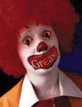

APPENDIX-1

A Typical McDonalds Flowchart

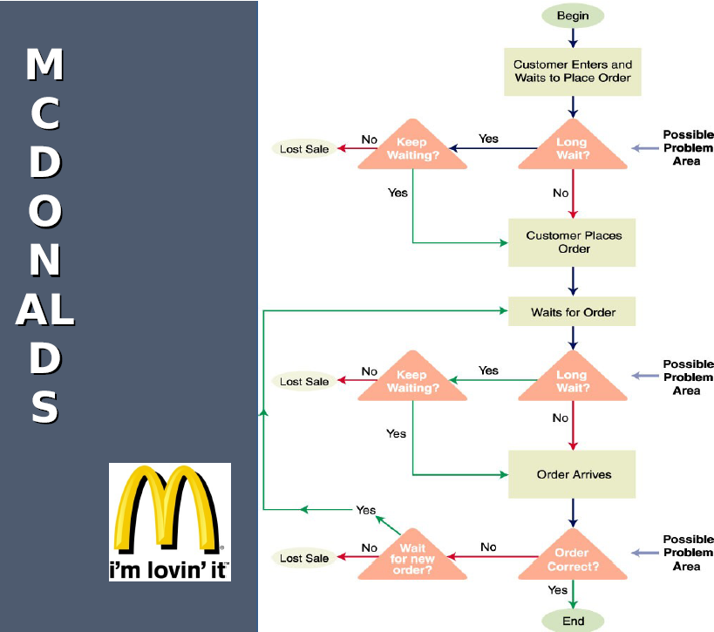
APPENDIX-II

McDONALD’S Global Locations

- Argentina  - Aruba  - Australia  - Austria  - Azerbaijan  - Bahamas  - Bahrain  - Bangladesh  - Barbados  - Belgium  - Bermuda  - Botswana  - Brazil  - Bulgaria  - Canada  - Cayman Islands  - Chile  - People's Republic of China  - Hong Kong  - Macau  - Colombia  - Costa Rica  - Croatia  - Cyprus  - Czech Republic  - Denmark  - Dominica | - Dominican Republic  - Ecuador  - Egypt  - El Salvador  - Estonia  - Fiji  - Finland  - France  - Georgia  - Germany  - Greece  - Grenada  - Guatemala  - Guyana  - Honduras  - Hungary  - Iceland  - Italy  - India  - Indonesia  - Ireland  - Israel  - Jamaica  - Japan  - Jordan  - Kuwait | - Latvia  - Lebanon  - Lithuania  - Malaysia  - Malta  - Mauritius  - Mexico  - Moldova  - Morocco  - Netherlands  - New Zealand  - Nicaragua  - Oman  - Pakistan  - Panama  - Peru  - Paraguay  - Philippines  - Poland  - Portugal  - Qatar  - Romania  - Russia  - Saint Lucia  - Saudi Arabia  - Serbia | - Singapore  - Slovakia  - Slovenia  - South Africa  - South Korea  - Spain  - Sri Lanka  - Sweden  - Switzerland  - Syria  - Taiwan  - Thailand  - Trinidad and Tobago  - Turkey  - Ukraine  - United Arab Emirates  - United Kingdom  - United States  - Guam  - Puerto Rico  - United States Virgin Islands  - Uruguay  - Venezuela  - Yemen

APPENDIX-III
Consumer Survey Form
I am undergoing my Research Project and this project is being conducted in lieu of partial fulfillment of 2nd semester for the degree of MBA and means no business.

1. What is your Gender ?
 | Male |  | Female

2. Which age group are you from ?
 | 15-19 |  | 20-24 |  | 25-29 |  | 30-34 |  | 35-39 |  | 40+

3. Is McDonalds your favourite fast food chain ?
 | Yes |  | No

4. What is the reason for your answer to question no. 3 ?
 | Price |  | Accessibility
 | Food Quality |  | Advertisement
 | Atmosphere |  | Ethical Issues

5. Do you think McDonalds Operates ethically in your Country ?
 | Yes |  | No

6. What is the reason for your answer to question no. 5 ?
Healthier Menu
Actions to protect the Environment
Considering Social Issues of the Community
Better Advertisement

7. | How often do you enjoy the catering service in McDonald’s?
7.
  Never
  Once or twice a week
  3 -4 times a week
  5 times or more than 5 times a week
 |  | 1( Totally Disagree) | 2 | 3 | 4 | 5(Totally Agree)
8 | How do you evaluate McDonald’s service in general?
9 | Do you like the smell inside McDonald’s?
10 | Do you enjoy the music inside McDonald’s?
11 | Do you enjoy the decoration of McDonald’s branches in general?
12 | Do you like the design of facilities inside McDonald’s? For example, chairs, tables.
13 | Do you find you spend more time in CCD’s or Pizza Hut than in general McDonalds?
14 | Do you think the hygienic environment of McDonald is acceptable?
15 | Do you think the food of McDonald’s is delicious?
16 | Do you consider the food of McDonald’s as healthy food?
17 | Do you think McDonald’s provide a variety of food?
18 | Do you think the size of McDonald’s food is acceptable?
19 | Do you think McDonald’s provide a sufficient variety of food to vegetarians?
20 | Do you think the general price level of McDonald’s service is acceptable?
21 | Do you think the price reflects the quality of food?
22 | Do you think the speed of food preparation is efficient?
23 | Do you think the logo of McDonald’s is sharp enough for you to recognize the location of the branch?

24 |  | Have you heard about McDonald’s FUN CLUB?
   | Yes |  | No
25 |  | Will you try the new product within 1 week after the latest advertisement released?
   | Yes |  | No
26 |  | Do you collect Happy Meal’s toys?
   | Yes |  | No

Thank you for your kind cooperation, valuable inputs and time.

A Survey done by:

Sreejit Kaimal
M.B.A.(2nd Sem.)
GSIMR,Indore(M.P)

BIBLIOGRAPHY:

http://www.mcdonalds.com
http://www.mcdonalds.com/investor
http://www.mcdonaldsindia.com
http://www.corpwatch.org

McDonald's application of marketing mix. Retrieved on January 20, 2005, from http://www.bized.ac.uk/compfact/mcdonalds/mc25.htm.

http://www.kaizencoaching.com.au/articles/basics_marketing_PLC.htm.
http://en.wikipedia.org/wiki/McDonald's
http://www.scribd.com/doc/11520753/Marketing-strategies-of-McDonalds

