Certificate of Completion of Internship Program

This is to certify that Mr. _ _ _ Sreejit Kaimal _ _ _ has successfully completed

Summer Internship Programme in _ _ _ _Godrej & Boyce Mfg Co. LTD._ _ _ _

for a duration of _ _ 45_ _ _ days under the supervision of _ _ _ _ _ _ _ _ _ _

_ _Mr. CHANDRESH MALVIYA _ _ _ , _ _ Asst. Manager, Prima Division_ _ _
(Name of the Company Guide) (Designation of the Company Guide)

_ _ _ _ _ _ _ _ _ _ _ _ _ _ _ _ _ _ _

(Mr. Chandresh Malviya)

(Company Guide)

ACKNOWLEDGEMENT

“I have searched for the definition of success, in the context of leading a successful life. It turns out that there are as many definitions as there are seekers and that success lies as much in the attempt as in the achievement.” - Robert Frost

“Feeling gratitude and not expressing it is like wrapping a present and not giving it.” - William Arthur Ward

First and foremost, I Thank the Almighty God for sustaining the enthusiasm with which I plunged into this endeavor.

I avail this Opportunity to express my profound sense of sincere and deep gratitude to many people who are responsible for the knowledge and experience I have gained during the Project Work.

I have great pleasure in expressing my deep sense of gratitude to guide
Mr. SUDIP (HEAD, PRIMA DIVISION) GODREJ for his valuable and prompt guidance without which this project would not have been a successful one. I extend My overwhelming gratitude to MR. CHANDRESH MALVIYA,(ASST. MANAGER, PRIMA DIVISION) GODREJ for his valuable guidance and meticulous supervision during the preparation of this Project Report.

My hearty and inevitable thanks to all the respondents who helped me to bring out the project in a successful manner. Last but not the least I extend my gratitude towards my parents, faculties and friends who extended their whole hearted support towards the successful completion of this Project Work.

SREEJIT KAIMAL

SYNOPSIS

The SIP titled,
To study The Market Share of Godrej in providing Conferencing Solutions with other Companies in BHOPAL’.

The main objective of the study was to know how the of Godrej sale perceive in Bhopal City. Customers are satisfied with the services provided by Godrej and also to identify the factors affecting the preferences of the customers.

The other objective of this report is to know the needs and wants, buying behavior of the customers toward their products. As a part of my study I covered most of the Area in Govindpura Industrial area. There are 50 Dealers which are surveyed by me in a given time of period of 45 Days. The sampling technique used for this study was simple random sampling and the sample size was 50.

The tool which I used to analysis the data was simple average method and the data’s where put in tabular form as well as in chart form also. In that manner we prepared a questionnaire of 17 questions which reflects all the aspects of our report.

Executive Summary

The project deals with finding out the demand and trend of Godrej’s Conferencing solutions in Bhopal. The project was limited to corporate offices only. The project focused in answering 6 basic questions.

- Overall demand of Conferencing solutions.
- Godrej’s current market share in this segment.
- Strengths and weakness of Godrej Conferencing solutions.
- Resolve, what factors Godrej Prima division needs to ponder on to increase its market share.
- Analysis of competitors strengths and weakness.
- Recommend Godrej Prima Division based on the above.

This all was done by collecting data over respondent companies. Each company
official was served with a questionnaire. The responses of those were stored into excel spreadsheet and then coded into numerical format for analysis.
Based on the responses for each question a finding series was prepared. This further went into deciding conclusions over material facts and ultimately producing the report with recommendations

.
While in the field survey a total of 50 respondents answered to the questionnaire.
Major results were like this-

1. Most of the consumers procured their conferencing requirements by outsourcing. Yet a substantial part of market remains untouched by the branded players.

2. Godrej was averagely ranked between 3 & 4 on a 5 point scale. Which means that consumers had a goon notion about the company

3. The factor analysis table resolved that people were greatly unsatisfied with
Godrej Conferencing solutions Pricing and Delivery schedule. These two factors must be taken care of.

4. The greatest of godrej was its Quality followed by its Brand name. Yet it was
found that Godrej Prima division was unable to completely exploit the Brand name. Godrej recently in 2008 had unveiled its new colorful logo with the motto to target the youth. Prima division must extensively try to exploit that brand value.

5. The advantage of having one of the most innovative products like in
Godrej’s basket has been nil. People were absolutely unaware of the series and its distinguished features.

6. A large part of market was not in mood to spend any more in conferencing products in this slowdown market. So there might not be good business prospects ahead

7. Godrej has not properly utilized its website. Infact Godrej Prima need its own
website. All other branded competitor operate their websites. Also since this is
particularly a B2B segment, online marketing is the best tool.

These were major findings of the research. Implementation of recommendations will solely rest with Godrej. All the above mentioned agendas have been deliberately explained in the report ahead.

TABLE OF CONTENTS

S.No. | CONTENTS | Page No.
1. | Executive Summary | 6
2. | Company Profile | 9
3. | Mission and vision statement | 18
5. | Introduction to the project | 24
6. | Prima Conferencing Solutions | 27
7. | Products | 28
8. | Research Methodology | 33
12. | Data Analysis and Interpretation | 40
13. | Observations and findings | 49
14. | Recommendations and Conclusion | 50
15. | Bibliography | 52
16. | Annexure | 53

Company Profile

 J. N. GODREJ

Chairman’s Message:-

“The corporate landscape is undergoing several sweeping changes and Indian companies across sectors have begun to pursue growth both within the country as well as overseas. Today, as India competes in an increasingly globalized economy, the Godrej Group is ready to play a major role in the Indian growth story”.

At Godrej, we have always successfully competed with MNCs in India and abroad and kept the spirit of enterprise alive. This has been possible for various important reasons. The Godrej name is synonymous with trust. It is a well-documented fact that ‘trust’ lowers transaction costs, corruption, and bureaucracy. Thus, ‘trust’ is a source of significant competitive advantage to us.

I firmly believe that our highest standards of corporate governance, modern management and use of cutting edge technology and long-term, performance-focused strategies will be the key drivers in future years.

GODREJ GROUP PROFILE

Started in 1897 as a locks manufacturing company, the Godrej Group is today one of the most accomplished and diversified business houses in India. Godrej's success has been driven by the company's commitment to delivering innovation and excellence. Through the consistent application of this commitment and a century of ethical business conduct, Godrej has earned an unparalleled reputation for trust and reliability. In 1930, Godrej became the first company in the world to develop the technology to manufacture soap with vegetable oils; that spirit of innovation has continued throughout the organization's history. Today Godrej is delivering consumers exciting innovations across a spectrum of businesses. The company's pursuit of excellence is equally well established and
enduring. In the 1944 Mumbai docks blast, Godrej safes were the only security equipment whose contents were unharmed; an equal level of product quality continues to be expected from every product bearing the Godrej brand name. Godrej management understands that the company's greatest asset is the trust and faith that consumers have reposed in it, and recognizes that the company must continue to earn this trust. This translates to the organization delivering outstanding quality and value in everything it does.

Godrej's ethical and visionary practices have allowed the company to successfully expand into a number of businesses. Today Godrej is a leading manufacturer of goods and provider of services in a multitude of categories: home appliances, consumer durables, consumer products, industrial products, and agri products to name a few. A recent estimate suggested that 350 million people across India use Godrej products. The group has more recently entered the real estate and information technology sectors, and management views these as avenues for enormous growth.

The Godrej Group stands in a strong position today. With annual sales in excess of $1 billion, a workforce of approximately 18,000, and a strong diversified portfolio, Godrej has proven its ability to deliver strong financial performance.

The Godrej Group

The Godrej Group has interests in a wide range of businesses. Apart from GCPL, the major Companies In the Group include:

Godrej & Boyce Manufacturing Co. Ltd. – a leading manufacturer of office and home Equipment including appliances, furniture, locks, security equipment, storage solutions and Industrial equipment

Godrej Industries Ltd. – a leading manufacturer of oleo chemicals that are used in more than two dozen industries. The Company also has a presence in the foods business.

Godrej Agro vet Ltd. – the market leader in animal feeds and innovative agri products in India. The Company also has a presence in the branded poultry, rural retailing and oil palm sectors.

Godrej International Ltd. – engaged in international trading.

Godrej Sara Lee Ltd. – a joint venture with Sara Lee Corporation, USA and a leading Manufacturer of household insecticides.

Geometric Ltd. – a specialist in Product Lifecycle management software solutions for the Mechanical design, manufacture and industrial markets.

Godrej Properties Ltd. - a leading developer of residential and commercial premises.

Godrej Hershey Ltd. – markets juices, fruit drinks, soya milk based drinks, edible oil and Packaged tea. In FY 2006, GBFL has acquired 100 percent stake in ‘Nutrine Confectionery Company Pvt. Ltd.’ (Nutrine). In April 2007, the company entered into a joint venture with the Hershey Company, North America’s leading chocolate and confectionery manufacturer, to Manufacture and distribute confectionery, snacks and beverages across India. Being part of the Godrej Group allows Godrej Consumer Products to draw upon the rich heritage and Experience of the Group.

In line with GCPL’s vision and long-term business objectives, all corporate Decisions are independently taken by the Company’s highly respected Board in conjunction with Competent management teams, keeping in view the best interest of all its stakeholders.

BUSINESS FACTS

Continuously expanding marketing and sales infrastructure
- GCPL possesses a well entrenched and established distribution network serviced by a highly motivated sales organization.
- Consistent focus on enhancing reach and presence especially in growing domestic rural regions as well as international markets.
- Sophisticated IT connectivity with distributors.
- Robust manufacturing and Supply Chain competencies.
- State of the art manufacturing facilities spread across the country.
- Factories strongly committed to TQM culture, adhering to International & Indian Standards and systems and following Good Manufacturing Practices (GMP).
- Sophisticated ERP systems across the business. Well-developed R&D capabilities.
- Focus on innovation and development of novel consumer centric products and processes.
- Energized and experienced teams.
- Strong focus on enhancing skills and competencies across functions through training.
- Young Executive Board comprising young managers formed as part of a Group initiative to Devise strategies and identify new opportunities Corporate Governance.
- Envisages attainment of the highest levels of transparency, accountability and equity in all Facets of its operations and in all its interactions with its stakeholders including shareholders, Employees, lenders and the Government.
- Committed to achieve and maintain the highest standards of Corporate Governance.
- Ensures that all its actions serve the underlying goal of enhancing overall stakeholder value over a sustained period of time.
- The Company continues to enjoy a corporate governance rating of CGR2+ (pronounced as CGR two plus) and Stakeholder Value Creation Rating of SVG1

BUSINESS DRIVERS, SUSTAINERS, ENABLERS

Godrej Consumer Products is a well entrenched, focused and growth oriented FMCG Company.

Key drivers
• Focus on completely understanding consumer requirements and behavior and
introduction of innovative new products
• Consistent focus on delivering Value for Money products
• Consistently augmenting domestic marketing and sales reach and distribution
• Globalization – introducing new product ranges, new variants and exploring new Geographies

Key sustainers
• Rich heritage and experience across identified segments
• Competent and experienced management team backed by committed executives and Workforce
• Cutting edge manufacturing and operating infrastructure.
• Well developed brands across both soap and personal care portfolios.

Key enablers
• Introduction of efficiency oriented measures like ‘EVA’ to encourage a result oriented Approach and reward correct decision-making.
• Focus on brand building.
• Cutting edge IT and systems infrastructure designed to optimize accounting,
Manufacturing, marketing and sales.
• Robust technology base and established systems and processes to ensure consistency in Quality.

Milestones:-



Ardeshir Godrej (1868-1936) was the first Indian manufacturer to displace well entrenched foreign brands from the market. The word GODREJ, etched into the metal of his locks, became a symbol of self-reliance for the generations that followed.

With each new product Ardeshir changed perceptions of industry in India. He produced the first finest security equipment, and stunned the world by creating soap from vegetable oils. What started as a dream had become a movement, but it was left to another man to carry it forward.

On 7th May, 1897, Ardershir Godrej gave up law and took up lock making. Godrej and Boyce Mfg. Co. Ltd., was established at Lalbaug, Mumbai. This was the holding company of the Godrej Group. On 3rd March, 1932, it was incorporated with limited liability. Even though Boyce was a business partner for a limited period only, his name was retained for legal purposes.

The Godrej Name displaced well established foreign brands from the Indian market. The name 'Godrej' engraved into the shiny metal of the Godrej Locks came to be known as a symbol of self reliance, trust-worthiness, assertiveness and progressiveness for a new generation of Indians.

Ardeshir Godrej's relentless quest of self-reliance made him explore newer avenues of opportunities. Manufacturing Soap was one of them. In the year 1918, Godrej Soaps Limited came into being. In 1920, he revolutionized the Soap industry by manufacturing the first toilet soap purely from vegetable oils. Before that, animal fat was used in soap manufacture. For his achievement, Ardeshir Godrej was bestowed with praises from India and from foreign lands too.

Consumer electronics milestones

1958 -1st Indian Company to manufacture Refrigerators.
1987 - Pioneered PUF (Polyurethane Foam) Technology in India.
1989 - First company to introduce PUF (Polyurethane Foam)
1989 - Introduces India's first and only 100% CFC, HCFC, HFC free refrigerators
1989 - First company to sell 10 million appliances
1994 - 1st Company in India to sell 10 million appliances.
1995 - Obtains ISO 9001 Certification
1996 - Launches Washing Machines by commissioning a new manufacturing set- up at Shirwal - State-of-art Manufacturing Plant starts operation at Mohali.
1997 - Launches Air Conditioners - Obtains ISO 14001 certification.
2000 - First Durable Company in India to launch Branded Customer Service -
SMARTCARE
2001 - Launches Pentacool Refrigerators with Revolutionary Five Side Cooling.
2002 - 1st and only Company in India to make its Entire Refrigerator Range Green (100% CFC, HCFC & HFC free).
2004 - Godrej Refrigerator awarded the Super Brand Status. Declared No. 1 in
Businessworld Consumer Delight Survey.
2005 - Launches Microwave Ovens and DVD players. Declared the Most Preferred Brand in CNBC Awaaz Consumer Awards.
2006 - Launches Eon Refrigerators with Cool Shower Technology that are adjudged the Best Design in Consumer Durables Category at Businessworld NID Design Awards.
- 1st Company in India to introduce Steam Microwave Oven.
- Declared the Most Trusted Refrigerator Brand in India by Reader’s Digest.
2007 - Godrej Refrigerators win ‘Trusted Brand – Gold’ award for the second consecutive year from Readers Digest consumer survey
- Godrej Refrigerators adjudged ‘Most Preferred Brand’ award for the third
consecutive year as per the CNBC Consumer Awaaz Survey

Corporate Timeline:-

- 1897 - Godrej & Boyce Mfg. Co. Ltd. was established.

- 1918 - Godrej Soaps Limited was incorporated.

- 1971- Godrej Agrovet Limited began as an Animal Feeds division of Godrej Soaps.

- 1974 - Veg oils division in Wadala, Mumbai was acquired.

- 1990 - Godrej Properties Limited, another subsidiary, was established.

- 1991 - Foods business started. Godrej Agrovet Limited was incorporated.

- 1994 - Transelektra Domestic Products was acquired.

- 1995 - Transelektra forged a strategic alliance with Sara Lee USA.

- 1999 - Transelektra was named Godrej Sara Lee Limited.

- 2001 - Godrej Consumer Products was formed as a result of the demerger of Godrej Soaps Limited. Godrej Soaps was renamed Godrej Industries Limited.

- 2002 - Godrej Tea Limited was set up.

- 2003 - We entered the BPO solutions and services space with Godrej Global Solutions Limited.

- 2004 - Godrej HiCare Limited was set up to provide a Safe Healthy Environment to customers by providing professional pest management services.

- 2006 - The foods business was merged with Godrej Tea and Godrej Tea was renamed Godrej Beverages & Foods Limited.

- 2007 - Godrej Beverages & Foods Limited formed a JV with The Hershey Company of North America and the company was renamed Godrej Hershey Foods & Beverages Limited.

In April 2001, Godrej Industries was formed the consumer products division of Godrej Soaps Limited was de-merged to form Godrej Consumer Products Limited. In the same year, Godrej Soaps was renamed Godrej Industries Limited. Godrej Industries expanded its portfolio of products. It added a slew of investments to its associate companies, while re-in forcing its existing businesses that include oleo chemicals, veg oils and medical diagnostic equipments.

As they say no guts, no glory. But at Godrej, we must say it has been a glorious 106 years of being the face of Indian industry. We have always set the trends, always defined the market place and always achieved our glory. Here is a quick preview of the various milestones we have crossed in the past 106 years.

AWARDS AND HONOURS

- Godrej Consumer Products Limited ranks 9th in the Great Place to Work Survey for 2008.
- GCPL, the Highest Ranked Indian FMCG in Asia's Hot Growth Companies' List by Business Week.
- Godrej Consumer Products Ltd. has been ranked 14th in The Best Companies to Work For study. This study was jointly conducted by Business Today, Mercer and Taylor Nelson Sofres (TNS) .
- Godrej Consumer Products Ranks 6th in ET-Hewitt Best Employers of India survey .
- GCPL ranked 15th in Great Places to Work 2006 survey .
- The Corporate Citizen of the Year Award given by Economic Times.
- Flagship brands Good knight, Cinthol and Ezee selected Super brands by the Super brands Council.
- Godrej Sara Lee, the JV between the Godrej Group and Sara lee Corporation, USA is acknowledged the World's largest mat manufacturers and South Asia's largest manufacturers of Coils.
- Godrej Consumer Products Limited, adjudged as a Business Super brand by the Super Brands Council.
- The Return on Capital Employed and Return on Net Worth ratios of Godrej Consumer Products - the highest in corporate India.
- Godrej Consumer Products was awarded the "Best Managed Workforce" award given by Hewitt Associates and CNBC TV18.
- Godrej Consumer Products features in the Top 25 list of Great Places to Work (survey conducted by Grow Talent in association with Business World) for four years in a row.
- Lifetime Achievement Award for Godrej Industries from CHEMEXCIL, the Basic Chemicals Pharmaceuticals and Cosmetics Exports Promotion Council.

2006
  - Lalji Mehrotra Foundation Award for Excellence, conferred by National Society for Equal Opportunities for the Handicapped.
  - Great Son of India Award given to Sohrab Godrej by National Convention for Protection of India's Resources and Environment.
2005
- BNHS Green Governance Award for the Category - Conservation & Restoration of Habitat, awarded to Godrej & Boyce Mfg. Co. Ltd

2003
- Economic Times Corporate Excellence Award for Corporate Citizenship
1994
- Nisarga Mitra Award from Rotary Club of Bombay, Vikhroli for Environmental Conservation

1991
- Indira Gandhi Paryavaran Puraskar awarded to Sohrabji Godrej.

1989
- Institution of Economic Studies Lok Shree Award for Social Commitment
towards the society.

Mission & Vision:-

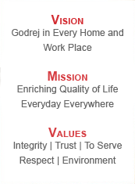

Mission:-

- Godrej Mission is to operate in existing and new businesses which capitalize on the Godrej brand and corporate image of reliability and integrity.

- Godrej objective is to delight our customer both in India and abroad.

- We shall achieve this objective through continuous improvement in quality, cost and customer service.
- We shall strive for excellence by nurturing, developing and empowering our employees and suppliers.

- We shall encourage an open atmosphere, conducive to learning and team work.

Values:-



- Commitment to Quality

- Customer Orientation

- Dedication & Commitment

- Discipline

- Honesty & Integrity

- Learning Organisation

- Openness & Transparency

- Respect/Care & Concern for People

- Teamwork

- Trust

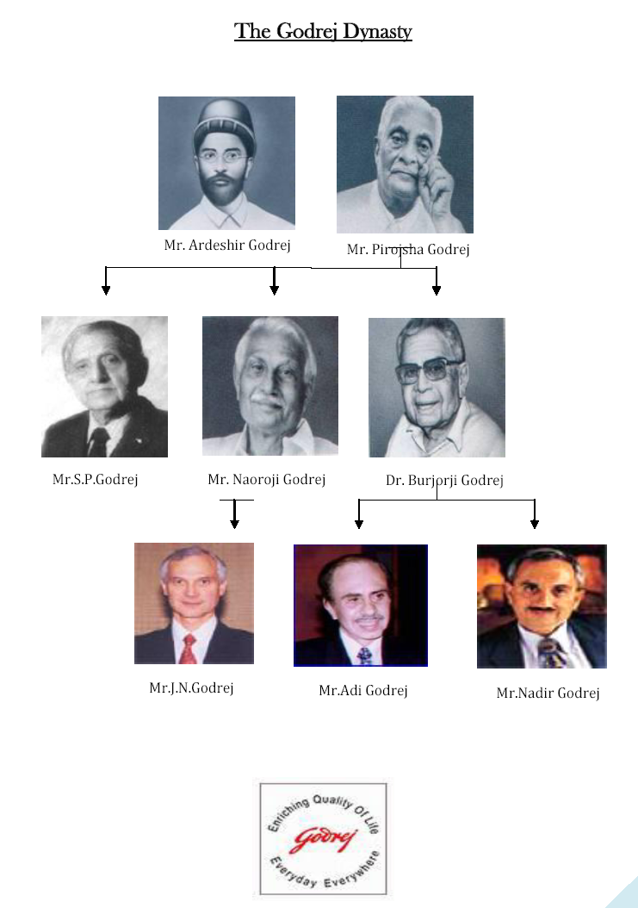

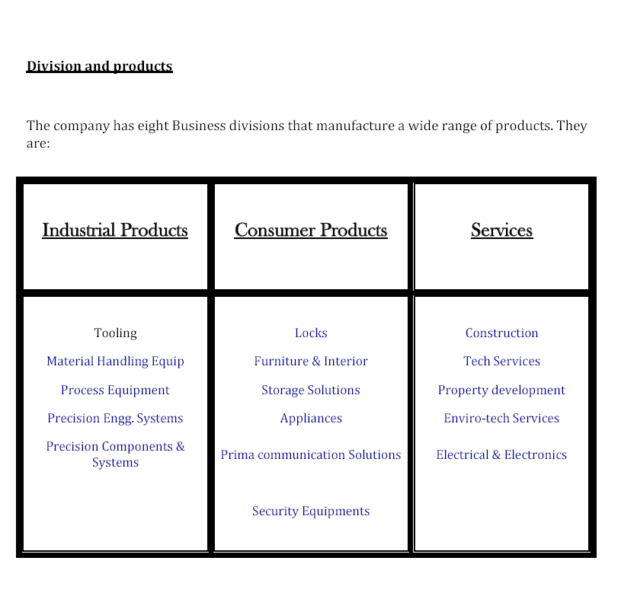

Location:-

GODREJ & Boyce Mfg.Co.Ltd
Registered Office, Head Office and Mumbai branch
Pirojshanagar, Vikhroli, Mumbai (400079), India

EAST
Kolkata, Bhubaneswar, Guwahati, Ranchi, Patna
WEST
Mumbai, Ahmedabad, Bhopal, Dombivli, Indore, Jabalpur, Pune, Raipur, Thane
NORTH
New Delhi, Chandigarh, Faridabad, Ghaziabad, Gurgoan, Jaipur, Jalandhar, Jammu, Kanpur, Lucknow, Noida
SOUTH
Chennai, Bangalore, Coimbatore, Hyderabad, Kochi, Secunderabad, Trivandrum, Visakhapatnam

12 Introduction to the Project

Description of project

The project has been assigned to me by Godrej & Boyce Mfg Co. ltd for my summer internship program with them. This project is a part of the Master in Business Administration (MBA) Program under DAVV University. The project entails finding out the demand of Godrej’s Conferencing solutions in offices around Bhopal region.

This demand analysis will be done with the help of a Business Research Questionnaire.The said Questionnaire will cover different attributes measurement techniques which will help me get responses from respondents which in turn will be then normalized using different Quantitative tools. Such normalized results will portray a clear picture of Current Consumer demand and will also help us know the changing business environment.

The project will help me develop Communication Skills, will enhance my marketing abilities, will give me a good exposure of market dynamics and will allow me to use the theory I have learnt so far.

Project Focus
The Conferencing Solutions of Godrej comes under Consumer products-Prima Division. My focus in this report will be to know the competition level and the competitive advantage of Godrej with the other conferencing solutions provider companies in BHOPAL CITY. This study is based on the selected area’s market share. For knowing the competition level and the advantage the objective is divided in to different segments.

Objectives of the Project

The primary objective of the study was:-
- To analyze the position of Godrej against its competitors.

The secondary objectives of the study was:-

- To know the dealers perceptions towards their sale of home appliances.
- To study and evaluate the various complaints of consumers on various aspects like after sales services, pricing, and quality.
- To know the customers needs and wants.
- To know that how many customers are satisfied or dissatisfied?
- To find the awareness among the customers about GODREJ and its new products.
- To find out the strength and weakness of product and its competitors
- To make suggestion, if any to improve existing condition.

Methodology

Step 1- Collection of data from market.
Step 2- Storage of the collected Data.
Step 3- Analysis of data collected so far.
Step 4- Preparation of project report.

Step 1 elaborate
The data collection process was done with the help of a well designed Questionnaire. The Questionnaire was designed taking considerations of
- Survey time
- Respondent willingness
- Project objective

The Questionnaire uses different types of Questions needed to conduct a research. I had used the following type of Questions-

- Lead in Questions.
- Qualifying Questions.
- Warm up Questions.
- Specific Questions.
- Demographic Questions.

The set of Warm up and Specific Questions uses different attitude measurement scales to capture the consumer responses. These attitude measurement scales assign numbers or symbols to some attributes of an object. Thus scaling involves developing a continuum based on which measured objects are located.
The questionnaire has been kept short so as to grip respondent’s interest and curtail biasness arising out of disinterest.
A copy of the Questionnaire has been attached with this report.
After the questionnaire is prepared the next part is how to get samples/ responses ?
Responses will be collected in the following manner-

Source- all responses will be collected from primary sources. In this case the primary sources will be the,
Facility managers / Project managers / Administrative managers.

Apart from the primary data, secondary data over the company’s past performances will be collected through company’s website, journals, editorials e.t.c.

Mode of communication – The managers are contacted personally either by visiting the office or over the phone. After that an appointment is fixed to have a tete-a-tete with the respective person.

Step 2 elaborate
The collected data was stored safely and intact so as to allow minimum deviation of results. While in interview process all data were scripted in a hand note book, which later on were transferred into excel sheets. Excel transformation helped best usage of quantitative tools to analyze data. Also tabular presentation in excel allows viewer a clear vies and better judgment.

As per the suggestions on my project guide the data was collected. This allowed me to collect data over a good number of samples. More will be
the number of samples, better will be the analysis.

Step 3 elaborate
The analysis part is purely done under guidance of my project guide and faculty guide. This analysis part entailed best usage of the data collected so far so as to produce best results. Different quantitative tools were used to calculate the median of responses. These were then normalized and with usage of various tools congeal attributes were defined. With focusing on such attributes the company can change their expansion plans accordingly and get a strong hold on its consumers.

Step 4 elaborate
Based on the findings of the analysis, the report is encrypted by me in an expressive and simple manner. Better presentations of results are as necessary as is the core task. More expressive is the presentation, more interested will be the readers in getting the essence of the project. This ultimately will serve the purpose of the project.

PRIMA CONFERENCING SOLUTIONS

There are 33 million business presentations everyday. Prima Communication Solutions system designers can make yours stand out

Godrej has been a name to reckon with for more than 105 years now. It is a name synonymous with trust and quality. We at Prima Division are a part of the Flagship Company- Godrej & Boyce Mfg. Co. Ltd. After gaining a rich experience in the Conferencing business for over a decade, our sales team is able to understand the needs and requirements of our customers and provide the most optimum solution for the same. Capitalizing on this ability of ours we have recently forayed into providing turnkey solutions for Conference Rooms Integration.

Our direct association with internationally acclaimed conferencing behemoths gives our customers complete confidence in the products we provide. We have international tie-ups like:-

- Tandberg for Video conferencing and video network.

- Polycom for Video & Audio Conferencing

- Panasonic and Benq for Projectors

- Panasonic for Plasma Displays

- Panasonic for Panaboards.

Godrej has a nation-wide sales and service support network comprising of technically sound workforce backed by complete training support from our principles.

PRODUCTS

1) Turnkey Conferencing Solutions

Brands: Creston

Godrej offer end to end turnkey conferencing solutions encompassing not only sourcing of right conferencing equipment but also providing Lighting control, Motorized curtains, Computers etc. and configuring them all to work together  seamlessly integrated through a Creston Touch Panel Control System ensuring hassle free plug and play operation.

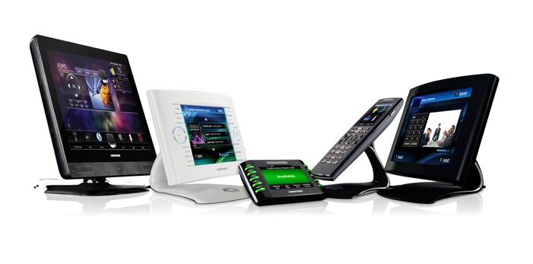
Perfect complement to a conference table, coffee table or night stand. No need to get up or walk across the room to a switch or keypad on the wall. Complete control is always at your fingertips. With several model s to choose from, select just the right size, design and features for any room, application or décor. Sizes range from a 3.6" FlipTop to a 17" widescreen, and many include built-in Web browsers, scalable video windows, speakers, microphone and electronic annotation.

2) PROJECTORS

Brands: Panasonic, BenQ

Generally, the display device used to produce an image is a projector. It should have an effective optical engine that delivers a good brightness level. The quality of the display would also depend on the screen on which the image is to be projected. Here the customer can choose from a motorized or a manual pull down screen. Switchers can be used to route multiple audio/video sources to multiple audio/video destinations. In other words, a switcher will enable multiple signals to be selected and send to one or more display device.

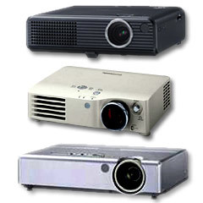
At first glance, portable digital projectors designed for the business market seem to have much in common with their home-theater counterparts. However, a closer look reveals some very significant differences, including weight, screen aspect, brightness, contrast, resolution and price. Digital projectors are also becoming an increasingly popular option for home theaters, and that's especially true of those capable of displaying widescreen high-definition TV signals in their full resolution.

LCD - liquid crystal display
An LCD projector works by passing a powerful light source through a transparent LCD chip made up of individual pixels and projecting that image through a lens to a large screen. 3 chips are often used to provide a color image.

DLP - Digital Light Processing (A Texas Instruments Technology). Like LCD, the actual image is displayed on a chip, however, the chip used in a DLP projector is different. The chip in a DLP projector is referred to as a DMD (Digital Micromirror Device). In essence, every pixel on a DMD chip is a reflective mirror.

3) PLASMA DISPLAY

Brands: Panasonic

Plasma TV displays and TFT flat panels are ideal when using video conferencing in boardrooms. Their ultra slim profile, stunning, video quality and image brightness make them perfectly suited to environments with high ambient light levels such as broadrooms with large windows.
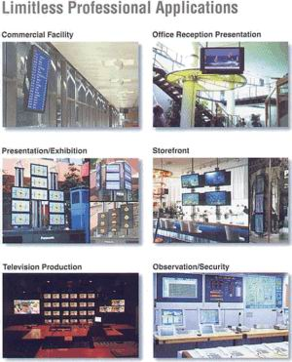

Flat panel displays encompass a growing number of technologies enabling video displays that are lighter and much thinner than traditional television and video displays that use cathode ray tubes, and are usually less than 100 mm (4 inches) thick. They can be divided into two general categories; volatile and static.

Volatile displays require pixels be periodically refreshed to retain their state, even for a static image. This refresh typically occurs many times a second. If this is not done, the pixels will gradually lose their coherent state, and the image will "fade" from the screen.
Static flat panel displays rely on materials whose color states are bistable. This means that the image they hold requires no energy to maintain, but instead requires energy to change. This results in a much more energy-efficient display, but with a tendency towards slow refresh rates which are undesirable in an interactive display.

4) INTERACTIVE WHITE BOARDS (Panaboards)

Brands: Panasonic

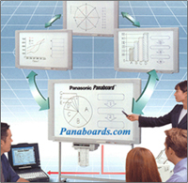
An interactive Whiteboard is a large, touch-sensitive panel that connects to a digital projector and a computer, displaying the information on the computer screen. It resembles a traditional White board and is used similarly. The computer connected to the interactive White board can be controlled by touching the board directly or by using a special pen. Such actions (inputs) are transmitted to the computer instead of using a mouse or keyboard.
With an interactive whiteboard you can easily access, display and control computer-based information during the meeting. The presenter can stand facing the audience, control the flow of the meeting and launch other programs, annotate and capture any changes that have been made. With the functionality of both whiteboards and flipcharts, interactive whiteboards are a powerful tool when brainstorming or problem solving.
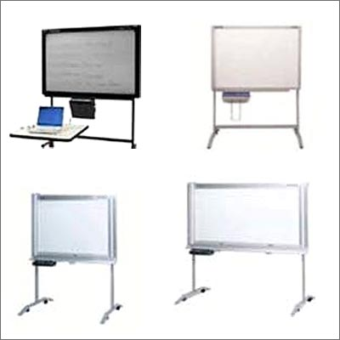
Panaboard comes with an integral printer for easy operation plain paper printing with multiple copies. Panaboard can also work as a PC printer. You can use it for seminars, meetings, brain storming, scheduling, training and copying charts and graphs.
They are used in a variety of settings such as in classrooms at all levels of education, in corporate board rooms and work groups, in training rooms for professional sports coaching, broadcasting studios and more.
5) AUDIO CONFERENCING

Brands: Polycom

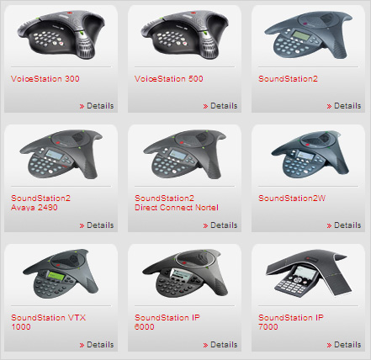
Businesses use conference calls daily to meet with remote parties, both internally and outside of their company. Common applications are client meetings or sales presentations, project meetings and updates, regular team meetings, training classes and communication to employees who work in different locations. Conference calling is viewed as a primary means of cutting travel costs and allowing workers to be more productive by not having to go out-of-office for meetings.
Conference calls are increasingly used in conjunction with web conferences, where presentations or documents are shared via the internet. This allows people on the call to view content such as corporate reports, sales figures and company data presented by one of the participants. The main benefit is that the presenter of the document can give clear explanations about details within the document, while others simultaneously view the presentation.
Conference calls are also beginning to cross over into the world of podcasting and social networking, which in turn fosters new kinds of interaction patterns. Live streaming or broadcasting of conference calls allows a larger audience access to the call without dialing in to a bridge. In addition, organizers of conference calls can publish a dial-in number alongside the audio stream, creating potential for audience members to dial in if and when they wish to interact.
6) VIDEO CONFERENCING
Brands: Polycom, Tandberg
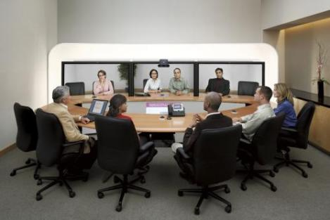
As the telecommunication networks mature they can provide an effective platform for working with colleagues, irrespective of location. The use of video conferencing for collaboration is currently the focus of much interest and development and many interesting new tools are appearing which make outline collaborative projective projects a realistic option for distributed workgroups.
To achieve successful business video conferencing, reliable and quality video conferencing system are a must. Having quality systems and equipment will ensure that there will be faster, more efficient, and hassle free communications with the parties involved during business video conferencing.
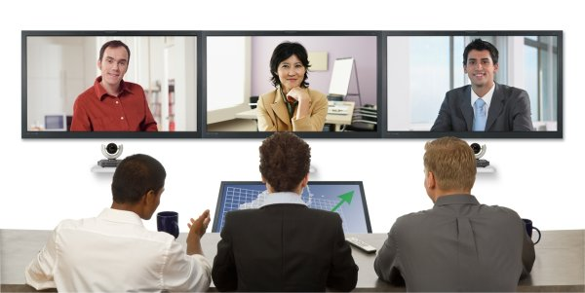
Videoconferencing can enable individuals in faraway places to have meetings on short notice. Time and money that used to be spent in travelling can be used to have short meetings. Technology such as VOIP can be used in conjunction with desktop videoconferencing to enable low-cost face-to-face business meetings without leaving the desk, especially for businesses with wide-spread offices. The technology is also used for telecommuting, in which employees work from home.
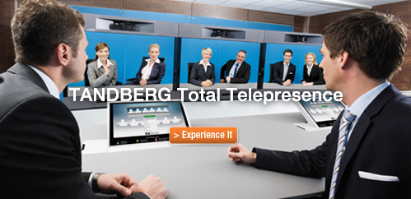
Videoconferencing is now being introduced to online networking websites, in order to help businesses form profitable relationships quickly and efficiently without leaving their place of work. This has been leveraged by banks to connect busy banking professionals with customer in various locations using video banking technology.
The considered use of different technologies couples with integrated control and environmental features, such as lighting design, will set the scene for a powerful and memorable presentation. It is then over to you to present your message using which ever of the facilities are appropriate for each meeting.

RESEARCH METHODOLOGY

The success of the analysis mostly depends on the methodology on which it is carried out. The appropriate methodology will improve the validity of the findings.

Area of the study:
The study was mainly concentrated on Bhopal city.

Research Design:
Descriptive Research: Descriptive research includes survey and fact-findings enquire of different kinds. The major purpose of descriptive research is description of the state affairs, as it exists at present.

Data Collection:
The study is based on the data collected through primary and secondary sources.

Primary Data:
An interview schedule was designed to collect primary data from various Industries.

Secondary Data:
Secondary data was collected from journals, magazines, web sites and from other relevant publications.

Sampling Design:
The sampling design mainly consists of the sample taken for the study along with
the sample size, sample frame and sampling method.

Sample Universe:
All Industries those who are in the selected area’s in BHOPAL were taken as the sample universe.

Sample Size:
From the universe, sample sizes of 50 companies were selected for the purpose of the study.

Sampling Method:
Convenience sampling was used, based on the willingness and availability of the
respondents. The study was conducted on industries with different type of brand business in same segment.

Research period:
The time for the project was limited to 45 days only, from this, 30 days was spent for the collection of data.

Design of the study:
The chapter briefly describes the design of the study to explain the objectives, scope of the study, methodology, sampling, field work and finally the limitations of the study.

STATEMENT OF PROBLEM
Today is the world of inventions and innovations and that lies in a customer who is dynamic and his beliefs, attitude and his satisfaction level. It is needless to affirm that marketing is a new way of thinking about how companies and other organization can develop beneficial change with target customer who is always inclined in seeking to satisfy some needs and wants. Hence the problem is how we can find more customers for what services we provide, how the company can live up to their expectations and understand the different aspects of customer’s views.

SCOPE OF STUDY
Today the Conferencing Industry is undergoing a revolution. Many types of branded companies are entering into this field. The survey was conducted in BHOPAL CITY and with the study we can get some suggestions from customers for service improvements in terms of quality. In the study we can find out the levels of customer satisfaction .we can also identify the causes for customer dissatisfaction like Relationship, more service charges, and delivery of the product.

RESEARCH DESIGN

Meaning of the Research Design:
Research design is the arrangement of conditions and analysis of data in a manner that aims to combine relevance to the research purpose with economy in procedure. In other words it is a logical and systematic plan prepared for directing a research study. It specifies the objectives of the study, the methodology and the techniques to be adopted for achieving the objectives.

Exploratory research:
Exploratory research is used when one is not conversant with the problem environment such type of investigation is mainly concerned in determining the general nature of the problem and variables related to it.
Research methodology is a way to systematically solve the research problem. It may be understood as a science of studying how research is done scientifically. Exploratory research is done through surveys to find the various aspects of customer satisfaction like margin, service charges, service delivery, etc. Questionnaire is prepared to collect the primary data.

Comparative research
Comparative research, simply put, is the act of comparing two or more things with a view to discovering something about one or all of the things being compared. This technique is often utilizes multiple disciplines in one study. When it comes to method, the majority agreement is that there is no methodology peculiar to comparative research. The multidisciplinary approach is good for the flexibility it offers, yet comparative programs do have a case to answer against the call that their research lacks a “seamless whole” There are certainly methods far more common than others in comparative studies, however Quantitative analysis is much more frequently perused than qualitative, and this is seen in the majority of comparative studies can be use quantitative data.

The general method of comparing things is the same for comparative research as it is in our everyday practice of comparisons. Like cases are treated alike, and cases are treated differently; the extent of difference determines how differently cases are treated. The point here is that if one is able to sufficiently distinguish two cases, comparative research conclusions will not be very helpful. Secondary analysis of quantitative data is relatively widespread in comparative research, undoubtedly in part because of the cost of obtaining primary data for such large things as a country’s policy environment. A typical method of comparing welfare state is to take balance their levels of spending on social welfare.

Comparative research is a methodology in the social sciences that aims to make
comparisons across different countries and cultures. A major problem in comparative research is that the data sets in different countries may not use the same categories, or define categories differently.

Customer satisfaction
It is a business term, is a measure of how products and services supplied by a company meet or surpass customer expectation. It is seen as a key performance indicator within business and is part of the four perspectives of a balanced score.
In a competitive marketplace where businesses compete for customers, customer satisfaction is seen as a key differentiator and increasingly has become a key element of business strategy. There is a substantial body of empirical literature that establishes the benefits of customer satisfaction for firms.

Measuring customer satisfaction:
Organizations are increasingly interested in retaining existing customers while targeting non-customers;] measuring customer satisfaction provides an indication of how successful the organization is at providing products and/or services to the marketplace. Customer satisfaction is an ambiguous and abstract concept and the actual manifestation of the state of satisfaction will vary from person to person and product/service to product/service. The state of satisfaction depends on a number of both psychological and physical variables which correlate with satisfaction behaviors such as return and recommend rate. The level of satisfaction can also vary depending on other options the customer may have and other products against which the customer can compare the organization's products.

The usual measures of customer satisfaction involve a survey with a set of statements using a Likert Technique or scale. The customer is asked to evaluate each statement and in term of their perception and expectation of performance of the organization being measured.

Customer Perception:
Customer perceptions are what indicate whether you have achieved satisfaction or not. In other words, they represent stepping stones along a continuum. Perceptions accumulate over time and gradually equate to either satisfaction or dissatisfaction. You job is to understand and act on these perceptions so the final result is customer satisfaction. The word ‘perception’ was used in ISO 9001, in my opinion, to highlight just how subjective this quality is. Perceptions can comprise just about anything: fact, fiction, fantasy, whatever. If customers believe their perceptions, though, the perceptions have the weight of fact. That is why it is so important to reach out to customers and specifically ask them what they think. By their very nature, you probably won’t agree with all the perceptions. A perception equals fact in the mind of the customer, though. You must act on these perceptions and let the customer know what you’ve done.

Consumer Behavior
I consumer business context referred to as the study of when, why, how, where and what people do or do not buy products.. It blends elements from psychology, sociology, social, anthropology and economics. It attempts to understand the buyer decision making process, both individually and in groups. It studies characteristics of individual consumers such as demographics and behavioral variables in an attempt to understand people's wants. It also tries to assess influences on the consumer from groups such as family, friends, reference groups, and society in general.
Customer behavior study is based on consumer buying behavior, with the customer playing the three distinct roles of user, payerand buyer. Relationship marketing is an influential asset for customer behavior analysis as it has a keen interest in the re-discovery of the true meaning of marketing through the reaffirmation of the importance of the customer or buyer. A greater importance is also placed on consumer retention, customer relationship management, personalization, customization and one-to-one marketing. Social functions can be categorized into social choice and welfare functions. Each method for vote counting is assumed as a social function but if Arrow’s possibility theorem is used for a social function, social welfare function is achieved. Some specifications of the social functions are decisiveness, neutrality, anonymity, monotonocity, unanimity, homogeneity and weak and strong Paretooptimality. No social choice function meets these requirements in an ordinal scale simultaneously. The most important characteristic of a social function is identification of the interactive effect of alternatives and creating a logical relation with the ranks. Marketing provides services in order to satisfy customers. With that in mind, the productive system is considered from its beginning at the production level, to the end of the cycle, the consumer.

Customer’s, Needs And Wants:
Meeting the objective needs and subjective wants of customers to drive sales is the basis of most businesses. It is how they build business relationships, remain profitable, and how they expand into new territories. While the process of meeting those needs and wants may be different for each client or project, your goal is to lead your team in satisfying customer’s goals and expectations so your company will receive future work. Needs can be very similar between customers, while wants can vary enormously based on the different perceptions and diverse experiences of your client base.

Talk With Customer’s
In order to meet your customers' expectations, your team must first understand what those expectations are. Ways to determine this include:
¥ Meeting with Customers
¥ Asking open creative questions about what is he required.
¥ Using a 'content mirror' to ensure understanding and show you are listening and interested
¥ Taking copious notes for future reference!
¥ Holding a team meeting afterward to compare notes and pinpoint exact needs and wants
¥ Returning to the customer if needed for clarification before beginning a project.

Even though many clients know what they require, some simply do not. And some may have an idea of what they want without that necessarily corresponding with what they need. It will be up to your team to draw the needs and wants out of them in order to devise a plan and goals. When talking with customers, you should ask questions about their business, what they feel are its strengths and what its weaknesses are. If working in sales, finding out what a client is lacking in their business can help you find the correct solution which then can lead to a sale.

Steps to Meet These Needs And Wants
Once you have established the expectations of your customer, then your work really begins. Whether you are working with a team on a project or you are trying to sell products or services, the steps you take should include:
¥ Brainstorming possible solutions to issues presented by the Customer.
¥ Outlining project goals and assigning tasks.
¥ Determining the correct product that will meet the needs and wants of Customers.
¥ Presenting solutions to the Customer.

When taking these steps, you may want to consult with the customer to make sure you are on the right track. Since Customers may at any time become worried, frustrated, angry, or anxious about the process, it is your job to let Customers know that they are a priority and that you are trying your best to meet their requirements. Keeping them informed will be an important ingredient of success.

Customer Follow Up:
After delivering a product / service or presenting a process to your Customer, you should follow-up to see if their expectations have been met. This is not only good business practice; it also let’s Customers know that you care about their business and that you want them to succeed, even beyond the sale. If they are not satisfied, then you should show ownership and follow company procedures in trying to fix any issues they may still have.

LIMITATIONS OF THE STUDY

- The sample size of Companies is limited to 50 because of time and cost factor.
- The information collected may not be sufficient and reliable in terms of total market conditions in BHOPAL.
- The study was time bound.
- Many of the respondents were not open with their responses.
- Majority of the dealer were too aggressive in nature.
- Lack of Dealer’s cooperation was a major constraint.
- There may be error due to bias of respondents.
- The behavior of the Dealers while approaching them to fill the questionnaire was unpredictable.

DATA ANALYSIS AND INTERPRETATION

Introduction To Analysis
After tabulating, the data must be analyzed, researcher often use statistical interpretation which concentrates on what is average or what deviates from an average. Statistical interpretation, shows how widely the response vary and how they are distributed in relation to the variable, being measured, statistical market rely on estimates of expected errors or deviation from the two values of population. The analysis and interpretation of data may lead the researcher to accept or reject the hypothesis being selected.

Data Analysis Tools Used
The process of arranging data into groups or classes according to resemblance and similarities is technically called classification. Classification is the process of arranging the data into sequences and groups according to their common characteristics or separating them into different related parts.

Data interpretation will be done through statistical tools like.
- Bar graphs
- Column chart
- Pie charts
- Hypothesis testing

In the hypothesis testing, we use two kinds of hypothesis first the null hypothesis and the other one is the alternative hypothesis.

Null Hypothesis (Ho)
It is the statement that says that there exists no difference between the parameter (a measure taken by a census of the population and prior measurement of a sample of the population) and the statistic being compared to it (a measure from a recently drawn sample of the population)

Alternative Hypothesis (Ha)
It is the statement that says that there exists a difference between the parameter (a measure taken by a census of the population and prior measurement of a sample of the population) and the statistic being compared to it (a measure from a recently drawn sample of the population). A alternative hypothesis is the logical opposite of the null hypothesis.

Formulation Of Hypothesis
- The more satisfied the customers are with the speed of data transmission, the higher is the customer satisfaction.
- The more satisfied the customers are with after sales service, the higher is the overall satisfaction.
- The process of getting the problem solved will increases the customer loyalty and satisfaction.
- The higher is the overall satisfaction, the higher is the intention of additional purchase. (up gradation or new purchase).
- The higher is the overall satisfaction, the higher is the intention of recommendation.

ANALYSIS AND INTERPRETATION

- Are you aware about these products ?
a) Yes b) No

- Which type of equipment do you think are necessary for your organization/site?

Options | Yes | No
Projector
Interactive Board
Touch Panel
Audio/Video Conferencing
Plasma Display

- Do you know about any other company which provide conferencing solutions ?
a) Yes b) No

- Which equipment(s) are you currently using in your boardroom ?
a) Projector b) Interactive board c) Video conferencing d)White Board

- Are you planning to purchase any product ?
a) Yes b) No

- In future would you like to avail the godrej advantage ?
a) Yes b) No

- Why are you not using these conferencing solutions uptil now ?
a) Costly b) No Requirement c) Not aware

- Are you looking for finance options ?
a) Yes b) No
- Do you think the conferencing solutions are beneficial ?
a) Yes b) No

- Do you think the conferencing products saves time ?
a) Yes b) No
- Do you like the concept of smart classroom solutions ?
a) Yes b) No

- Do you want to see a live demo of the conferencing products ?
a) Yes b) No

- Do you think the conferencing products are of high quality ?
a) Strongly agree b) Agree c) Neither agree nor disagree d) Disagree e) Strongly disagree

- Are you satisfied with the company’s product & services after sales?
a) Yes b)No c) Average

- Which External/Internal Factor mostly affects the Need/Demand ?
a) Price b) Quality c) Brand d) Company’s services e) Advt./Mktg

- Do you think Conferencing Products Needs Sales Promotion/Advertising?
a) Yes b) No
17) Are you satisfied with the information provided by me ?
a) Extremely satisfied b) Satisfied c) Not enough d) Dissatisfied

OBSERVATIONS AND FINDINGS

- 23 respondents are already using conferencing products.
- Most of the respondents like Projector and Interactive boards.
- 30 respondents already know about other companies which are providing conferencing solutions. Some of the companies they specified are Panasonic, LG etc.
- 50% of the respondents are currently using projectors, 30% use Interactive boards and 20% use white boards.
- 65% of the respondents have shown their willingness to purchase conferencing products in the future.
- 65% respondents are not using conferencing solutions because currently they have no requirement, 25% feel that the products are very costly and 10% are not aware of some of the products.
- 60% respondents are not willing to take conferencing products on finance.
- 80% respondents feel that conferencing products saves time and money.
- 60% of the respondents strongly agree that conferencing products are of high quality.
- 50% respondents are satisfied with the companies after sales service while 40% hace rated it on an average scale.
- 40% of the respondents feel that Price factor mostly affects the demand, followed by 20% saying for Brand name and marketing of the product while 10% have rated quality as their preference.
- 85% of the respondents feel that the conferencing products needs Sales promotions and Advertising.
- 60% of the respondents have shown the interest to see the demo of the conferencing products.
- 20% respondents say that they are extremely satisfied with the information provided by me while 60% say that they are averagely satisfied.

CONCLUSION

The project Titled “To study The Market Share of Godrej in providing Conferencing Solutions with other Companies in BHOPAL” was carried out among the companies in Bhopal. Overall objective of the study was to find out the companies/firms perception about godrej’s product and their view, and to find out their satisfaction towards the sale and service compare to its competitors.

The study revealed the picture of the firms perception and satisfaction which help godrej to encourage more people to be the customers/consumers of godrej. Marketing is key factor for everything in sale.

I have surveyed about 50 Companies. I found that most of the companies are using Projectors and whiteboards.

Thus at the end I want say that godrej has a good position in mind of customers.

RECOMMENDATIONS

- Company should focus on pricing policy in comparison to its competitors because its competitors provide same products in lower rates.

- The company should focus on their after sale services.

- Company Should Increase Man Power for sales.

- The customer rate quality of the service as the most relevant one and hence Godrej should maintain the quality in conferencing products and after Sale services.

- Any complaint is observed from the dealers, it should be dealt quickly. This will reduce the chance for dissatisfaction.

- Company should try to Maintain competitive prices for consumers ,And should focus on these to keep the brand image in the minds of people.

- Market strategies of conferencing solutions providers should emphasize in price strategy.

- If any complaint is observed from the consumer, it should be dealt quickly. This will reduce the chance for dissatisfaction.

- Finance options must be properly explained to the customers.

- A proper follow up must be done.

BIBLIOGRAPHY

Websites:

- www.godrej.com

- www.godrejindia.com

- www.google.com

- www.scribd.com

Books:

- Philip Kotler and Koshy Jha, Marketing Management.

- C .R .Kothari, Marketing Research Methodology Second Edition; 2004

- Shankar Ravi (2008): Services Marketing.

ANNEXURE



QUESTIONNARE

- Are you aware about these products ?
a) Yes b) No

- Which type of equipment do you think are necessary for your organization/site?

Options | Yes | No
Projector
Interactive Board
Touch Panel
Audio/Video Conferencing
Plasma Display

- Do you know about any other company which provide conferencing solutions ?
a) Yes b) No

- Which equipment(s) are you currently using in your boardroom ?
a) Projector b) Interactive board c) Video conferencing d)White Board

- Are you planning to purchase any product ?
a) Yes b) No

- In future would you like to avail the godrej advantage ?
a) Yes b) No

- Why are you not using these conferencing solutions uptil now ?
a) Costly b) No Requirement c) Not aware

- Are you looking for finance options ?
a) Yes b) No

- Do you think the conferencing solutions are beneficial ?
a) Yes b) No

- Do you think the conferencing products saves time ?
a) Yes b) No

- Do you like the concept of smart classroom solutions ?
a) Yes b) No

- Do you want to see a live demo of the conferencing products ?
a) Yes b) No

- Do you think the conferencing products are of high quality ?
a) Strongly agree b) Agree c) Neither agree nor disagree d) Disagree e) Strongly disagree

- Are you satisfied with the company’s product & services after sales?
a) Yes b)No c) Average

- Which External/Internal Factor mostly affects the Need/Demand ?
a) Price b) Quality c) Brand d) Company’s services e) Advt./Mktg

- Do you think Conferencing Products Needs Sales Promotion/Advertising?
a) Yes b) No

17) Are you satisfied with the information provided by me ?
a) Extremely satisfied b) Satisfied c) Not enough d) Dissatisfied

