A PROJECT REPORT ON
WORKING CAPITAL MANAGEMENT
IN BHEL, HARIDWAR

SUBMITTED AS AN ANALYSIS ON PART OF ACADEMIC ENDEAVOUR

“MASTER OF MANAGEMENT STUDIES”



Under the guidance of:

Dr. PEEUSH RANJAN AGRAWAL
Prof. & Head, SMS

Submitted by:

DEEPIKA AGGARWAL
MMS (2005-07)

________________________________________________________________________
SCHOOL OF MANAGEMENT STUDIES
MOTILAL NEHRU NATIONAL INSTITUTE OF TECHNOLOGY
ALLAHABAD-211004

ACKNOWLEDGEMENT

I would like to express my gratitude for the people who were part of this Project Report, directly or indirectly people who gave unending support right from the stage the idea was conceived.
In particular, I would like to thank Mr. Vipin Kumar Singhal, A.O,BHEL,HEEP, Haridwar and Mr.Sharad Kumar Goel, SA.O, BHEL,HEEP, Haridwar for helping me to decide the topic and providing their full cooperation in completing this report. I would also like to thank Prof. Dr.Peeush Ranjan Agarwal, Head of Department, School of Management Studies, MNNIT, Allahabad for preparing the report and helping me achieve the best of my performance. Then I would like to thank Dr. Geetika, Reader, SMS, MNNIT for her unending support for the report.
I would like to extend my heartiest thanks to Dr. Tripti Singh and Mr. K.K. Pandey for providing us with the necessary resources and guidance for the paper without which we may not have been able to undertake the survey.
And finally I am indebted to the non-teaching staff for extending their helping hand for the paper.
I am also greatly thankful to all the respondents for their patience and kindness to respond wisely to the question.

DEEPIKA AGGARWAL
MMS-II Reg. No. 2005 MS22

TABLE OF CONTENTS

- Introduction Of Bhel
- Bhel At A Glance
- Bhel Five Year Summary
- Bhel Haridwar-An Introduction
- Balance Sheet Of Heep, Haridwr
- Profit And Loss A/C Heep Haridwar
- Defining Working Capital
- Determinants Of Working Capital And Wc Cycle
- Issues In Working Capital Management
            - Receivables management
            - Payables management
            - Inventory management
- Key Ratios
- Summary
- Recommenedations

BHEL

Company background
1956 - Company was set up at Bhopal in the name of M/s Heavy electrical (India) Ltd. in collaboration with AEI, UK. Subsequently, three more plants were set up at Hyderabad, Hardwar and Trichy. The Bhopal Unit was controlled by the company, the other three were under the control of Bharat Hevey Electricals Ltd. - The Company`s object is to manufacture of heavy electrical equipments. 1972 - In July the Operations of all the four plants were integrated. 1974 - In January Heavy electrical (India) Ltd was merged with BHEL. - For the manufacture of a wide variety of products, the company has developed technological infrastructure, skills and quality to meet the stringent requirements of the power plants, transportation, petro chemicals, oil etc. - BHEL has entered into collaboration which are technical in nature. Under these agreements, the collaborators have transferred, furnished the information, documentation, including know-how relating to design, engineering, manufacturing assembly etc. 1982 - BHEL also entered into power equipments, to reduce its dependence on the power sector.

BHEL has
- Installed equipment for over 90000MW of power generation-for utilities,captive and industrial users.
- Supplied over 225000MW a transformer capacity and other equipment operating in transmission and distribution network up to 400Kv (AC& DC)
- Supplied over 25000 motors with drive control system to power projects,petro chemicals, refineries, steel, aluminium, fertilizers, cement plants etc.
- Supplied traction electrics and AC/DC locos to power over 12000kms railway network.
- Supplied over one million valves to power plants and other industries.

BHEL caters to core sectors of the Indian economy viz; power generation & transmission, industry, transportation, telecommunication, renewable energy, defence etc. the wide network of BHEL’s 14 manufacturing divisions, four power sector regional centers, over 100 project sites, eight service centers and 14 regional offices enables the company to be closer to its customers and provide them with suitable products, systems and services efficiently and at competitive prices. Having attained ISO 9000 certification, BHEL is now well on its journey towards total quality management (tqm). On the environmental management front, the major units of bhel have4 already acquired the ISO 14001 certification,
Power sector
Power generation sector comprises thermal, gas, hydro and nuclear power plant business. As of 31-3-2004, BHEL supplied sets account for nearly 71,255 MW or 64% of the total installed capacity of 1,11,151 MW in the country, as against nil till 1969-70.
BHEL has proven turn key capabilities for executing power projects from concepts to commissioning. It possesses the technology and capability to produce thermal sets with super critical parameters up to 1000 mw unit rating and gas turbine-generator sets of up to 250 mw unit rating. Cogeneration and combined-cycle plants have been introduced to achieve higher plant efficiencies. To make efficient use of the high ash-content coal available in India, BHEL supplies circulating fluidized bed combustion boilers to both thermal and combined-cycle power plants.
The company manufactures 235 MW nuclear turbine generator sets and has commenced production of 500 MW nuclear turbine generator sets.
Custom-made hydro sets of Francis, Pelton And Kaplan types for different head discharge combinations are also engineered and manufactured by BHEL. In all, orders for more than 700 utility sets of thermal, hydro, gas and nuclear have been placed on the company as on date. The power plant equipment manufactured by BHEL is based on contemporary technology comparable to the best in the world, and is also internationally competitive.
The company has proven expertise plant performance improvement through renovation, modernization and upgrading of a variety of power plant equipment, besides specialized know how of residual life assessment, health diagnostics and life extension of plants.
Transmission
BHEL also supplies a wide range of transmission products and systems of upto 400KV class. These include high voltage power & instrument transformers, dry type transformers, shunt & series reactors, sf switch gear, 33KV gas insulated subn station capacitors, insulators etc. for economic transmission of bulk power over long distances, High Voltage Direct Current(HVDC) systems are supplied. Series and shunt compensation systems, to minimize transmission loses, have also been supplied.
Industry sector
Industries
BHEL is a major contributor of equipment and systems to industries: cement, sugar, fertilizer, refineries, petrochemicals, steel, paper etc. the range of systems and equipment supplied includes: captive power plants, dg power plants, high speed industrial drive turbines, industrial boilers and auxillaries, waste heat recovery boilers, gas turbines, heat exchangers and pressure vessels, centrifugal compressors, electrical machines, pumps, valves, seamless steel tubes and process controls, control systems for process industries, and control and instrumentation systems for power plants, defence and other applications. The company has commenced manufacture of large scale desalination plants to help augment the supply of drinking water to people.
Transportation
Mosty of the trains operated by the Indian railways, including the metro in Calcutta, are equipped with BHEL’s traction electrics and traction control equipment. The company supplies electric locomotives to Indian Railways and diesel shunting locomotives to various industries. 5000/4600 hp ac/dc locomotives developed and manufactured by BHEL have been supplied to Indian railways. Battery powered road vehicles are also manufactured by the company.
BHEL also supplies traction electrics and traction control equipment for electric locos, diesel electric locos, and EMUs/ DEMUs to the railways.
Telecommunication
Bhel also caters to telecommunication sector by way of small, medium, and large switching systems.

Renewable energy
Technologies that can be offered by BHEL for exploiting non-conventional and renewable resources of energy include:wind electric generators,solar power based water pumps,lighting and heating systems.
The company manufactures wind electric generators of unit size upto 250 KW for wind farms, to meet the growing demand for harnessing wind energy.

International operations
BHEL has, over the years established its references in over 50 countries of the world,ranging from the united states in the west to new-zealand in the far east. These references encompass almost the entire product range of BHEL, covering turnkey power projects of thermal, hydro and gas based type sub-station projects, rehabilitation projects, besides a wide variety of products, like switch gear, transformer,heat exchangers,insulators,castings and forgings. Apart from over 1100MW of boiler capacity contributed in Malaysia, some of the other major successes achieved by the company have been in Oman,Saudi Arabia, Libya,Greece,Cyprus,Malta,Egypt,Bangladesh,Azerbaijan,Sri lanka,Iraq etc. execution of overseas projectys has also provided BHEL the experience of working with world renowned consulting organizations and inspection agencies.

Technology Upgradation and research and development
To remain competitive and meet customers’ expectations,BHEL lays great emphasis on the continuous Upgradation of products and related technologies, and development of new products. The company has upgraded its products to contemporary levels through continuous inhouse efforts as well as through acquisitions of new technologies fron leading engineering organizations of the world.
The corporate r&d divison at Hyderabad leads BHEL’s research efforts in a number of areas of importance to BHEL’s product range. Research and product development centers at each of the manufacturing divisions play a complementary role.
BHEL’s investment in R&D us amongst the largest in the corporate sector in India. Products developed in house during the last five years contributed about 8% to the revenues in 2003-04.

BHEL AT A GLANCE

(Rs in Million)
2003-04 2004-05 CHANGE(%)

Turnover 86625 103364 19.32
Value added 36800 42540 15.60
Employee 43952 43302 -1.48
Profit before tax 10148 15816 55.85
Profit after tax 6582 9534 44.85
Dividend 1469 1958 33.29
Dividend tax 190 266 40.00
Retained earnings 4923 7310 48.49
Total assets 116564 144915 24.32
Net worth 52781 60269 14.19
Total borrowings 5400 5370 -0.56
Debt : equity 0.10 0.09 -10.90
Per share(in Rupees)
Net worth 215.64 246.24 14.19
Earnings 26.89 38.95 44.86
Dividend 6.00 8.00 33.33

FIVE YEAR SUMMARY

Management discussion and analysis
Financial operations

Turnover for the year has touched a new high for the fourth year in succession thereby reaching the figure of Rs.103364 million against rs.86625 million in 2003-04, an increase of 19.32%.
Value addition for the year 2004-05 stood at Rs.42540 million as against Rs. 36800 million for the year 2003-04, registering an increase of 15.60%.

PBT for the stood at Rs. 15816 million and is higher by 55.85% as compared to PBT of
Rs.10148 million in 2003-2004. this all has been shown in above mentioned graphs.
Net Working Capital (other than cash and bank balances) increased by Rs.2910 million during the year. The factors contributing to the increase are:
- increase in sundry debtors by Rs.13636 million over previous year.
- increase in inventory by Rs 8122 million
- increase in other current assets and loans and advances by Rs. 2242 million
however, increase in current liabilities and provisions by Rs. 21090 million has marginally offset the increase in working capital.
Sundry debtors increased from Rs. 46085 million in 203-04 to Rs.59721 million in 2004-05, an increase of 29.59%. in terms of number of sales days, sundry debtors increased from 194 days in 2003-04 to 211 days in 2004-05. the increase is mainly attributable
To predominance of sale of long cycle time power projects, change in payment terms by State utilities leading to a higher percentage of deffered payment, delay in payments by Government departments and long process of verification of documents in case of exports.
Inventory increased by 38.605 over previous year i.e from Rs. 21039 million in 2003-04 to Rs. 29161 million in 2004-05. inventory, in number of days of turnover ,increased from 89 days in 2003-04 to 103 days in 2004-05. the increase is mainly attributed to higher inventory holding for steel and pipes on account of uncertainity of availability , longer deliveries from vendors, steel price increase and to meet higher turnover targets for the year 2005-06. the increase is also due to some finished goods awaiting customer clearance.
Cash and bank-balances , including short term deposits, at the year-end stood at Rs.31779 million as against Rs.26596 million at the end of last year. Equity remained at Rs.2448 million. Net worth increased by Rs.7488 million to Rs.60269 million. Debt equity ratio improveb from 0.10 in 2003-04 to 0.09 in 2004-05.
International business
BHEL achieved physical export inflow of Rs 6380 million during the year 2004-05
Some of them are:
- 2*60MW steam turbine based thermal power plant from PT Merak,Indonesia.
- Compressors-one from Lekhwair and three for Yibal projects of petroleum development Oman-largest overseas orders.
- Main line Diesel Electric Locomotives for Sudan Railways-this is the first ever order for locomotives.
- 15.3MW STG package (supply& supervision)from Thai Carbon Black Co. Ltd.,Thailand
- Solar cells & PV modules to Italy & Germany. These were largest even orders secured from SE projects,Italy & IRRON Germany, further expanding BHEL’s presence in export market for photovoltaics.
- Orders fro spare & services from Bangladesh, South Korea,Kazakhstan, Cyprus,Oman etc.
- 19 no. motor for Nigeria/Bangladesh/UAE/AFRICA
- 5 NO. 3MW LT alternators for Indonesia and Bangladesh through M/s TEIL & m/S BELLIISS.

Execution of major overseas orders:
- A significant landmark was achieved with the copletion and handing over of the QUARN ALAM power project of Petroleum Development Oman, equipped with the first ever Advanced Class Gas Turbine Generators, exported from India.
- BHEL’s first Steam Cycle Project in SE Asia,2*10.8 MW Plant for PT Indo Bharat Rayon Indonesia, was commissioned.

Capital investment
In our sustained thrust towards continuous modrenisation of the manufacturing technology and facilities and augmentation of manufacturing capacity, a capital investment of Rs. 1550 million was made during the year 2004-05. out of this, an investment of Rs 1010 million was made towards aquiring latest “state of the art”anufacturing facilities for upgrading the technology and increasing capacity
Of various products in the manufacturing units and Rs.540 million for modernizing and upgrading equipment at various power plant sites to gear up for the enhanced erection & commissioning plans. These investments will facilitate the capacity augmentation for different products, modernization of manufacturing facilities, cycle time reduction, up gradation/replacement of ageing facilities and modernization /Upgradation of erection &commissioning related equipment. Thrust, in the coming years , is also directed towards these objectives both at units and at site.

Schemens completed
- modernization of Steam Turbine Manufacturing Facilities, Phase-1 at HEEP, Haridwar.
- Facilities to enable in-house manufacture of GT Nozzles & Bucket at HEEP, Hyderabad.
- Fume extraction & Dust Collection system at CFFP/Haridwar for a cleaner environment and to meet statutory emission norms.
In addition following major approved schemes wrer under implementation:
At Bhopal unit
- Modernisation of Hydro Projects manufacturing facilities to improve quality and enhance manufacturing capacity to 2500 MW.
- Augmentation of facilities for Transformer manufacturing operations to enhance the capacity to 20,000MVA (At Bhopal and Jhansi).
At Haridwar Unit
- Modernisation Of Steam Turbine Manufacturing facilities, Phase-II and Generator Manufacturing facilities to reduce manufacturing cycle and improve quality.
- Steam Turbine and Generator facilities augmentation to 5200 MW per annum.
- New Blade Shop Phase-II, to augment capacity to 3500MW.
At Hyderabad Unit
- Modernisation of manufacturing facilities for Pumps, Generators, and Heat Exchangers.
- Augmentation of facilities for advanced class and large size gas turbines, facilities for repair of Fr-9E Compressor rotor and establishment assembly and test facilities for Fr9FAGTs
- Capacity augmentation of Pulveriser manufacturing facilities.
At Electronic Division – Bangalore Unit
- Augmentation of manufacturing facilities for maxDNA technology
- Development of Poly Crystalline Silicon Solar Cells technology with Anti-reflection Coating to increase the conversion efficiency.

Operating efficiency

BHEL is the only company in India with manufacturing facilities for theentire range of PPE. The company's wide product range enables it to offercomplete PPE packages. Its product range inlcudes over 180 products under 30 major product groups and meets the needs of major sectors like power, industry, transmission, railways, defence, telecommunication and oil & gas.The company has 14 manufacturing locations, of which plants located at Bhopal, Hyderabad, Trichy and Hardwar manufacture the critical PPE and industrial equipment, and account for around 70% of the total sales turnover. The multi-locational operations offer significant advantages like multiple lines having product focus, which facilitate in parallel processing and enable reduction in delivery schedules. Moreover, the impact of problems relating to labour (with 62,000 employees) or natural calamities is lower as compared to a single unit operation. BHEL has a cost advantage (in terms of lower capital servicing charges) over any other player planning to set up new facilities in India, due to depreciated plants, and existing infrastructure at several locations. The company is also better positioned to supply PPE within the country as compared to equipment imports due to lower freight costs, especially of high volume equipment. Local manufacturing facilities also facilitate lower transportation lead times and thereby shorten delivery schedules.BHEL’s products are technology intensive, with continuous developments taking place in various segments in PPE, power transmission and transportation equipment. BHEL’s relatively small size of operations, therefore, limits its ability to make the necessary investments in R&D to keep pace with the international majors in technological developments in the sector. The company would therefore have to primarily rely on technological collaborations/licensing arrangements to meet its tecnumber of technological collaborations with international majors for most products, and has successfully adapted technology for Indian conditions.Given that other players are global and BHEL's sales are restricted mainly to Indihnology needs. R&D plays an important role in critical equipment such as gas turbines and boilers, which account for around 50% of the equipment value in a power project. Additionally, technology is important in the products designed for the industrial sector, especially transmission systems (HVDC),transportation (high power locomotives) and electrical machinery. Consequent to the opening up of the Indian Power sector and the entry of some of BHEL's licensors in the Indian market, BHEL's access to technology could become increasingly difficult in the long term.

Joint ventures

The two joint venture companies promoted by BHEL viz “BHEL-GE Gas Turbine Services Ltd. (BGGTS) with GE, USA for repair & servicing of GE designed Gas Turbines and “Power Plant Performance Improvement Ltd.”(PPIL) with Siemens AG, Germany for plant performance improvement of old fossil fuel power plants, have now completed seven full financial years of operation.
- During the year, PPIL has refurbished and uprated the fourth unit at Kothagudem TPS from 110MW to 120MW. In addition, the second 120MW unit of Korba (East) was also synchronized after refurbishment. PPIL has so far successfully uprated four Kothagudem units and enhanced performance of units at Neyveli, Durgapur, and Korba (East) Thermal Power Stations after carrying out refurbishment work. The total income and expenditure of PPIL during 2004-05 were Rs. 58.58 million(unaudited) and Rs 67.68 million (unaudited) respectively.
- BGGTS achieved a sales turnover of Rs 2405 million during the the year 2004-05 with profit after tax of R s 270 million. Orders for Rs 2508 million were booked during the year. BGGTS has bagged break-through retrofit orders for Mark VI controls for the first time in India, besides successful completion of fuel conversion project for 2 X Fr gas turbines from gas to naptha for BPCL, Mumbai. During the year, BGGTS has enhanced the coating facility at its repair shop by adding Robot and HVOF (High Velocity Oxy Fuels) process to sustain its edge over competition in terms of technology and quality. BGGTS has paid a final dividend of 425% for the year 2004-05.
Internal control system
.

The internal control procedures of the company are prescribed in various codes and manuals issued by the Management covering all important areas of activities viz.Budget, Purchase, Material, Stores, Works, Accounts,Personnel etc. These codes and manuals are updated from time to time. The company has a full-fledged Internal Audit Department at Corporate Office and eleven Internal Audit
Cells located at manufacturing units and regional offices of the company which carry out audit as per annual audit programme approved by Director (F)/BLAC and monitored by Corporate Internal Audit. The prime objective of such audits is to check the adequacy and effectiveness of Internal Control System laid down in the prescribed codes and manuals of the company. Functioning of Internal Audit and adequacy of Internal Control System is reviewed by Unit Level Audit Committee.

OPPORTUNITIES AND THREATS

- Government of India has embarked upon an ambitious programme of doubling the generation capacity to ensure “Power on demand by 2012”. This would necessitate huge mobilisation of resources to the tune of Rs.80,00,000 million including Transmission and Distribution (T&D) sector which has been identified as a high priority area. Due to inadequate investments in Transmission Sector so far, power evacuation from generating stations remains a major bottleneck. Accordingly, a perspective plan to build 30,000 MW inter-regional transmission network and formation of national grid are being drawn up. Distribution is another area which is being reformed to improve the financial health of the State Electricity Boards (SEBs) through various initiatives like privatisation/ Corporatisation. In order to bring about improvements in the functioning of the SEBs,Government has taken a number of initiatives including securitisation of outstanding dues of SEBs.This development will improve the credit rating of SEBs enabling raising of funds for investments.
- Government has been developing strategies to improve the hydro-thermal mix and substantially step up the contribution of this clean and stably priced source of energy through higher budgetary allocation and speedier clearance process. BHEL, being a major equipment supplier, is likely to reap benefits from this initiative.
- Government is also taking steps to promote captive power capacity which is estimated to be about 20,000 MW. A comprehensive Captive power generation policy for purchase and wheeling of surplus power is being evolved, which is likely to boost investment in this area. BHEL being a major player in this business segment stands to gain.

- Coal as a fuel will continue to dominate powergeneration in our country, more so for the reason of energy security. To reduce the cost of power, pit-head and coastal plants are planned to be set up to avoid high cost of transportation of coal and relieve the already stretched rail network. In addition to this, from the point of view of greater thermal efficiency and environmental considerations, Gas/ LNG based power plants will continue to be the preferred choice of power plantbuilders in the medium term.
- During the year gone by, industries, to which BHELsupplies the capital goods, experienced a slow rate of growth as well as stagnation in investment activity in the country. Also, the prospects of investment activity picking up during the current year seem difficult. Index of Industrial Production (IIP) is projected to grow by a higher rate of 3.5% in 2002-03 compared to 2.7% in 2001-02, a positive signal for impending industrial recovery. Among the sectors, Cement and Transportation are poised for healthy growth in 2002-03.
- for optimal development of electrical energy in its totality, an integrated approach, including capacity addition through Non-conventional sources has been adopted by the Government. Accordingly, a target of 10700 MW through non-conventional sources has been fixed for the period up to 2012.
- Distributed Generation (DG) and Combined Heat and Power (CHP) are emerging growth opportunities in the near future. In addition to conventional DG technologies, Biomass, Photo-voltaics, Wind turbines, Micro turbines and Fuel Cells are progressing at rapid pace and promise to change the economic equation of this large and important market.
- In order to accelerate rural electrification, it has been proposed to treat rural electrification as a basic minimum service in the Prime Minister’s Gramodaya Yojna. Rural electrification plan for electrification of 62000 villages by 2007 and 18000 remote villages (throughrenewables) by 2012 is being proposed.

OUTLOOK
while the Indian Economy is continuing to grow at slow pace, there are positive impulses like on-going Restructuring and initiative. Reforms in the Power Sector, enhanced focus on Distribution, ive increased outlay for Accelerated Power Development and Reforms Programme (APDRP), creating regulatory system, new Electricity Bill etc. Government’s commitment to enhance private and public investments in the infrastructure is a positive aspect that will spur Industrial Growth and enhance market prospects for industrial products in the coming years.

BHEL has put in place a number of initiatives, as follows,
.
- Strengthening company’s core businesses of Power Generation, Transmission & Distribution,Transportation and Industrial Systems & Products, through accelerated project completion and consequent benefits to customers, along with new initiatives in marketing, technology, facility up-gradation and modernisation, enhancing operational effectiveness etc.
                - .
- Business Development efforts in related and allied areas utilising the organisational strengths and forming customer focused specialised business groups e.g. formation of Oil Sector R&M Business Group to address business in Renovation and Modernisation of off-shore and on-shore oil platforms, downstream petroleum refining areas and Power Plant Operational Services Group to provide Operations and Maintenance (O&M) , Services for Power Plants.

- After Market Services being the areas for future growth, spares and R&M services business have been integrated into one focused group. R&M for hydro sets is an area having major growth opportunity which BHEL is poised to tap.
        - .
- Exploring Business opportunities in areas like Energy Conservation, Water Management, Pollution Control and Waste Management, Ports, LNG terminals etc.

- Positioning for Information technology Business leveraging the domain knowledge in Power Sector& Engineering field to provide IT enabled services for Power Sector and software services for Engineering Industry.

Sustain and Enhance Exports for products and services through multi-pronged approaches like entering new territories, focus on product sales, entry into IPP segment, offering O&M and LTSA, EPC, becoming a service center for international Original Equipment Manufacturers (OEMs) and setting up of manufacturing assembly and repaircenters in the regions of demand etc.
BHEL is also taking steps to re-position itself to meet the demands of the new market economy through suitable strategies keeping in view the ultimate objective of enhancing value for its stakeholders.

RISKS AND CONCERNS
- Since most of the projects in industry are being contemplated on BOO/BOOT basis, various issues viz. business model of the Project, revenue collection, operation and maintenance etc. would need to be suitably addressed to gain entry in the business.

- Railways have indicated 3% growth in Xt h plan as against 6% growth during the IXth plan, which would result in scanty order flow for Electric locos and dip in demand for electrics for Locos.

- Collaborators are increasingly restricting export territories under license agreements in order to protect their market share in territories outside India particularly where BHEL has built up references and strengths.

RECENT ACHIEVEMENTS OF BHEL

- BHEL's R&D ops contribute Rs 1,151 cr to turnover in 2005-06 [May 19 2006]NEW DELHI: Bharat Heavy Electricals Ltd on May 18 said the company has achieved a turnover of Rs 1,151 crore during 2005-06 through products developed by in-house research and development operations. This revenue was eight per cent of its total revenue of Rs 14,410 crore in 2005-06. This was the result of a constant thrust on developing new technologies and products, improving existing products and systems in terms of reliability, cost and quality through in-house R&D efforts. The company invested about Rs 150 crore on Research and Development of products and systems during the year, which was among the highest in the country. The company also filed for 84 patents, including three abroad, taking the total number of patents filed till date to 339. Out of this, BHEL has been granted 26 patents and the rest are in various stages of processing. Thirteen copyrights have also been filed. R&D and technology development are of strategic importance to BHEL as it operates in a competitive environment where technology is a major factor.
- BHEL to manufacture 800 mw thermal sets [Apr 14 2006]Catching up with the advancement in global technologies, Bharat Heavy Electricals Ltd (BHEL), through the efforts of its corporate research and development division in Hyderabad, is now equipped to manufacture 800 mw super-critical thermal power sets in the country. Much sought-after by several players in power generation, including APGenco, for its fuel efficiency, the super-critical technology has been till now viewed as the sole domain of developed world. As part of its effort to emerge as one of the global technology players in power systems and other new technologies, the R&D division of BHEL has started fresh initiatives by setting up centres of excellence for surface engineering (CoE-SE) and intelligent machines and robotics (CIMAR). According to the source, CIMAR would be set up at the Corporate R&D division in Hyderabad at an initial investment of Rs 4.77 crore. Among the new products, the BHEL Corporate R&D has successfully completed design, supply and commissioning of automated storage and retrieval systems for four of the 13 warehouses at the Central Ordnance Depot, Kanpur.

- BHEL inks agreement with IIT Madras for new courses [Apr 25 2006]
Chennai: Bharat Heavy Electricals Ltd and the Indian Institute of Technology-Madras have signed a memorandum of understanding for collaborative research in the areas of design of boilers, manufacturing, metallurgical engineering, mechanical engineering, information technology and other areas of mutual interest. With the help of BHEL, Tiruchi, IIT-M will establish a research centre at the BHEL campus for the purpose. IIT-M will select MS/PhD research scholars to work as research associates/project associates. BHEL on its part will make available its research facilities and laboratories for the purpose. The collaboration has also given scope for IIT-M to start two new courses one on energy engineering and another on welding engineering. The courses will start from the academic year 2006-07. BHEL, which designs power plant boilers for handling a variety of coals, is also interested in getting into coal research.

- BHEL secures Rs 80 cr export order from EETC [May 10 2006]NEW DELHI: Bharat Heavy Electricals Ltd (BHEL) has bagged its largest ever export order for transformers worth Rs 80 crore from Egyptian Electricity Transmission Co (EETC). BHEL will supply 14 transformers of 125 MVA to the state-run Egyptian company as a part of the order. These transformers would be installed in eight sub-stations at different locations in Egypt. The transformers, to be built at the company's Jhansi plant, would be installed and commissioned under BHEL supervision.The company had earlier executed a boiler project at Al Arish in Egypt. With the order for transformers, BHEL has also established itself in the transmission market in Egypt. BHEL had earlier reported a six-fold increase in its export orders booking for the fiscal ended March 31 at Rs 3,348 crore. These orders contributed to one-fifth of the company's total orders booked last year. With this BHEL is poised to achieve a quantum growth in its export business driven by consolidation in existing markets and widening its export base through expansion of existing basket of products and services and entering new markets.

BHEL net profit up 62 pc(the tribune,3 june 2006)BHEL has posted a net profit of Rs 867.95 crore for the quarter ended March 31,2006, as compared to Rs 534.28 crore for the quarter ended March 31, 2005, an increase of 62.45 pc. Total income has increased from Rs 4,518.94 crore in Q4 FY 04-05 to Rs 5728.96 crore for Q4 FY 05-06.It has posted a net profit of Rs 1679.16 crore for the year ended March 31,2006(FY 05-06) as compared to Rs 953.40 crore for the uear ended March 31,2005. total income has increased from Rs 9977.36 crore in FY 04-05 to Rs 13820.02 crore for FY 05-06.The board of directors has recommended a final dividend of 20 percent of equity of the company, making it to total of 145 percent of the equity share capital of the company for the financial year 2005-06. this includes the interim dividend of 40 percent and special dividend of 85 percent already paid during the year.
- Workers’ participation in management yields savings at BHEL, Hardwar DEHRA DUN, Nov 16: Empowerment of employees through the "quality the areas of import substitution, revamping of old machine tools and safety over the past two decades based on the principle of people-building and mutual development, the "quality circle" was adopted by the BHEL’s Hardwar Plant in the year 1981 and has, since then, yielded savings of nearly Rs five crore, according to Mr Ashwini Dhar, Public Relations Officer of the organisation. The quality circle guides the combined efforts and knowledge of workmen of a particular section. There are more than four hundred quality circles actively working to enhance the excellence on the process, quality and delivery fronts, Mr Dhar said. Coordinators and facilitators alongwith other members of the workers’ groups identify problems and think of solutions collectively to prevent defects and maintain overall quality. Mr Dhar said upgrading, renovation and modernisation of hydro sets installed at various power stations equipped with BHEL and non-BHEL equipment was being now undertaken by the Hardwar unit through its research and development efforts. The Hardwar unit of BHEL has received an order of Rs eight crore from Power Development Corporation, Jammu and Kashmir, to carry out renovation and modernisation of the lower Jhelum Hydro Electric Project. This project is equipped with turbine and operator equipment supplied by BHEL and the project was commissioned in 1980. Another order, worth Rs thirty crore, was received by the BHEL plant for renovation, modernisation and uprating of the units of Ganguwal and Kotla Hydro Electric Projects under Bhakra Beas Management Board and will ensure an increased output of the generating units by as much as twenty per cent. Earlier, one unit each of the above machines was renovated and uprated by the BHEL resulting in a similar output increase for these machines. More than a hundred sets of different capacities supplied by BHEL, Hardwar, are commissioned at various power stations all over the country. The hydro sets are tailormade to suit varying hydro electric parameters. Mr Dhar said that at the Hardwar Plant, excellent engineering and manufacturing facilities are available to supply kaplan, francis, pelton and reversible hydro turbines alongwith matching generators and associated equipment. (UNI)

BHEL, HARIDWAR,RANIPUR ROAD

Organization

The Chief Executive (Normally Executive Director/G.G.M),WHO REPORTS TO THE Chairman And Managing Director At Corporate Office,Heads Both The Plants(HEEP & CFFP). He Is Suppoted By Functional Heads(Normally General Managers) For Various Disciplines Vis Electric Machines,Fabrication,Turbine Manufacturing, Quality, Engineering, Commercial, R&D, Human Resources & Administration, Maintenance & Services, Finance,Material Management, Central Planning etc.

The Company Is Driven By Clear Vision, Mission And Committed Values To Sustain And Augment Its Image As A World Class Enterprise.

Vision

A world class, innovative, competitive and profitable engineering enterprise providing total business solutions.

Mission

To be the leading Indian engineering enterprise providing quality products systems and services in the field of energy, transportation, infrastructure and other potential areas.

Corporate OHS and environmental policy

Corporate OHS and environmental policy is the principle guiding factor for BHEL hardwar’s health, safety and environmental management systems.

Health, safety and environmental management systems

BHEL corporate management has recognized health, safety and environmental issues as a major thrust areas and has issued guidelines to its various units. This health, safety and environmental management systems manual has been formulated in line with corporate guidelines on OHS and environmental management systems and OHSAS 18001:1999 & O 14001:1996 STANDARDS. The HSE manual is further support by 2nd and 3rd level documents like departmental manuals, SMIs and work instructions.

BHEL, HARDWAR COMPLEX

Location

BHEL, hardwar complex is situated in the foothills of Shivalik range Hardwar district of Uttranchal state. The main administrative building is at a distance of about 6K.M from hardwar railway station.

Area

BHEL,Hardwar complex consists of two manufacturing units, namely Heavy Electrical Equipment Plant(HEEP) and Central Foundry Forge Plant(CFFP). THE APPROXIMATE TOTAL approximate area of these plants is as follows:

HEEP:.845 sq.Km

CFFP:1.0 sq. Km

About 40% of the area in HEEP and 10% in CFFP is covered area and rest is occupied by pathways, roads and greenbelts.

Product Profile

HEEP

S.NO PRODUCT INSTALLED CAPACITY(LICENSED)

1. thermal sets 3000MW

2. Hydro Sets 625 MW

3. Electrics machines(AC/DC) 450MW

4. Gas Turbines @

5. Super Rapid Guns 3 no.

@ capacity installed for manufacturing of gas turbines componenets like rotor equivalent to 600MW gas turbines. Balance components for turbines from existing thermal sets facilities.

CFFP

S.NO. PRODUCT INSTALLED CAPACITY(LICENCED)

1. Castings 6000MT

2. Forgings

1. Heavy Forgings 2410MT

2.Medium Forgings 3000MT

3. Billets and Blooms 4000MT

4. CI Castings 7180 MT

5. Non Ferrous Castings 250MT

Number of employees(Approx.)

HEEP: 6500

CFFP:7800

No. of approximate contract workers :1000 No.

Year of Commisioning :1967

Technical Collaboration

(Milestones of the Unit)

1962 Technical Collaboration with Prommashexport, USSR

1976 Technical Collaboration with KWU (Siemens),

Germany for Thermal Sets upto 1000 MW

1989 Technical Collaboration with KWU (Siemens),

Germany for Gas Turbine

1991 Collaboration signed for Defence Project

2001 Technical Collaboration with Siemens for extended for 10 years

2004 Technical Collaboration with Siemens, for V94.3A Gas Turbine being finalised

Historical first

(milestones of the unit)

1963 Construction begin with the collaboration of

M/s Prommashexport, USSR

1967 First product (Electric motor) rolled out

1969 First 100 MW Steam Turbine manufactured

1971 First 100 MW Turbo Generator manufactured

1974 Unit’s Breakeven achieved

1977 First 200 MW TG set was commissioned

1983 Commissioning of first set of 500 MW TG

1994 First 150 MW ISO rating Gas Turbine exported to Germany

1997 National Productivity Award

2001 First Top Management TQM Workshop

EXCELLENCE INITIATIVES

(Milestones of the Unit)

1976 Launched Suggestion Scheme

1982 Launched Productivity Movement

1983 Launched Quality Circle Concept

1997 TQM implementation in the entire HEEP

1999 Launched 5-S Implementation

2001 Launching of QTM & RCA at HEEP by CMD

2002 Evolved Business Policy and CSFs

2003 Reviewed Business Policy and CSFs 03-04

2003 Unified Reward Scheme for Suggestions & Improvement Projects

2004 Three Inter Unit TQM Workshops

2004 Reviewed Business Policy and CSFs 04-05

BHEL Haridwar Contribution to National Power Generation

42% HARDWAR

36% BHEL OTHER THAN HARDWAR

22% OTHERS

List of Certification during 2000-2004

1ISO-14001 Certification was awarded in May 2000.

NLC Trophy for best Public Sector undertaking in the field of QC for years 2000.

Prime Minister’s Shram Award for year 2000 to one employee Sri Satya Pal Singh.

Vishwakarma Rashtriya Puruskar to 27 employees during last three years.

INSAAN award from last ten consecutive years for Excellence in Suggestion Scheme.

Best Productivity Performance Award in the category of Heavy Engineering Industry by National Productivity Council for the year1998.

WORKING CAPITAL MANAGEMENT

Cash is the lifeline of a company. If this lifeline deteriorates, so does the company's ability to fund operations, reinvest and meet capital requirements and payments. Understanding a company's cash flow health is essential to making investment decisions. A good way to judge a company's cash flow prospects is to look at its working capital management (WCM).

Defining Working Capital

Working capital refers to the cash a business requires for day-to-day operations, or, more specifically, for financing the conversion of raw materials into finished goods, which the company sells for payment. Among the most important items of working capital are levels of inventory, accounts receivable, and accounts payable. Analysts look at these items for signs of a company's efficiency and financial strength.
The term working capital refers to the amount of capital which is readily available to an organisation. That is, working capital is the difference between resources in cash or readily convertible into cash (Current Assets) and organisational commitments for which cash will soon be required (Current Liabilities).
Thus:
WORKING CAPITAL = CURRENT ASSETS - CURRENT LIABILITIES
In a department's Statement of Financial Position, these components of working capital are reported under the following headings:
Current Assets
- Liquid Assets (cash and bank deposits)
- Inventory
- Debtors and Receivables
Current Liabilities
- Bank Overdraft
- Creditors and Payables
- Other Short Term Liabilities
There are basically two concepts of working capital:-
- Gross working capital
- Net working capital

Current assets are those which can be converted into cash within an accounting year and include cash,short-term securities,debtors,bills receivables(accounts receivables or book debts) and stock(inventory)

Current liabilities are those claim of outsiders which are expected to mature for payment within an accounting year and include creditors(accounts payable),bills payable and outstanding expenses.

Gross working capital:-it refers to the firm’s investment in current assets.

Net working capital:-it refers to the difference between current assets and current liabilities.

Net working capital is positive
When current assets >current liabilities
Net working capital is negative
When current asset<current liabilities

The Importance of Good Working Capital Management

Working capital management involves the relationship between a firm's short-term assets and its short-term liabilities. The goal of working capital management is to ensure that a firm is able to continue its operations and that it has sufficient ability to satisfy both maturing short-term debt and upcoming operational expenses. The management of working capital involves managing inventories, accounts receivable and payable, and cash.
Working capital constitutes part of the Crown's investment in a department. Associated with this is an opportunity cost to the Crown. (Money invested in one area may "cost" opportunities for investment in other areas.) If a department is operating with more working capital than is necessary, this over-investment represents an unnecessary cost to the Crown.
From a department's point of view, excess working capital means operating inefficiencies. In addition, unnecessary working capital increases the amount of the capital charge which departments are required to meet from 1 July 1991.
There are many aspects of working capital management which make it an important function of the financial manager
- TIME: working capital management requires much of the financial manager’s time.
- INVESTMENT: working capital represents a large portion of the total investments in assets.
- CRITICALITY: working capital management has great signifance for all firms but it is very critical for small firms.
- GROWTH: the need for working capital is directly related to the firm’s growth.
Sources of working capital
- FIFO
- Sale of non-current assets
  - sale of long term investments(shares,bonds/debentures etc.)
  - sale of tangible fixed assets like land,building,plant or equipments.
  - sale of intangible fixed assets like goodwill,patents or copyrights

- long term financing
- long term borrowings/institutions loans,debentures,bonds etc.
- issuance of equity and preference shares

- short term financing such as bank borrowings.

Uses of working capital

- Adjusted net loss from operations
- Purchase of non-current assets
- Purchase of long term investments like shares,bonds/debentures etc.
- Purchase of tangible fixed assets like land,building,plant,machinery,equipment etc.
- Purchase of intangible fixed assets like goodwill,patents,copyrights
3. Repayment of long-term debt(debentures or bonds)and short-term debts(bank borrowings)
  - Redemption of redeemable preference shares.
  - Payment of cash dividend.

Focusing on liquidity management

Net working capital is a qualitative concept. It indicates the liquidity position of the firm and suggest the extent to which working capital needs may be financed by permanent sources of funds. Current assets should be sufficiently in excess of current liabilities to constitute a margin or buffer for maturing obligations within the ordinary operating cycle of a business. In order to protect their interests, short-term creditors always like a company to maintain currnet assets at a higher level than current liabilities. It is a conventional rule to maintain the level of currnet assets twice the level of current liabilities. However, the quality of current assets should be considered in determining the level of current assets vis-a –vis current liabilities. A weak liquidity position poses a threat to the solvency of the company and makes it unsafe and unsound. A negative working capital means a negative liquidity and may prove to be harmful for the company’s reputation. Excessive liquidity is also bad. It may be due to mismanagement of current assets. Therefore prompt and timely action should be taken by management to improve and correct imbalances in the liquidity position of the firm.
Net working capital concept also covers the question of judicious mix of long-ter and short-term funds for financing current assets. For every firm there is a minimum amount of net working capital which is permanent. Therefore a portion of the working capital should be financed with the permanent sources of funds such as equity, share capital, debentures, long-term debt, preference share capital or retained earnings. Management must decide the extent to which current assets should be financed with equity capital or borrowed capital.

Balanced working capital position
The firm should maintain a sound working capital position.it should have adequateworking capital to run its business operations.both excessive and inadequate working capital positions are dangerous from the firm’s point of view.excessive working capital means holding costs and idle funds which earn no profits for the firm.paucity of working capital not only impairs the firm’s profitability but also results in production interruptions and inefficiencies and sales disruptions.

The dangers of excessive working capital are as follows:
1.it results in unnecessary accumulation of inventories.thus chances of inventory mishandling,waste,theft and losses increase.
2.it is an indication of defective credit policy and slack collection period. Consequently, higher incidence of bad debts result, which adversely affects profits.
3. excessive working capital makes management complacent which degenerates into managerial inefficiency.
4.tendencies of accumulating inventories tend to make speculative profits grow. This may tend to make dividend policy liberal and difficult to cope with in future when the firm is unable to make speculative profits.

Inadequate working capital is also bad and has the following dangers:
- it stagnates growth. It becomes difficult for the firm to undertake profitable projets for non-availability of working capital funds.
- it becomes difficult to implement operating plans and achieve the firm’s profit target.
- operating inefficiencies creep in when it becomes difficult even to meet day to day commitments.
- fixed are not efficiently utilized for the lack ofworking capital funds. Thus the firm’s profitability would dweteriorate.
- paucity of working capital funds render the firm unable to avail attractive credit opportunities etc,
- the firm loses its reputation when it is not in a position to honour its short term obligations.as a result the firm faces tight credit terms.
An enlightened management should,therefore, maintain the right amount of working capital on the continuous basis. Only then a proper functioning of business operations will be ensured. Sound financial and statistical techniques, supported by judgement,should beused to predict the quantum of working capital needed at different time periods.
A firm’s net working capital position is not only important as an index of liquidity but it is also used as a measure of the firm’s risk.risk in this regard means chances of the firm being unable to meet its obligations on due date. The lender considers a positive networkingas a measure of safety. All other things being equal, the more the networking capital a firm has, the less likely that it will default in meeting its current financial obligations. Lenders such as commercial banks insist that the firm should maintain a minimum net working capital position.
Determinants of working capital
There are not set rules or formulae to determine the working capital requirements of firms. A large number of factors, each having a different importance, influence working capital needs of firms. The importance of factors also changes for a firm over time. Therefore, an analysis of relevant factors should be made in order to determine total investment in working capital. The following is the description of factors which generally influence the working capital requirements of firms.

Nature of business

Working capital requirements of a firm are basically influenced by the nature of its business. Trading and financial firms have a very small investment in fixed assests,but require a large sum of money to be invested in working capital. Retail stores, for example, must carry large stocks of a variety of goods to satisfy varied and continuous demands of their customers. A large departmental store like wal-mart maycarry, say, over 20,000 items. Some manufacturing businesses, such as tobacco manufacturers and construction firms, also have to invest substantially in working capital and a nominal amount in fixed assests. In contrast, public utilities may have limited need for working capital and have to invest abundantly in fixed assests. Their working capital requirements are normal because they may have only cash sales and supply services, not products. Thus no funds will be tied up in debtors and stock(inventories). For the working capital requiorements most of the manufacturing companies will fall between the two extreme requirements of trading firms and public utilities. Such concerns have to make adequate investment in current assests depending upon the total assessts structure and other variables.

Market and demand conditions

The working capital needs of a firm are related to its sales.however,it is difficult to precisely determine the relationship between volumes of sales and working capital needs.in practice,current assets will have to be employed before growth takes place.it is,therefore,necessary to make advance planning of working capital for a growing firm on continous basis.
Growing firms may need to invest funds in fixed assests in order to sustain growing production and sales.this will,in turn, increase investment in current assests to support enlarged scale of operations.growing firms need funds continuously.they use external sources as well as internal sources to meet increasing needs of funds.these firms face further problems when they retain substantial portion of profits,as they will not be able to
Pay dividends to shareholders. It is ,therefore,imperative that such firms do proper planning to finanace their increasing neefws of working capital.
Sales depend upon demand conditions. Large number of firms experience seasonal and cyclical fluctuations in the demand for their products and services.these business variations affect the working capital requirement,specially the temporary working capital requirement of the firm. When there is an upward swing in the economy ,sales will increase;orrespondingly , the firm’s investment in inventories and debtors will also increase. Under boom,additional investment in fixed assests may be made by some firms to increase their productive capacity. This act of firms will require additions of working capital. To meet their requirements of funds for fixed assests and current assests under bom period,firms generally resort to substantial borrowing. On the other hand ,when there is decline in the economy,sales will falll and consequently, levels of inventories and debtors will also fall.under recession,firm try to reduce their short term borrowings.
Seasonal fluctuations not only affect working capital requirement but also create production problems for the firms. During peak periods of demand,increasing production may be expensive for the firm. Similarly,it will be more expensive during the slack periods when the firm has to sustain its working force and physical facilities without adequate production and sales. A firm may thus follow a policy of level production irrespective of seasonal changes in order to utilize its resources to the fullest extent. Such a policy will mean accumulation of inventories duing off season and their quick disposal during the peak season.
The increasing level of inventories during the slack season will require increasing funds to be tied up in the working capital for some months. Unlike cyclical fluctuations, seasonal fluctuations generally conform to a steady pattern. Therefore,financial arrangements for seasonal working capital requirements can be made in advance.

Technology and manufacturing policy
The manufacturing cycle comprise of the purchase and use of raw materials and the production of finished goods. Longer the manufacturing cycle ,larger will be the firms working capital requirements.therefore the technological process with the shortest manufacturing cycle may be chosen.once a manufacturing technology has been selected, it should be ensured that manufacturing cycle must be completed within the specified period. This nees proper planning and coordination at all levels of activity.any delay in the manufacturing process will result in the accumulation of WIP and waste of time. In order to minimize their investment in working capital, some firms ,specifically those manufacturing industrial products,have a policy of asking for advance payments from their customers. Non manufacturing firms,services and financial enterprises do not have a manufacturing cycle.

Credit policy
The credit policy of the firm affects the working capital by influencing the level of debtors. The credit terms to be granted to customers may depend upon the norms of the industry to which the firm belongs. But a firm has the flexibility of shaping its credit policy within the constraint of industry norms and practices. The firm should use discretion in granting credit terms to its customers. Depending upon the individual case,different terms may be given to different customers. A liberal credit policy,without rating the credit worthiness of customers,will be detrimental to the firm and will create a problem of collection later on. The firm should be prompt in making collections. A high collection period will mean tie up of large funds in debtors. Slack collection procedures can increase the chance of bad debts. In order to ensure that unnecessary funds are not tied up in debtors, the firm should follow a rationalized credit policy based on the credit standing of customers and other relevant factors. The firm should evaluate the credit standing of new customers and periodically review the credit worthiness of the existing customers. The case of delayed payments should be thoroughly investigated.

Availability of credit from suppliers
The working capital requirements of a firm are also affected by credit terms granted by its suppliers. A firm will needless working capital if liberal credit terms are available to it from suppliers. Suppliers’ credit finances the firm’s inventories and reduces the cash conversion cycle. In the absence of suppliers’ credit the firm will borrow funds for bank.
The availability of credit at reasonable cost from banks is crucial. It influences the working capital policy of the firm. A firm without the suppliers’ credit, but which can get bank credit easily on favourable conditions, will be able to finance its inventories and debtors without much difficulty.

Operating efficiency
The operating efficiency of the firm relates to the optimum utilization of all its resources at minimum costs. The efficiency in controlling operating costs and utilizing fixed and current assests leads to operating efficiency. The use of working capital is improved and pace of cash conversion cycle is accelerated with operating efficiency. Better utilization of resources improves profitability and thus,helps in releasing the pressure on working capital. Although it may not be possible for a firm to control prices of materials or wages of labour,it can certainly ensure efficient and effective utilization of materials ,labour and other resources.

Price level changes
The increasing shift in price level make functions of financial manager difficult. He should anticipate the effect of price level changes on working capital requirement of the firm. Generally,rising price levels will require a firm to maintain a higher amount of working capital. Same levels of current assests will need increased investment when prices are increasing. However, companies that can immediately revise their product prices with rising price levels will not face a severe working capital problem. Further,
Firms will feel effects of increasing general price level differently as prices of individual
Products move differently. Thus,it is possible that some companies may not be affected by rising prices while others may be badly hit.

Working Capital Cycle
Cash flows in a cycle into, around and out of a business. It is the business's life blood and every manager's primary task is to help keep it flowing and to use the cashflow to generate profits. If a business is operating profitably, then it should, in theory, generate cash surpluses. If it doesn't generate surpluses, the business will eventually run out of cash and expire. The faster a business expands, the more cash it will need for working capital and investment. The cheapest and best sources of cash exist as working capital right within business. Good management of working capital will generate cash will help improve profits and reduce risks. Bear in mind that the cost of providing credit to customers and holding stocks can represent a substantial proportion of a firm's total profits.
There are two elements in the business cycle that absorb cash - Inventory (stocks and work-in-progress) and Receivables (debtors owing you money). The main sources of cash are Payables (your creditors) and Equity and Loans.
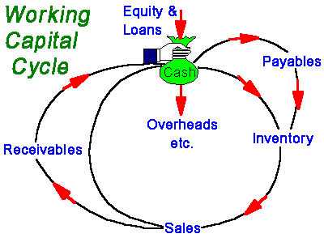

Each component of working capital (namely inventory, receivables and payables) has two dimensions ........ TIME ......... and MONEY. When it comes to managing working capital - TIME IS MONEY. If you can get money to move faster around the cycle (e.g. collect monies due from debtors more quickly) or reduce the amount of money tied up (e.g. reduce inventory levels relative to sales), the business will generate more cash or it will need to borrow less money to fund working capital. As a consequence, you could reduce the cost of bank interest or you'll have additional free money available to support additional sales growth or investment. Similarly, if you can negotiate improved terms with suppliers e.g. get longer credit or an increased credit limit, you effectively create free finance to help fund future sales

If you ....... | Then ......
- Collect receivables (debtors) faster | You release cash from the cycle
- Collect receivables (debtors) slower | Your receivables soak up cash
- Get better credit (in terms of duration or amount) from suppliers | You increase your cash resources
- Shift inventory (stocks) faster | You free up cash
- Move inventory (stocks) slower | You consume more cash

It can be tempting to pay cash, if available, for fixed assets e.g. computers, plant, vehicles etc. If you do pay cash, remember that this is now longer available for working capital. Therefore, if cash is tight, consider other ways of financing capital investment - loans, equity, leasing etc. Similarly, if you pay dividends or increase drawings, these are cash outflows and, like water flowing down a plug hole, they remove liquidity from the business

More businesses fail for lack of cash than for want of profit.

BHEL, HEEP HARDWAR
BALANCE SHEET

BHEL,HEEP HARDWAR
PROFIT & LOSS A/C

Issues in working capital management

Working capital management refers to the administration of all components of working capital.

- Debtors Management
- Creditors(Payables)
- Inventories Management(Stock)

Calculate current assets to fixed asset ratio
A firm needs current and fixed assets to support a particular level of output. However, to support the same level of output the firm can have different levels of current assets. As the firm’s output and sales increases, the need for current asset increases. Generally the current assets do not increase in direct proportion to output ; current assets may increase at a decreasing rate with input. This relationship is based upon the notion that it takes a greater proportional investment in current assets when only a few units of output are produced than it does later on when the firm can use its current assets more efficiently.

The level of the current assets can be measured by relating current assets to fixed assets.
There are three policies:-
- conservative current assets policy:
CA/FA is higher. It implies greater liquidity and lower risk.
- aggressive current assets policy:
CA/FA is lower . it implies higher risk and poor liquidity.
- moderate current assets policy:
CA/FA ratio falls in the middle of conservative and aggressive policies.
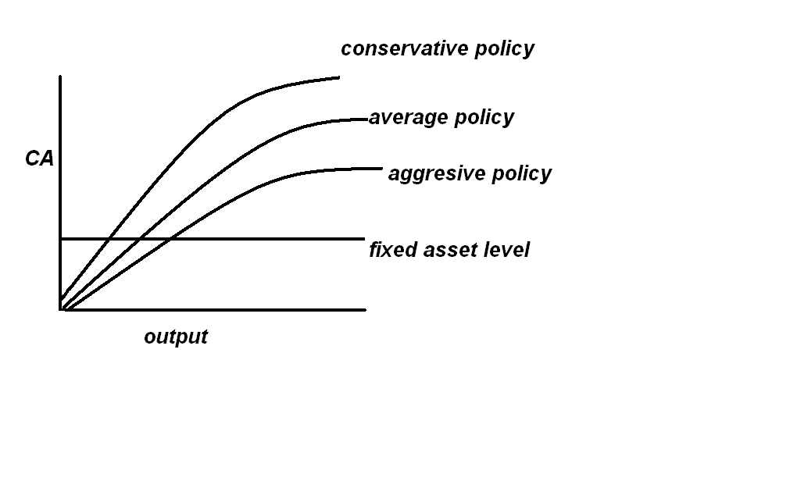
In case of BHEL, Haridwar, the ratio of current asset to fixed asset is

Estimating working capital needs
1.Liquidity Vs. Profitability: Risk Return Trade Off.
The firm would make just enough investment in current assets if it were possible to estimate working capital needs exactly. Under perfect certainity, current assets holdings would be at the minimum level. A larger investment in current assets under certainity would mean a low rate of return of investment for the firm, as excess investment in current assets will not earn enough return. A small invest in current assets, on the other hand, would mean interrupted production and sales, because of frequent stock-cuts and inability to pay to creditors in time due to restrictive policy.
As it is not possible to estimate working capital needs accurately, the firm must decide about levels of current assets to be carried.
2.The Cost Trade Off:
A different way of looking into the risk return trade off is in terms of the cost of maintaining a particular level of current assets. There are two types of cost involved:-
I. Cost of liquidity
II. cost of illiquidity

- --If the firm’s level of current assets is very high , it has excessive liquidity. Its return on assets will be low, as funds tied up in idle cash and stocks earn nothing and high level of debtors reduce profitability. Thus, the cost of liquidity increases with the level of current assets.
- --the cost of illiquidity is the cost of holding insufficient current assets. The firm will not be in a position to honour its obligations if it carries to little cash. This may force the firm to borrow at high rates of interests. This will also adversely affect the credit-worthiness of the firm and it will face difficulties in obtaining funds in the future. All this may force the firm into insolvency. Similarly, the low levels of stock will result in loss of sales and customers may shift to competitors. Also, low level of debtors may be due to right credit policy which would impair sales further. Thus the low level of current assets involves cost that increase as this level falls.

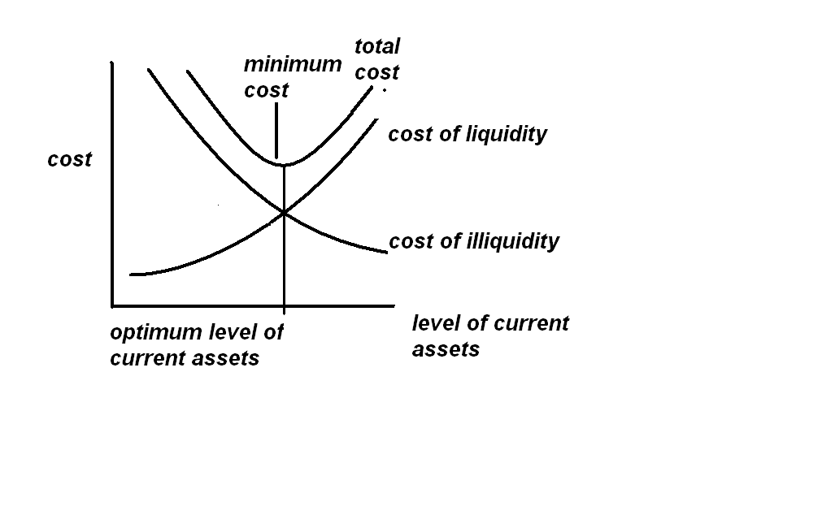

Policies for financing current assets

The following policies for financing current assets in HEEP, Haridwar:-
LONG TERM FINANCING: The sources of long term financing include ordinary shares capital, preference share capital debentures, long term borrowings from financial institutions and reserves and surplus. The HEEP Haridwar manages its long term financing from capital reserve, share premium A/C , foreign project reserve, bonds redemption reserve and general reserve.

SHORT TERM FINANCING: The short term financing is obtained for a period less than one year. It is arranged in advance from banks and other suppliers of short term finance include working capital funds from banks, public deposits, commercial paper, factoring of receivables etc.
The HEEP, Haridwar manages secured loans as:-
- Loans and advances from banks
- Other loans and advances:
          - Debebtures/bonds
          - Loans from State Govt.
          - Loans from financial institutions(secured by pledge of PSU bonds and bills accepted guaranteed by banks)
- Interest accrued and due on loans
        - from State Govt.
        - from financial institutions bonds and other
        - packing credit

The HEEP, Haridwar manages unsecured loans as:-
- Public deposits
- Short term loans and advances:
      - From banks
        - Commercial papers
      - From others
        - From campanies
        - From financial institutions
- Other loans and advances
        - From banks
        - From others
          - from govt. of India
          - from state govt.
          - from financial institutions
          - from foreign financial institution
          - post shipment credit exim bank
          - credit for assets taken on lease
- Interest accrued and due on
        - Post shipment credit
        - Govt. credit
        - State Govt. loans
        - Credits for assets taken on lease
        - Financial institutions and others
        - Foreign financial institutions
        - Public deposits
SPONTANEOUS FINANCING:-
Spontaneous financing refers to the automatic sources of short term funds arising in the normal course of a business. Trade Credit and outstanding expenses are examples of spontaneous financing.
A firm is expected to utilise these sources of finances to the fullest extent. The real choice of financing current assets, once the spontaneous sources of financing have been fully utilized, is between the long term and short term sources of finances.

What should be the mix of short and long term sources in financing current assets ?
Depending on the mix of short and long term financing, the approach followed by a company may be referred to as :
- matching approach
- conservative approach
- aggressive approach

Matching approach
The firm can adopt a financial plan which matches the expected life of assets with the expected life of the source of funds raised to finance assets. Thus, a ten year loan may be raised to finance a plant with an expected life of ten year; stock of goods to be sold in thirty days may be financed with a thirty day commercial paper or a bank loan. The justification for the exact matching is that, since the purpose of financing is to pay for assets, the source of financing and the asset should be relinquished simultaneously. Using long term financing for short term assets is expensive as funds will not be utilized for the full period. Similarly, financing long term assets with short term financing is costly as well as inconvenient as arrangement for the new short term financing will have to be made on a continuing basis.
When the firm follows matching approach (also known as hedging approach) long term financing will be used to finance fixed assets and permanent current assets and short term financing to finance temporary or variable current assets. How ever, it should be realized that exact matching is not possible because of the uncertainty about the expected lives of assets.
The firm fixed assets and permanent current assets are financed with long term funds and as the level of these assets in increases, the long term financing level also increases. The temporary or variable current assets are financed with short term funds and as their level increases, the level of short term financing also increases. Under matching plan, no short term financing will be used if the firm has a fixed current assets need only.

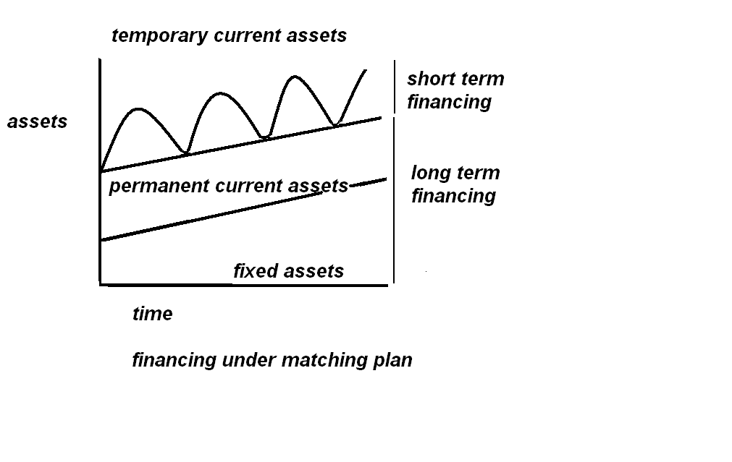

Conservative approach
A firm in practice may adopt a conservative approach in financing its current and fixed assets. The financing policy of the firm is said to be conservative when it depends more on long term funds for financing needs. Under a conservative plan, the firm finances its permanent assets and also a part of temporary current assets with long term financing. In the period when the firm has no need for temporary current assets, the idle long term funds can be invested in the tradable securities to conserve liquidity. The conservative plan relies heavily on long term financing and, therefore, the firm has less risk of facing the problem of shortage of funds. The conservative financing policy is shown below. Note that when the firm has no temporary current assets, the long term funds released can be invested in marketable securities to build up the liquidity position of the firm.

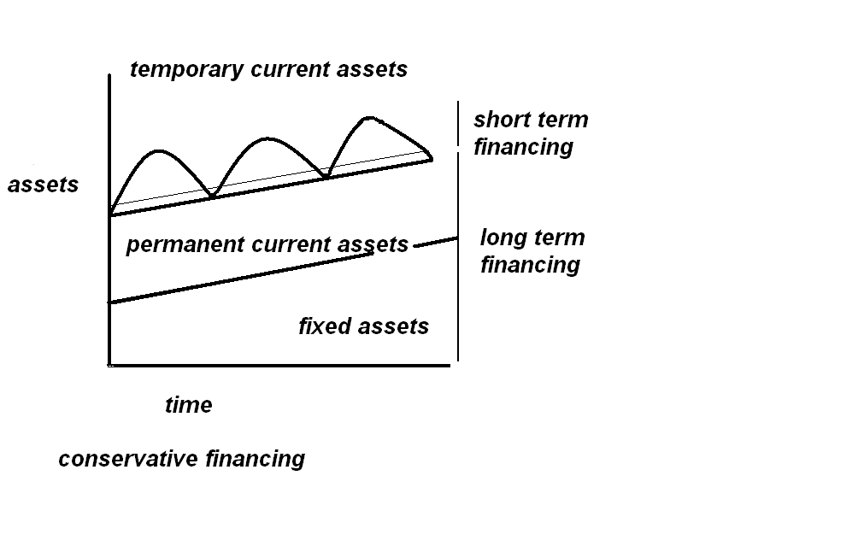

Aggressive Approach
A firm may be aggressive in financing its assets. An aggressive policy is said to be followed by the firm when it uses more short term financing than warranted by the matching plan. Under an aggressive policy, the firm finances a part of its permanent current assets with short term financing. Some extremely aggressive firms may even finance a part of their fixed assets with short term financing. The relatively more use of short term financing makes the firm more risky. The aggressive financing is Illustrated in fig below.

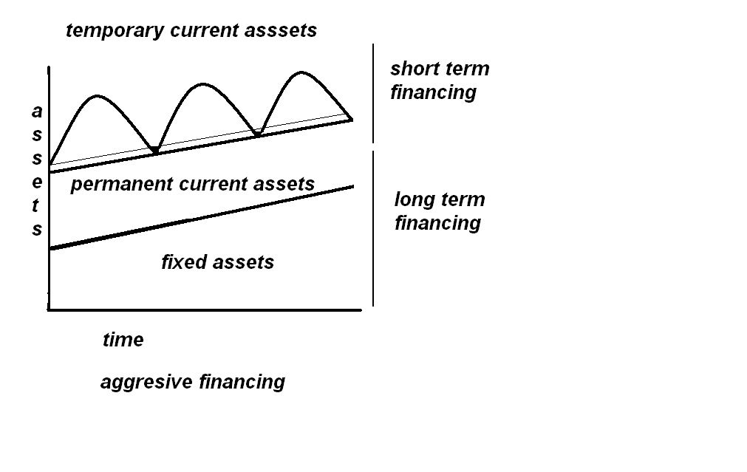

Short term vs long term financing: A Risk Return Trade off
A firm should decide whether or not it should use short term financing. If short term financing has to be used, the firm must determine its position in total financing. This decision of the firm will be guided by the risk return trade off. Short term financing may be preferred over long term financing. For two reasons: 1. the cost advantage 2. flexibility. But short term financing is more risky than long term financing.
Cost: short term financing should generally be less costly than long term financing. It has been found in developed countries like usa, the rate of interest is related to the the maturity of debt. The relationship between the maturity of debt and its cost is called the term structure of interest rates. The curve, relating to maturity of debt and interest rates, is called the yield curve. The yield curve may assume any shape, but it is generally upward sloping. Fig below shows the yield curve. The fig indicates that more the maturity greater the interest rate.

The justification for the higher cost of long term financing can be found in the liquidity preference theory. This theory says that since lenders are risk averse, and risk generally increases with the length of lending time (because it is more difficult to forecast the more distant future), most lenders would prefer to make short term loans. The only way to induce these lenders to lend for longer periods is to offer them higher rates of interest.
The cost of financing has an impact on the firm’s return. Both short and long term financing have a leveraging effect on shareholders’ return. But the short term financing ought to cost less than the long term financing; therefore, it gives relatively higher return to shareholders.
It is noticeable that in India short term loans cost more than the long term loans. Banks are the major suppliers of the working capital finance in India. Their rates of interest on working capital finance are quite high. The main source of long term loans are financial institutions which till recently were not charging interest at differential rates. The prime rate of interest rate charged by financial institutions is lower than the rate charged by banks.
Flexibility: it is relatively easy to refund short term funds when the need for funds diminishes. Long term funds such as debenture loan or preference capital cannot be refunded before time. Thus, if a firm anticipates that its requirement for funds will diminish in near future, it would choose short term funds.
Risk: although short term financing may involve less cost, it is more risky than long term financing. If the firm uses short term financing to finance its current assets, it runs the risk of renewing borrowing again and again. This is particularly so in the case of permanent assets. As discussed earlier, permanent current assets refer to the minimum level of current assets which a firm should always maintain. If the firm finances it permanent current assets with short term debt, it will have to raise new short term funds as debt matures. This continued financing exposes the firm to certain risks. It may be difficult for the firm to borrow during stringent credit periods. At times, the firm may be unable to raise any funds and consequently, it operating activities may be disrupted. In order to avoid failure, the firm may have to borrow at most inconvenient terms. These problems are much less when the firm finances with long term funds. There is less risk of failure when the long term financing is used.
Risk returned trade-off: Thus, there is conflict between long term and short term financing. Short term financing is less expensive than long term financing, but, at the same time, short term financing involves greater risk than long term financing. The choice between long term and short term financing involves a trade-off between risk and return.

- HANDLING RECEIVABLES(DEBTORS)
- MANAGING PAYABLES(CREDITORS)
- INVENTORY MANAGEMENT
- KEY WORKING CAPITAL RATIOS

HANDLING RECEIVABLES(DEBTORS)
Cashflow can be significantly enhanced if the amounts owing to a business are collected faster. Every business needs to know who owes them money.... how much is owed.... how long it is owing.... for what it is owed.
Late payments erode profits and can lead to bad debts.
Slow payment has a crippling effect on business, in particular on small businesses who can least afford it. If you don't manage debtors, they will begin to manage your business as you will gradually lose control due to reduced cashflow and, of course, you could experience an increased incidence of bad debt.
It is very difficult for the organization to sell always on cash basis in today’s competitive market. In almost every business, we have to sell on credit basis.
The basic objective of management of sundry debtors is to optimize the return on investment on this asset. It is obvious that if there are large amounts tied up in sundry debtors, working capital requirement would be high and consequently interest charges will be high. In such cases, the bad debts and cost of collection of debts would be high. On the other hand if the credit policy is very tight, investment in sundry debtors is low but the sale may be restricted, since the competitors may offer more liberal credit term.
We have limited resources and therefore every resource has its own opportunity cost. Therefore the management of sundry debtors is an important issue and requires proper policies and efficient execution of such policies.
Debtors and cost of debtors have direct relation,cost will increase due to increase in debtors and vice-versa. It depend on the credit sale of concern and credit period (collection period) allowed to customer. It is interest of customer to pay as late as possible and company who made sales, would like to collect their debtor as early as possible. There is a conflict between the two aspects.
Debtor management is the process of finding the balance at which company agree to receive its payment without hampering or having any adverse effect on its sales and customer agree to pay at their economical buying concept.
Sundry debtor level depends on two measure issues:
- Volume of Credit sales
- Credit period allowed to customers.
Following factors may be considered before allowing credit period to the customer:-
  - Nature of product
  - Credit worthiness of the customer, which varies from customer to customer
  - Quantum of advance received from customers
  - Credit policy of company, say number of days allowed to customer for payment to the customers
  - Cost of debtors
  - Manufacturing cycle time of the product etc.

Credit policy:
The term credit policy is used to refer to the combination of three decision variables:
Credit standard are criteria to decide the types of customers to whom goods could be sold on credit. If a firm has more slow paying customers, its investment in accounts receivable will increase. The firm will also be exposed to higher risk of default.
Credit terms specify duration of credit and terms of payment by customers. Investment in accounts receivables will be high if customers are allowed extended time period for making payments.
Collection efforts determine the actual collection period. The lower the collection period, the lower the investment in accounts receivable and vice-versa.

Credit Policy Variables
These are:
- Credit standars and analysis
- Credit terms
- Collection policy and procedures
The financial manager or the credit manager may administer the credit policy of a firm. Credit policy has important implications for the firm’s production,marketing and finance functions.the impact of changes in the major decision variables of credit policy are:

Credit standards
These are the criteria which a firm follows in selecting customers for the purpose of credit extensions. The firm may have tight credit standards;that is , it may sell mostly on cash basis and may extend credit only to the most reliable and financially strong customers. Such standards will result in no bad debt losses and less cost of credit administration. But the firm may not be able to expand sales. The profit sacrificed on lost sales may be more than the costs saved by the firm. On the contrary, if credit standards are loose, the firm may have larger sales. But the firm will have to carry large receivables. The cost of administrating credit and bad debt losses will also increase. Thus, the choice of optimum credit standards involves a trade-off between incremental return and incremental costs.
Credit analysis: credit standards influence the quality of the firm’s customers. There are two aspects of the quality of customers;(I) the time taken by customers to repay credit obligation and(II)the default rate. The average collection period determines the speed of payment by customers. It measures the number of days for which credit sales remain outstanding. The longer the average collectionperiod, the higher the firm’s investment in accounts receivables. Default rate can be measured in terms of bad debt losses ratio.-the proportion of uncontrolled receivable. Bad debt losses ratio indicates default risk. Default risk is the likelihood that a customer will fail to repay the credit obligation. On the basis of past practice and experience ; the finance manager should be able to form a reasonable judgement regarding the chance of default. To estimate the probability of default, the financial or credit manager should consider:
Character refers to the customer’s willingness to pay. The financial or credit manager should judge whether the customers will make honest efforts to honour their credit obligations. The moral factor is of considerable importance in credit evaluation in practice.
Capacity refers to the customer’s ability to pay. Ability to pay can be judged by assessing the customer’s capital and assets which he may offer as security. Capacity is evaluated by the financial position of the firm as indicated by analysis of ratios and trends in firm’s cash and working capital position. The financial or credit manager should determine the real worth of assets offered as security.
Condition refers to the prevailing economic and other conditions which may affect the customer’s ability to pay. Adverse economic conditions can affect the ability or willingness of a customer to pay. The firm may categorise its customers at least in the following three categories:
- Good accounts; financially strong customers
- Bad accounts; financially very weak, high risk customers.
- Marginal accounts; customers with moderate financial health and risk.

Credit terms: the stipulations under which the firm sells on credit to customers are called credit terms. These stipulations include(A) credit period (b) cash discount.
Credit period: the length of time for which credit is exyended to customers is called the credit period. It is generally stated in term of a net date. A firm’s credit period may be governed by the industry norms. But depending on its objectives the firm can lengthen the credit period. On the other hand, the firm may tighten its credit period if customers are defaulting too frequently and bad debts losses are building up.
Cash discount: it is a reduction in payment offered to customers to induce them to repay credit obligations within a specified period of time, which will be less than the normal credit period. It is usually expressed as a percentage of sales. Cash discount terms indicate the rate of discount and the period for which it is available. If the customer does not avail the offer, he must make payment within the normal credit period. A firm uses cash discount as a tool to increase sales and accelerate collections from customers. Thus,the level of receivables and associated costs may be reduced. The cost involved is the discounts taken by customers.

Collection policy and procedures
A collection policy is needed because all customers do not pay the firm’s bill in time. Some customers are slow payers while some are non-payers. The collection efforts should, therefore, aim at accelerating collections from slow-payers and reducing bad-debt losses. A collection policy should ensure prompt and regular collection. Prompt collection is needed for fast turnover of working capital, keeping collection costs and bad debts within limits and maintaining collection efficiency. The collection policy should lay down clear cut collection procedures. The collection procedures for past dues or delinquent accounts should also be established in unambiguous terms. The slow paying customers should be handled very tactfully. Some of them may not be permanent customers.
The firm should decide about offering cash discount for prompt payments. Cash discount is a cost to the firm for ensuring faster recovery of cash. Some customers fail to pay within the specified discount period, yet they may make payment after deducting the amount of cash discount. Such cases must be promptly identified and necessary action should be initiated against them to recover the full amount.

BHEL HARIDWAR
The unit is engaged in the manufacturing business of heavy electrical equipments, where cycle time of the product is 18-24 months and most of the contracts take approximately 3-5 years to complete. Customers of BHEL Hardwar are broadly divided into following categories:-
- State electricity boards
- Power project
- Public sector undertakings
- Railways
- Government departments
- Private sectors
- Exports
In most of the contracts, payments of BHEL Hardwar are made in following stages:-
- Payment terms
- Advance from customers
- At the time of dispatch of goods
- At the time of MRC deferred payment after commissioning of project with certain test.
However the above mentioned terms may vary from contract to contract.

The following measures will help manage your debtors:
- Have the right mental attitude to the control of credit and make sure that it gets the priority it deserves.
- Establish clear credit practices as a matter of company policy.
- Make sure that these practices are clearly understood by staff, suppliers and customers.
- Be professional when accepting new accounts, and especially larger ones.
- Check out each customer thoroughly before you offer credit. Use credit agencies, bank references, industry sources etc.
- Establish credit limits for each customer... and stick to them.
- Continuously review these limits when you suspect tough times are coming or if operating in a volatile sector.
- Keep very close to your larger customers.
- Invoice promptly and clearly.
- Consider charging penalties on overdue accounts.
- Consider accepting credit /debit cards as a payment option.
- Monitor your debtor balances and ageing schedules, and don't let any debts get too large or too old.
Recognize that the longer someone owes you, the greater the chance you will never get paid. If the average age of your debtors is getting longer, or is already very long, you may need to look for the following possible defects:
- Weak Credit Judgement
- Poor Collection Procedures
- Lax Enforcement Of Credit Terms
- Slow Issue Of Invoices Or Statements
- Errors In Invoices Or Statements
- Customer Dissatisfaction.
Debtors due over 90 days (unless within agreed credit terms) should generally demand immediate attention. Look for the warning signs of a future bad debt. For example.........
- longer credit terms taken with approval, particularly for smaller orders
- use of post-dated checks by debtors who normally settle within agreed terms
- evidence of customers switching to additional suppliers for the same goods
- new customers who are reluctant to give credit references
- receiving part payments from debtors.
Profits only come from paid sales.
The act of collecting money is one which most people dislike for many reasons and therefore put on the long finger because they convince themselves there is something more urgent or important that demand their attention now. There is nothing more important than getting paid for your product or service. A customer who does not pay is not a customer. Here are a few ideas that may help you in collecting money from debtors:
- Develop appropriate procedures for handling late payments.
- Track and pursue late payers.
- Get external help if your own efforts fail.
- Don't feel guilty asking for money.... its yours and you are entitled to it.
- Make that call now. And keep asking until you get some satisfaction.
- In difficult circumstances, take what you can now and agree terms for the remainder. It lessens the problem.
- When asking for your money, be hard on the issue - but soft on the person. Don't give the debtor any excuses for not paying.
- Make it your objective is to get the money - not to score points or get even.

MANAGING PAYABLES(CREDITORS)
Creditors are the businesses or people who provide goods and services in credit terms. That is, they allow us time to pay rather than paying in cash.
There are good reasons why we allow people to pay on credit even though literally it doesn't make sense! If we allow people time to pay their bills, they are more likely to buy from your business than from another business that doesn't give credit. The length of credit period allowed is also a factor that can help a potential customer decide whether to buy from your business or not: the longer the better, of course.
In spite of what we have just said, creditors will need to optimise their credit control policies in exactly the same way that we did when we were assessing our debtors' turnover ratio - after all, if you are my debtor I am your creditor!
We give credit but we need to control how much we give, how often and for how long. The formula for this ratio is:
Creditors' Turnover | = | Average Creditors
Creditors' Turnover | = | (Cost of Sales/365)

Creditors are a vital part of effective cash management and should be managed carefully to enhance the cash position.
Purchasing initiates cash outflows and an over-zealous purchasing function can create liquidity problems. Consider the following:
- Who authorizes purchasing in your company - is it tightly managed or spread among a number of (junior) people?
- Are purchase quantities geared to demand forecasts?
- Do you use order quantities which take account of stock-holding and purchasing costs?
- Do you know the cost to the company of carrying stock ?
- Do you have alternative sources of supply ? If not, get quotes from major suppliers and shop around for the best discounts, credit terms, and reduce dependence on a single supplier.
- How many of your suppliers have a returns policy ?
- Are you in a position to pass on cost increases quickly through price increases to your customers ?
- If a supplier of goods or services lets you down can you charge back the cost of the delay ?
- Can you arrange (with confidence !) to have delivery of supplies staggered or on a just-in-time basis ?
There is an old adage in business that if you can buy well then you can sell well. Management of your creditors and suppliers is just as important as the management of your debtors. It is important to look after your creditors - slow payment by you may create ill-feeling and can signal that your company is inefficient (or in trouble!).
Remember, a good supplier is someone who will work with you to enhance the future viability and profitability of your company.

INVENTORY MANAGEMENT

Inventories constitute the most significant part of current assets of a majority of companies in India. On an average, inventories are approximately 60 percent of current assets in public limited companies in India. Because of the large size of inventories maintained by firms,a considerable amount of funds is required to be committed to them. It is, therefore, absolutely imperative to manage inventories efficiently and effectively in order to avoid unnecessary investment. A firm neglecting the management of inventories will be jeopardizing its long run profitability and may fail ultimately. It is possible for a company to reduce its level of inventories to a considerable degree, e.g.,10 to 20 per cent, without any adverse effect on production and sales, by using simple inventory planning and control techniques. The reduction in excessive inventories carries a favourable impact on company’s profitability.

Nature Of Inventories
Inventories are stock of the product a company is manufacturing for sale and components that make up the product. The various forms in which inventories exist in a manufacturing company are:
Raw Materials: These are those basic inputs that are converted into finished product through the manufacturing process. Raw materials inventories are those units which have been purchased and stored for future productions.
Work In Process: These inventories are semi-manufactured products. They represent products that need more work before they become finished for sale.
Finished Goods: These inventories are those completely manufactured products which are ready for sale. Stocks of raw materials and work-in-process facilitate production, while stock of finished goods is required for smooth marketing operations. Thus, inventories serve as a link between the production and consumption of goods.

The levels of three kinds of inventories for a firm depend on the nature of its business. A manufacturing firm will have substantially high levels of all three kinds of inventories. Within manufacturing firms, there will be differences. Large heavy engineering companies produce long production cycle products;therefore they carry large inventories. Firms also maintain a fourth kind of inventory, supplies or stores and spares. Supplies include office and plant cleaning materials like soap, brooms, oil, fuel, light bulbs etc. these materials do not directly enter production , but are necessary for production process. Usually, these supplies are small part of the total inventory and do not involve significant investment. Therefore, a sophisticated system of inventory control may not be maintained for them.

Need To Hold Inventories
The question of managing inventories arises only when the company holds inventories. Maintaining inventories involves tying up of the company’s funds and incurrence of storage and handling costs. If it is expensive to maintain inventories, why do companies hold inventories?
There are three general motives for holding inventories:-
TRANSCATIONS MOTIVE: It emphasizes the need to maintain inventories to facilitate smooth production and sales operations.
PRECAUTIONARY MOTIVE: It necessitates holding of inventories to guard against the risk of unpredictable changes in demand and supply forcs and other factors.
SPECULATIVE MOTIVE: It influences the decision to increase or reduce inventory levels to take the advantage of price level fluctuations.

A company should maintain adequate stock of materials for a continuous supply to the factory for an uninterrupted production. It is not possible for a company to procure raw materials whenever it is needed. A time lag exists between demand for materials and its supply. Also, there exists uncertainty in procuring raw materials in time on many occasions. The procurement of materials may be delayed because of such factors as strike, transport disruption or short supply. Therefore, the firm should maintain sufficient stock of raw materials at a given time to stream line production. Other factors which may necessitate purchasing and holding of raw materials inventories are quantity discounts and anticipated price increase. The firm may purchase large quantities of raw materials than needed for the desired production and sales levels to obtain quantity discounts of bulk purchasing. At times, the firm would like to accumulate raw materials in anticipation of price rise.
Work in process inventory builds up because of the production cycle. Production cycle is the time pan between introduction of raw materials into production and emergence of finished product at the completion of production cycle. Till production cycle completes, stock of WIP has to be maintained.
Stock of finished goods has to be held because production and sales are not instantaneous. A firm cannot produce immediately when customers demand goods. Therefore , to supply finished goods on a regular basis, their stock has to be maintained.

Objective Of Inventory Management

In the context of inventory management, the firm is faced with the problm of meeting two conflicting needs:
- To maintain a large size of inventories of raw materials and WIP for efficient and smooth production and of finished goods for uninterrupted sales operations.
- To maintain a minimum investment in inventories to maximize profitability.
Both excessive and inadequate inventories are not desirable. These are two danger points which the firm should avoid. The objective of inventory management should be determine and maintain optimum level of inventory investment. Te optimum level of inventory will lie between the two danger points of excessive and inadequate inventories.
The firm should always avoid a situation of over investment or under investment in inventories. The major dangers of over investment are:
- Unnecessary tie up of the firm’s funds loss of profit
- Excessive carrying costs
- Risk of liquidity
The excessive level of inventories consumes funds of the firm, which cannot be used for any other purpose, and thus, it involves an opportunity cost. The carrying costs such as the costs of storage, handling, insurance, recording and inspection, also increases in proportion to the volume of inventory. These costs will impair the firm’s profitability further. Excessive inventories carried for long period increases chances of loss of liquidity. It may not be possible to sell inventories in time and at full value. Raw materials are generally difficult to sell as the holding period increases. Another danger of carrying excessive inventory is the physical deterioration of inventories while in storage.
Maintaining an inadequate level of inventories is also dangerous. The consequences of under investment in inventories are
- Production hold-ups
- Failure to meet delivery commitments
- Inadequate raw materials and WIP inventories will result in frequent production interruptions.
The aim of inventory management is to avoid excessive and inadequate levels of inventories and to maintain sufficient inventory for the smooth production and sales operations. An effective inventory management should:
Ensure a continuous supply of raw materials to facilitate uninterrupted production
Maintain sufficient stock of raw materials in periods of short supply and anticipate price changes.
Maintain sufficient finished goods inventory for smooth sales operation and efficient customer service.
Minimize the carrying cost and time
Control investment in inventories and keep it at an optimum level.

HEEP HARIDWAR
BHEL produces long production cycle items against the firm orders from customers. Because of this as well as sizeable imported raw materials and compulsory bulk purchases of items like steel and copper in line with availability from SAIL and MMTC,
the company has to carry high level of inventories.

For the year 2004-05
- Inventory percentage of sales is 64.87%
- Inventory percentage of current assets is 59.4%
- Inventory percentage of total assets is 49.55%

Following steps have been taken to control inventory:

- An inventory monitoring cell is constituted at the corporate office.
- The purchases were controlled by the materials management group reporting to the Director of Finance.
- The company provided for weekly meetings between material planning, production control and purchase departments for better matched material availability.
- Monthly review of total inventory at the level of chief executives of plants and corporate management is introduced.
- Inventory control is dovetailed with the budgeting system.
Top 100 inventory items are identified for closer scrutiny and control

KEY WORKING CAPITAL RATIOS

The following, easily calculated, ratios are important measures of working capital utilization.

Ratio | Formulae | Result | Interpretation
Stock Turnover  (in days) | Average Stock * 365/  Cost of Goods Sold | = x days | On average, you turn over the value of your entire stock every x days. You may need to break this down into product groups for effective stock management.  Obsolete stock, slow moving lines will extend overall stock turnover days. Faster production, fewer product lines, just in time ordering will reduce average days.
Receivables Ratio  (in days) | Debtors * 365/  Sales | = x days | It take you on average x days to collect monies due to you. If your official credit terms are 45 day and it takes you 65 days... why ?  One or more large or slow debts can drag out the average days. Effective debtor management will minimize the days.
Payables Ratio  (in days) | Creditors * 365/  Cost of Sales (or Purchases) | = x days | On average, you pay your suppliers every x days. If you negotiate better credit terms this will increase. If you pay earlier, say, to get a discount this will decline. If you simply defer paying your suppliers (without agreement) this will also increase - but your reputation, the quality of service and any flexibility provided by your suppliers may suffer.
Current Ratio | Total Current Assets/  Total Current Liabilities | = x times | Current Assets are assets that you can readily turn in to cash or will do so within 12 months in the course of business. Current Liabilities are amount you are due to pay within the coming 12 months. For example, 1.5 times means that you should be able to lay your hands on $1.50 for every $1.00 you owe. Less than 1 times e.g. 0.75 means that you could have liquidity problems and be under pressure to generate sufficient cash to meet oncoming demands.
Quick Ratio | (Total Current Assets - Inventory)/  Total Current Liabilities | = x times | Similar to the Current Ratio but takes account of the fact that it may take time to convert inventory into cash.
Working Capital Ratio | (Inventory + Receivables - Payables)/  Sales | As % Sales | A high percentage means that working capital needs are high relative to your sales.

NET WORKING CAPITAL RATIO:
NWC is sometimes used as a measure of firm’liquidity. But exactly it is not so. The measure of liquidity is a relationship rather than the difference between current assets and current liabilities. NWC measure the firm’s potential reservoir of funds.
WORKING CAPITAL TURNOVER
A Firm may also like to relate net WC to sales. It may thus compute NWC turnover by dividing sales by NWC.
CAPITAL EQUITY RATIO
This helps in calculating how much funds are being contributed together by lender and owner for each one rupe’s of the owner’s contribution.

Other working capital measures include the following:
- Bad debts expressed as a percentage of sales.
- Cost of bank loans, lines of credit, invoice discounting etc.
- Debtor concentration - degree of dependency on a limited number of customers.
Once ratios have been established for your business, it is important to track them over time and to compare them with ratios for other comparable businesses or industry sectors.

Summary
Let us summarise our discussion on the structure and financing of current assets. The relative liquidity of the firms assets structure is measured by current to fixed assets or current asset to total asset ratio. The greater this ratio , the less risky as well as the less profitable will be the firm and vice versa. Similarly, the relative liquidity of the firm’s financial structure can be measured by short-term financing to total financing ratio. The lower this ratio the less risky as well as profitable will be the firm and vice-versa. In shaping its working capital policy, the firm should keep in mind these two dimensions : relative asset liquidity (level of current assets) and relative financing liquidity(level of short term financing) of the working capital management. A firm will be following a very conservative working capital policy if it combines a high level of current assets with a high level of long term financing (or low level of short term financing). Such a policy will not be risky at all but would be less profitable. An aggressive firm on the other hand would combine low level of current assets with a low level of long term financing(or high level of short term financing ). This firm will have high profitability and high risk. In fact, the firm the firm may follow a conservative financing policy to counter its relatively liquid asset structure in practice. The conclusion of all this is that the considerations of assets and financing mix are crucial to the working capital management.

Recommendations

There is a great need for effective management of working capital in any firm. There is no precise way to determine the exact amount of gross or net working capital for any firm. The data and problems of each company should be analysed to determine the working capital. There is no specific rule as to how current assets should be financed. It is not feasible in practice to finance current assets by short-term sources only. Keeping in view the constraints of the company, a judicious mix of short and long term finances should be invested in current assets. Since current assets involve cost of funds,they should be put to productive use.

